**ST EBBA’S**

SCOTTISH EPISCOPAL CHURCH

**EYEMOUTH**

**March 2015**

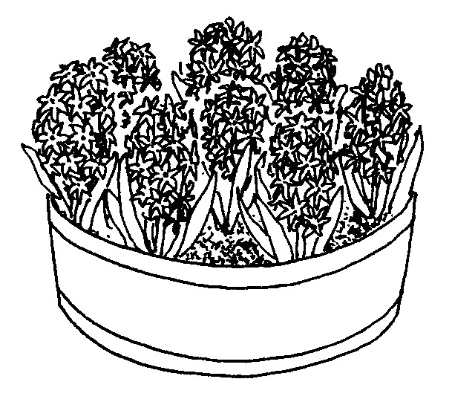



**Times of worship**

Every Sunday: 11am Eucharist in church

OSCR number SC023275

**C:\Users\Pat\AppData\Local\Microsoft\Windows\Temporary Internet Files\Content.IE5\34GZLM5O\MC900371036[1].wmf Priest’s Letter C:\Users\Pat\AppData\Local\Microsoft\Windows\Temporary Internet Files\Content.IE5\34GZLM5O\MC900371036[1].wmf**

Dear friends in Christ

By the time you read this Lent will have begun. Ash Wednesday over with pancakes on Shrove Tuesday and time for us to prepare ourselves for Easter now with Lenten discipline.

How are you getting on with your New Year resolutions? And here we are again with another new beginning for our spiritual and physical bodies. Spring is so full of signs of new life, of encouragement for us to keep going by starting again, over and over.

New every morning is God’s love for us, so why do we so often give up on him or at best let our spirits get so low by life’s trials? Often it is bereavement or serious illness that can topple our faith letting us drop into the darkness of existence.

People often construct great programmes for Lent – some far too ambitious to achieve and some which concentrate on what might be called the ‘negative’ aspect – giving up something. Whilst fasting in some way is always part of Lenten discipline, it is the doing of something simple, but with more effort, that can be the best way of growing in faith. A way to give us a new beginning again to fuel the spark of faith that has grown dim.

What better way can we have than to go back to the story of Jesus as found in the Gospel accounts and seek to refresh our lives with His. The real purpose of Bible Study is to feed our love for Christ, to kindle our hearts into prayer, and to provide us with guidance in our personal lives. A few verses at a time is quite sufficient – the mistake is to read too much at once. Just let the words speak within and then we are on the threshold of prayer, when our whole being is caught and focused on God with an awareness of immense need or perhaps overwhelming delight.

Putting this practically, and taking, say, St Mark’s Gospel, a pattern of daily meditation would begin with the first eight verses of chapter one, followed by nine to thirteen on the next occasion. You will get a feel for when to break up each section as you work through the Gospel. A little each day, even only for ten or fifteen minutes is so much better (and easier to become habit forming) than to try a long chunk occasionally. I always get so

2

dispirited when I try that. Even if you miss a day or two just pick up where you left off and carry on. God is waiting for you. He’s always there even when we seem to lose him, he never loses us.

If even all this is too much, just go out and enjoy the sun that rises anew each day that reminds us of the love around us. Maybe the sight of birds in flight or a new lamb – God will bless you anew with his closeness and love.

With love and prayer,

**Sheila**

[](http://www.livingmadeeasy.org.uk/communication/domestic-induction-loop-systems-1434-p/) **Do you use a hearing aid?** [](http://www.livingmadeeasy.org.uk/communication/domestic-induction-loop-systems-1434-p/)

If you do, the Vestry are delighted to let you know that, thanks to the organisation of Ian Taylor, St Ebba’s now has a loop system installed. If you adjust your hearing aid to the appropriate setting we hope you will be able to hear better what is being said in church. You may have noticed that microphones are now installed at the lectern and in the pulpit and the worship leaders will also be using roving microphones in the service.

If you do not use a hearing aid, you will find no difference as this is not an amplifying system but is designed specifically to assist those who do use hearing aids.

**Quote of the Month**

Give me, good Lord, a humble, lowly, quiet, peaceable, patient, charitable, kind, tender and pitiful mind; with all my works and all my words and all my thoughts to have a taste of the holy blessed spirit.

Sir Thomas More

3

**MARCH DIARY**

**Sun 1st LENT 2**

11am Eucharist

Readings Genesis 17 vs 1-7, 15-16

Psalm 22 vs 22-30

Romans 4 vs 13-25

Mark 8 vs 31-38

**Wed 4th** 10.00am Eucharist in the Parsonage

Readings Jeremiah 18 vs 18-20

Psalm 31 vs 1-5, 13-16

Matthew 20 vs 17-28

**Sun 8th LENT 3**

11am Eucharist

Readings Exodus 20 vs 1-17

Psalm 19

1 Corinthians 1 vs 18-25

John 2 vs 13-22

**Sun 15th LENT 4 MOTHERING SUNDAY**

11am Eucharist

Readings Exodus 2 vs 1-10

Psalm34

Colossians 3 vs 12-17

Luke 2 vs 22-35

**Sun 22nd LENT 5 PASSION SUNDAY**

11am Eucharist

Jeremiah 31 vs 31-43

Psalm 51 vs 1-13

Hebrews 5 vs 5-10

John 12 vs 20-33

4

**MARCH DIARY (cont)**

**Sun29th LENT 6 PALM SUNDAY**

Isaiah 50 vs 4-9a

Psalm 31 vs 9-16

Philippians 2 vs 5-11

Mark 15 vs 1-47

**Mon 30th HOLY WEEK**

10am Eucharist

Readings Isaiah 42 vs 1-9

Psalm 36 vs 5-11

Hebrews 9 vs 11-15

John 12 vs 1-11

**Tues 31st** **HOLY WEEK**

10am Eucharist

Readings Isaiah 49 vs 1-7

Psalm 71 vs 1-14

1 Corinthians 1 vs 18-31

John 12 vs 20-36

**INTERCESSORS AND READERS – MARCH**

|  |  |  |  |
| --- | --- | --- | --- |
|  | **Server** | **Intercessor** | **Reader** |
| Sun 1st | Richard Oldale | Joan Shelmerdine | Brian Payne |
| Sun 8th | Joan Shelmerdine | Ernie Cox | Ian Taylor |
| Sun 15th | Debbie Higson | Sheila Cox | Pat Elliott |
| Sun 22nd | Joan Shelmerdine | Joan Thomas | Simon Furness |
| Sun 29th | Richard Oldale | David Smout | Passion |

5

6

**Report from the Worship Team**

David Smout; Richard Oldale; Joan Shelmerdine; Tim Morris; Jennifer Edie

**Favourite Hymns**

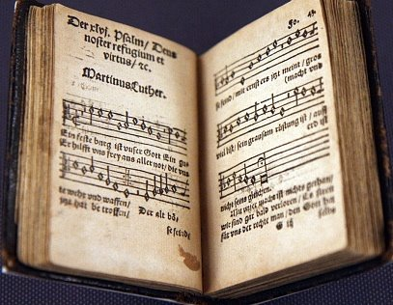

We discussed the choice of **hymns** and agreed that we would welcome a list of your 10 favourite hymns that we could include in our worship on Sundays. There will be a box in the church where you can leave your list.

**Dates for your diary**

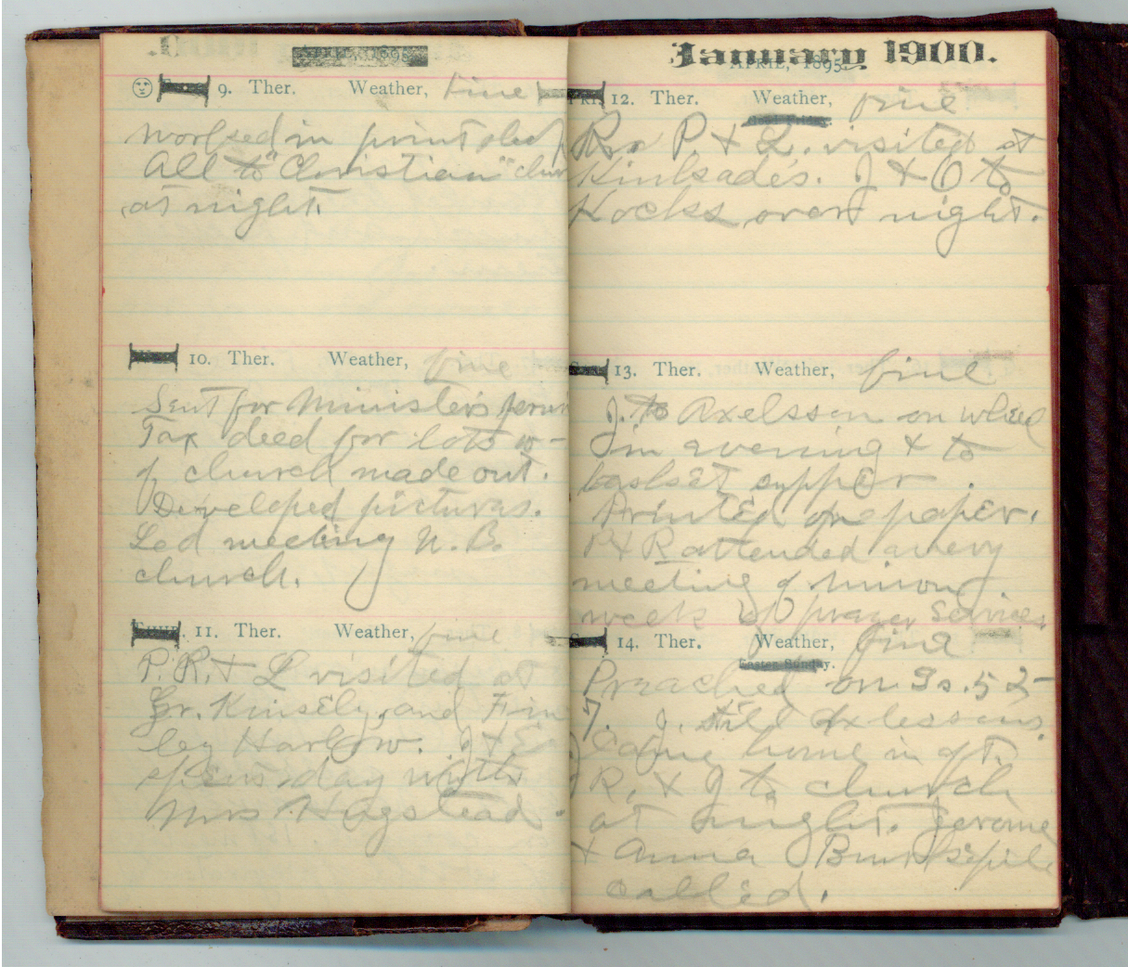

**Ecumenical Lent Group** will meet on **Wednesdays** in Lent at

11 a.m. in the Parsonage to follow the York Course on the Hymns of the New Testament, beginning on Wednesday 25th February. All welcome.

Also on **Wednesdays** in Lent there will be a **Eucharist** in the

Parsonage at 10 a.m.

**Holy Week** Eucharist in the Parsonageat 10 a.m. on Monday, 30th March and Tuesday, 31st March. We are invited to join the worship in St Andrew’s R.C. church on Wednesday 1st April. There will a Eucharist in St Ebba’s at 7.30 p.m. on **Maundy Thursday** with foot washing, followed by a time of silent prayer to watch with Christ in Gethsemane. On **Good Friday** there will be an ecumenical Prayer Walk through the town starting at Victoria Road car park at 10 a.m. and finishing with an open air service on the Bantry at 11 a.m. In St Ebba’s, there will be a service on guided meditation and silent prayer from 2 p.m. to 3 p.m.

**Easter Day** will begin with Dawn Praise outside St Ebba’s at 6.30 a.m. There will be a Festival Eucharist at 11 a.m.

**Satire Or Sacrilege – A Response**

Pat Elliott’s thought provoking article, on the ‘Charlie Hebdo’ affair, asked if we should support the magazine as a champion of free speech.

The right to speak freely is undeniable, but, as always, this must be balanced by the need for responsibility.

I can give a concrete example. People now have the right to roam through the grounds of Netherbyres – which I welcome – but I wish some were responsible enough not to drop litter and not to peer through the windows of occupied houses.

Rights and responsibilities are two counterweights to be balanced against one another.

Charlie Hebdo had the right to publish the cartoons but were irresponsible to do so, as they were bound to offend many people. Where should we stand as Christians? The answer is to do as you would be done by, or, in biblical terms, ‘love thy neighbour as thyself’.

Simon Furness

**Questions? **

*Last month Jennifer invited questions about why particular gestures are made during a service. The following question has often puzzled one member of the congregation.*

‘I’ve noticed that priests often make the sign of the Cross at the mention of the Holy Spirit. Why is this and why do the congregation not do the same?’

*Jennifer replies:*

‘It is a matter of personal choice, and depends on how you choose to identify yourself with the words being spoken. I was brought up to make the sign of the Cross when hearing or saying "In the name of the Father, the Son and the Holy Spirit". The sign of the cross may be made by individuals as a form of [prayer](http://en.wikipedia.org/wiki/Prayer_in_Christianity), and by clergy as an act of [blessing](http://en.wikipedia.org/wiki/Blessing). I make the sign of the cross as an acknowledgement of the grace and glory of the Trinity and a prayer that I may be faithful.’

** Meditation for Lent – Simon Tugwell OP**

In the springtime the world awakens and we see life springing up, swelling out in the branches, blossoming in the flowers, singing in the birds.

If we would let go –

So that our hands could be empty to receive.

The tree that is planted by the riverside need not fear that its water will dry up.

The sap rises from the unlimited waters –

The waters that flow are not contained.

Let us plunge our roots deep down – into the living waters.

The living waters that flow are not contained.

‘Drink deep,’ says the Lord to those whom he loves,

‘Drink deep and be drunk with the torrents of my delights.’

Do not be afraid of the wideness of his life.

Lift high your branches into the wind of his Spirit.

Rejoice to be tossed around – for you are rooted in Him.

And His life is stronger than death.

In Him, even the hard, even the dead wood can feel the sap rising again- can be brought back to life.

Do not be afraid of the power of His life, the fervour of his love.

There is no need for us to be afraid.

No need for us to narrow our hearts.

If only we will open our hearts

A tiny bit

However timidly,

The first drops of life will trickle in,

The sap will begin to rise – it will find a way.

‘O my loved ones,’ He cries –

‘O you who are thirsty, old and tired – drink deeply from the fountain of life.’

In Him is life and life is the light of men,

Giving light to everyone who is in the world.

In Him is life and life more abundant.

In Him is the fullness of joy.

8

**FAITH in ACTION**

**March**

**Asylum Seekers**



*Of the thousands of people who apply for asylum, only a thousand or so come to Scotland each year. However, due to government reorganisations, this number is set to rise over the next few years. So, what can we do? It is important to keep informed and up to date with accurate statistics and information about asylum seekers. You can do this easily by contacting and/or applying for a free e-mail newsletter from the Scottish Asylum Seekers Consortium which will give you accurate coverage of the state of affairs in Scotland*

**Prayer for asylum seekers:**

**Almighty God, through your Son, Jesus Christ we are called to serve the marginalised and vulnerable within our society. Give us Your gift of Grace that we might share in the plight of all asylum seekers and refugees and open our hearts to them, that Your love may be known, through Christ our Lord. AMEN**

*CONTACTS*

*Scottish Refugee Council, 5 Cadogan Square, 170 Blythswood Court*

*Glasgow G2 7PH 0141 248 9799 www.scottishrefugeecouncil.org.uk*

*Scottish Asylum Seekers Consortium, COSLA, Strategic Migration Partnership, Cadell House, Suite 2/3, 27 Waterloo Street, Glasgow G2 6BZ www.migrationscotland.org.uk*

*Scottish Churches Housing Action, 44 Hanover Street, Edinburgh*

*EH2 2DR 0131 477 4500 www.churcheshousing.org*

*Refugee Council Online,*  020 7820 3000 [www.refugeecouncil.org.u](http://www.refugeecouncil.org.u)k

*Faith in Action: The Church in Society Committee of the Scottish Episcopal Church, the Methodist Church in Scotland and the Church & Society Committee of the United Reformed Church Synod of Scotland*

**9**

**Christian Aid supports thousands hit by Malawi floods**

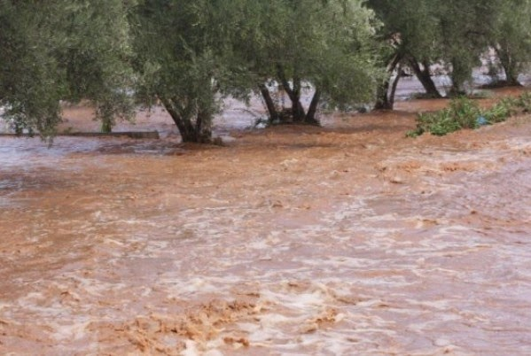

Christian Aid is providing emergency assistance to deluged communities in Malawi, in the aftermath of the worst floods the country has seen in nearly two decades. More than 630,000 people have been affected, with 120,000 of these displaced by the torrential rain and flooding that recently hit the country’s southern districts, washing away homes, livestock, crops and roads.

Christian Aid partners are working to provide 40,000 people in Nsanje and Chikwawa districts with access to clean water, toilet facilities and temporary shelter. Existing water sources such as boreholes and wells have been damaged or swept away, as have many public and household latrines. As many homes have been destroyed, 1,800 tarpaulins have been distributed to provide emergency shelter for up to 9,000 people.

Christian Aid’s Malawi Country Manager, MacDuff Phiri, described the floods as “catastrophic”. He said: “The impact has been huge. The majority of people here live on less than US$1 a day, and everything they own has been washed away. It means they need to rebuild their lives, which isn’t going to be easy.” Malawi is among the world’s poorest countries.

[](http://www.clipartpanda.com/categories/holy-spirit-dove-symbol)***To make a regular donation to Christian Aid telephone 0****131 220 1254* or ***go to www.christianaid.org.uk/give***

**10**

**ST. FRANCIS OF ASSISI**

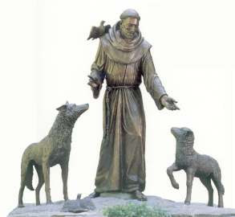

St. Francis lived from 1182 - 1226 and within his lifetime, his followers travelled widely through Europe, even as far as Scotland, to spread his message of love, joy and humility by following the footsteps of Christ.  The Franciscan way has drawn people ever since.  The Anglican Society of St Francis is alive and well around the world today. It has three Orders:

**First Order** Brothers and Sisters living in community and taking the Franciscan message out to the world around them.

**Second Order** Sisters enclosed in a community of prayer, work and contemplation according to the pattern of life of St Clare of Assisi.

**Third Order** members, lay and ordained, men and women, living in their own homes, working and endeavouring to serve their church and community, having made a pledge to follow the teaching of St Francis and St Clare.

If you are interested in finding out more about St Francis and St Clare and their 21st century followers, the North Northumberland/Scottish Borders Area of the Third Order is holding an Open Day on Saturday 18th April at Holy Trinity Church in Berwick-upon-Tweed from 10.30 a.m. to 2.30 p.m.  There will be talks, time for discussion and questions and the day will close with shared worship. The day will include a shared lunch - all we ask people attending this event to bring is a small food contribution to lunch.  More details will follow this advance notice but if you want to ask any questions, please contact

Jennifer Edie (01890750169): email [rev.jennifer@gmail.com](mailto:rev.jennifer@gmail.com).

**11**

**Help the thirsty on World Water Day, Sunday 22nd March**



*Top of Form*

*Bottom of Form*

*Tap, bottled, still, sparkling ………. we take clean drinking water for granted. But in some parts of the world clean water is not on offer*

The relief charity Samaritan’s Purse is appealing for help in its efforts to provide clean drinking water to a community in Karamoja, northern Uganda.

“People there drink dirty water because they have no choice. There are no functioning wells nearby. Every sip of water they drink is a potential killer,” explains Simon Barrington, UK head of Samaritan’s Purse.

The charity’s aim is to give 50 villages in Karamoja - that’s 20,000 men, women and children - the choice to drink clean water everyday. To make this happen they need to raise £300,000 between February – April 2015.

And so it is that Samaritan’s Purse is appealing to people to remember Karamoja on World Water Day on 22nd March by supporting their TurnOnTheTap initiative. You can find more details at: [www.TurnOnTheTap.org.uk](http://www.TurnOnTheTap.org.uk)

[](http://turnonthetap.org.uk/)

***I WAS THIRSTY AND YOU GAVE ME SOMETHING TO DRINK - Matt 25:35***

**Outside our Borders**

*This month Brian Payne takes us to troglodyte homes in France*

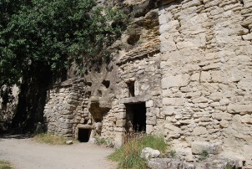

In the valleys that lie south of Tours in France are a collection of communities whose houses are far from standard. The steep valley sides and soft geology have allowed villages to grow where the houses have facades, but the rooms are excavated from the rock face. Some dwellings do not even bother with a façade – a door is set into the rock face and windows appear higgledy piggledy as the stone allows. The villages are known as the troglodyte communities and they remain well occupied although perhaps not so much as before. They date back hundreds of years. As the casual passer by follows the line of the valley, he passes neat little gardens, cars parked against the rock face and village folk going about their business. In some places, chimneys rise out of the field at the top of the cliff. Seen from across the farmland, they appear to be a bizarre monument, unless you know of the houses concealed in the valley below.

Life in these villages is no different to those of the more normal rural settlements around and about the Loire Valley. There are bakers and some small shops in the larger villages, and where the valleys open out, there are often houses built without using the rock at all. In one such village, we came across a small family business, making baskets. Father and son together sat on adapted chairs, weaving wicker into an array of useful containers. There were some more fanciful decorative items, seemingly designed to attract the weekenders who have bought a fair number of the troglodyte houses as a bolt hole from Tours or Paris. Photographs on the walls of the shop showed that the family had been making baskets in the village for generations. A small puppy gambolled between the two men, making a nuisance of itself, but hardly interfering with the measured creation of yet another deep shopping basket.

We bought two baskets, and use them. I am delighted to know that in our busy world, set about with multimedia platforms and speeding traffic, there still exist places where the pattern of life is set by the slow weaving of wicker, and the houses are individually carved from the solid rock.

13

**LAUGHTER LINES**

*Do the Maths ………* 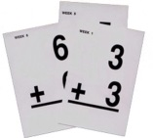

**A farmer died and left seventeen sheep to his three sons – half to the eldest, a third to the second son and one ninth to the youngest.**

**This was very awkward and the sons quarrelled about it and eventually went to the priest for help in solving the problem.**

**He said, ‘Go and get the sheep out of my garden which has broken through the fence and is eating my plants, and add it to the little flock making eighteen; now, half to the eldest is nine: one third to the second son is six: and one ninth to the youngest is two. Total seventeen.**

**Now take the remaining sheep to auction and make sure I get a good price for it!’**

***And a challenge to mental arithmetic ……*.**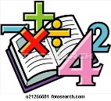

A father took his small son to church. The boy sat passively until the minister announced: “We will now sing hymn four hundred and twenty-nine: ‘Ten Thousand Times Ten Thousand’….four hundred and twenty-nine.”

Alarmed, the boy nudged his father: “Do we have to work this out?”

***Creative accounting ……..***

Three people applied for the same job. One was a mathematician, one a statistician, and one an accountant. The interviewing committee first called in the mathematician. They said "we have only one question. What is 500 plus 500?" The mathematician, without hesitation, said "1000." The committee sent him out and called in the statistician. When the statistician came in, they asked the same question. The statistician pondered the question for a moment, and then answered "1000... I'm 95% confident." He was then also sent on his way. When the accountant entered the room, he was asked the same question: "what is 500 plus 500?" The accountant replied, "what would

you like it to be? They hired the accountant.

**14**

**CHURCH CONTACTS**

Priests the Revd Sheila Cox 01890 771764

the Revd Jennifer Edie 01890 750169

the Revd David Smout 01890 771220

the Revd Tim Morris 01289 386615

Lay Rep Brian Payne 018907 81825

Alt Lay Rep David Garside 01890 751159

People’s Warden Richard Oldale 01890 750939

Administrator Jennifer Edie 01890 750169

Treasurer David Garside 01890 751159

St Ebba’s Church, Fort View, Paxton Terrace, Eyemouth, TD14 5EL

St Ebba’s Parsonage, Beach Avenue, Eyemouth, TD14 5EL

[www.stebbas.org.uk](http://www.stebbas.org.uk)

***If you are in hospital and would like us to know and/or to visit, under the current regulations you have to specifically ask the hospital to inform us.***

If you want to keep up with what’s happening here and across the Borders, you will find the minutes of our own Vestry meetings and the Borders Area Council meeting in the files at the back of the church.

***EDITOR’S NOTE:***

*Our thanks, as always, to the Parish Pump website for providing material for our newsletters throughout the year and thanks too to each of this month’s contributors.*

*Copy for your April newsletter is 13 March. Do drop me a line to the email address below or to Birchfield House, Auchencrow, TD14 5LS to share your stories, thoughts, news and views.*

*Yours,*

Pat

E: [info@thebordersdesignhouse.co.uk](mailto:info@thebordersdesignhouse.co.uk) T: 01890 761271

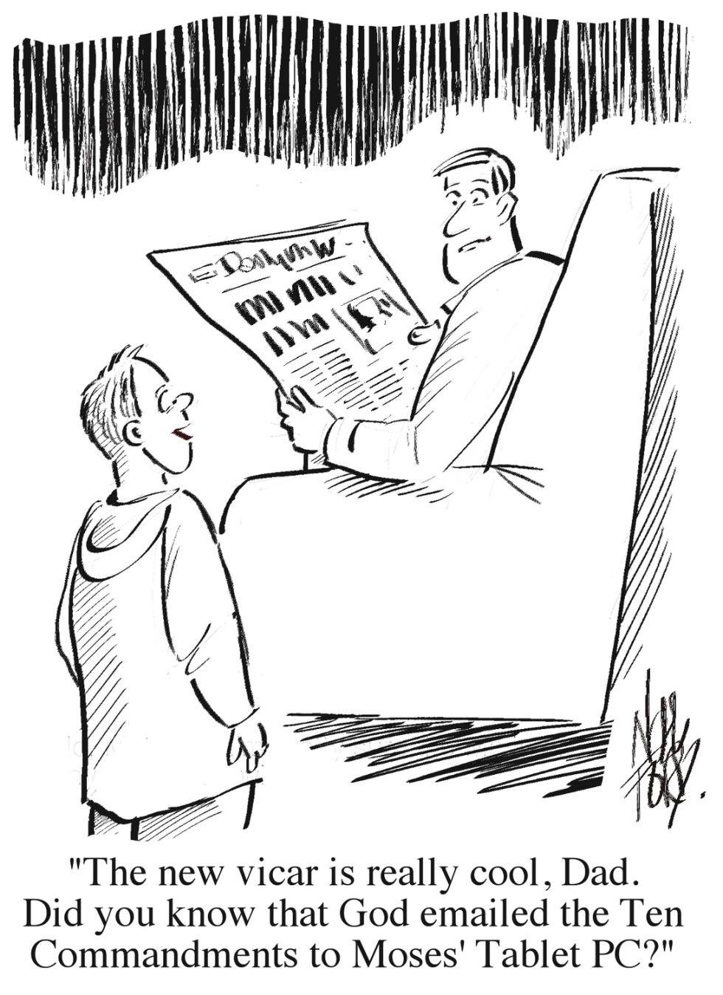

© 2015 Parish Pump Ltd, all rights reserved