ST EBBA’S
SCOTTISH EPISCOPAL CHURCH
EYEMOUTH

JUNE 2016

Times of worship
Every Sunday: 11am Eucharist in church

OSCR number SC023275
PRIEST’S PONDERINGS

Greetings to you all.
“A swarm of bees in June is worth a silver spoon.” We need the bees to pollinate our flowers and vegetable plants so let’s hope we have good weather and that the bees can fend off the diseases that threaten their existence and the scientists find ways of dealing with those diseases.
Thus was an intuitive response to the quotation I started with because of my amazement at discovering new delights in learning this late in life. I have been privileged to discern this new enthusiasm for learning gained by attending three very different events.
First – our joint churches Lent group where new understanding of the Psalms developed. Second – a day on meditation which is something I have tried to do without much success in the past but am now endeavouring to work harder at because of what I learned. Third and most exciting was a weekend course on ‘The integrity of creation’.
This was an exciting journey of exploration into how everything living in the world God created is inextricably linked together in a shared life. Since I visited the John Muir Woods in California and walked through paths between the towering redwood trees I have been intrigued by how the Scotsman John Muir came to such prominence in America in spite of, or perhaps because of, his rigorous upbringing and labouring on a small farm in Scotland. I am now reading a biography of this amazing man who had to struggle to bring together his fundamentalist faith in God which he learned from his stern father with all the new discoveries in science in the nineteenth century which questioned all the beliefs that had been drummed, sometimes beaten, into him.
Out of all this struggle, he was able to rescue the wilderness world where all species could co-exist in the provision of protected areas, national parks, where they were protected from the ravages of a new industrialising nation. He wrote about the natural world in inspirationally moving language of faith and the love of beauty.
I now feel I want to go out and save the world but I realise my contribution will be small but if we could all make a contribution of whatever size, the world would rejoice in its glory. Recycling, protecting, saving power and fuel can all play their part if we make a determined effort to rescue the great gifts that God has lovingly showered upon us in his creation.
If you are interested in the Psalms, meditation or ethical living, do get in touch. I’d love to share these God-given gifts with you.
Jennifer
***********
JUNE DIARY

Sun 5th PENTECOST 3
11am Eucharist
Readings 1 Kings 17 vs 17-24
Galatians 1 vs 11-24
Luke 7 vs 11-17

Wed 8th St Columba
10am Eucharist
Readings 1 Thessalonians 2 vs 2-12
Luke 12 vs 32-37

Sun 12th PENTECOST 4
St Barnabas
11.00am Eucharist
Readings Isaiah 45 vs 5-12
Acts 11 vs 19-30 + 13 vs 1-3
John 15 vs 12-17

Sun 19TH PENTECOST 5
11.00am Eucharist
Readings Isaiah 65 vs 1-9
Galatians 3 vs 23-29
Luke 8 vs 26-39

Sun 26th PENTECOST 6
HEALING
11am Eucharist
Readings 1 Kings 19 vs 15-16, 19-21
Galatians 5 vs 1, 13-25
Luke 9 vs 51-62
INTERCESSORS AND READERS – JUNE

Date Intercessor Reader
Sun 5th Ernie Cox Debbie Higson
Sun 12th Jan Simpson Pat Elliott
Sun 19th Joan Thomas Frankie Taylor
Sun 26th Simon Furness Brian Payne
A little reminder ……. Could all readers and intercessors please use the lectern where there is a microphone for the T loop system. This will pick up your voice and enable those with hearing aids to hear you well. There is also a neat little light (kindly donated by Brian Payne) which you can switch on to see your page better. Clergy and Worship Leaders should have their mikes attached to their robe. This system cost a lot of money so let’s use it!

If you are in hospital and would like us to know and/or to visit, under the current regulations you have to specifically ask the hospital to inform us.

As this issue was being prepared for press, we all learned with sadness the news of Ian Taylor’s death.
Ian will be sorely missed from the life of St Ebba’s. Not only did he ably assume the duties of Vestry Chair and of Treasurer but he organised the installation of the hearing loop system in church, was always willing to volunteer for the miscellaneous jobs needing attention and led the small building group in their explorations of how we might take forward plans, first inspired by Dave Garside, for reconfiguring our church buildings.
We remember Ian’s valued contributions with gratitude and send our sympathies to Frankie and all the family.

DIARY DATES

30 May This was the last chance to claim any items you may wish to keep from the Parsonage. Help is now needed to sort and clear any items remaining.

23 July Everyone is warmly invited to join St Ebba’s Ministry Team and Vestry for an Awayday at Alnmouth Priory. Coffee and tea are provided but you are asked to bring your own packed lunch. Car share will be organised. Enquiries and bookings to Jennifer please.

21 August Bishop John will be with us at 11 a.m. for St Ebba's Day on August 21st with a bring and share buffet lunch after the service. Please keep this date free!

VACANCIES AT ST EBBA’S
APPLY NOW!

Relief Sacristan
Frankie Taylor would very much appreciate help on one Sunday per month with Sacristan duties.
It is not, she assures us, an onerous task once you’ve been shown the ropes and only takes about 15 minutes before and after a service. Please speak to Frankie for more information> Tel 018907 51123 or email her on taylor_fct@hotmail.com

Treasurer
The Vestry is in urgent need of someone to take over the role of Treasurer. This need not be a daunting task but it would help to have some knowledge of using a spreadsheet.
If you know of anyone who may be willing to help out, even if they are not regular attendees of St Ebba’s, please ask them to get in touch with a member of the Vestry or, with their permission, pass on their name.

FAITH in ACTION
June
Peace & Justice

For some, the issue of nuclear disarmament has been superseded while for others it is still central. Some Christians oppose war at any cost while others look to seek ways to support the armed forces. It is essential to recognise that Christians can hold opposing views on pacifism, animal testing and many other issues with integrity. So …..
♣ pray for peace and justice in the world: locally, nationally and internationally
♣ consider joining a peace and justice organisation and participating in their work
♣ join Amnesty International and help campaign for justice
♣ consider the work of CND or Scotland 4 Peace
♣ use your LOAF when buying food: Locally produced, Organically farmed, Animal friendly, Fairly traded
♣ observe the World Council of Churches’ World Week for Peace in
Palestine Israel in June

Give us, Lord God, a vision of our world as your love would make it:
A world where the weak are protected, and none go hungry or poor;
a world where the benefits of civilised life are shared, and everyone can enjoy them; a world where different ethnic groups, nations and
cultures live in tolerance and mutual respect; a world where peace is built with justice, and justice is guided by love;
And give us the inspiration and courage to build it,
through Jesus Christ our Lord.
AMEN From a prayer by Trevor Williams

Faith in Action: The Church in Society Committee of the Scottish Episcopal Church, the Methodist Church in Scotland and the Church & Society Committee of the United Reformed Church Synod of Scotland
http://www.scotland.anglican.org/spirituality/prayer/faith-in-action

The threat of radical Islamists ……….

and what the Church should do

Radical Islamist ideologies are threatening not only to world peace and national security, but the very survival of Christian, Yazidi, Jewish and other minorities throughout the Islamic world and beyond. So says the former Bishop of Rochester, the Rt Revd Michael Nazir-Ali, in a new book.
In Faith, Freedom & The Future; Challenges for the 21st Century (Wilberforce Publications, £12.99), the Bishop – from both a Muslim & Christian background – also claims that “here [in the UK] the abandoning of the Christian faith by large numbers of people, the continual secularising of the state, and the large-scale rejection of Christian teaching in the mainline churches themselves has left the West unprepared to understand and meet the challenge from a religiously-inspired ideology.”
The Bishop argues that it is only through a renewal of the vision of the Bible that the West will be able to strengthen its own moral and social basis and to counter the challenges being posed from outside. He says “It may be that God, in his mercy, will renew and revive the existing denominations or, if not, it may be in fresh ways that the Spirit will blow over parched lands and dry bones. Whichever it is, we must pray urgently for the Spirit’s refreshment and for not only spiritual but moral renewal. The one must lead to the other.”
Prior to becoming Bishop of Rochester, Bishop Michael was Bishop of Raiwind, Pakistan, and formerly General Secretary of the Church Mission Society (CMS). His concern over the growing rise of Islamism led him to resign from his diocesan responsibilities in Rochester, to help develop Christian Leadership in the persecuted church.

Turn on the Tap

Samaritan’s Purse has launched an urgent appeal to provide clean water to over 35,000 people in desperate need in South Sudan.

Angelina is just one of many thousands whom Samaritan’s Purse plans to help. Along with her family of ten children, she moved into a camp for internally displaced people in Abiemnhom County, South Sudan. Now she must walk for six hours in intense heat on dangerous terrain to collect dirty water from a river. She risks being attacked and beaten on each journey.

With an estimated 55,000 internally displaced people across Mayom and Abiemnhom counties in Unity State, overcrowding and overuse of clean water sources has led to one third of existing hand pump wells breaking down. So Samaritan’s Purse plans to rehabilitate and install 70 wells in this region, for people who currently have no choice but to drink dirty water.

To achieve their goal Samaritan’s Purse needs to raise £525,000 by 30th June.

More details and free resource pack: www.turnonthetap.org.uk

CHURCH CONTACTS

Priests the Revd Sheila Cox 018907 71764
the Revd Jennifer Edie 018907 50169
the Revd Tim Morris 01289 386615
the Revd David Smout 018907 71220
Rev Canon Jeffry Smith 07818 445743
(Interim Rector)

VESTRY MEMBERS 2016
Jennifer Edie (Administrator) 018907 50169
Richard Oldale (Peoples' Warden) 018907 50939
Brian Payne (Lay Rep) 018907 81825
Frankie Taylor (Alternate Lay Rep) 018907 51123
Joan Thomas
Mary Fyall 018907 71749
Debbie Higson 018907 71202
Pat Elliott 018907 61271

St Ebba’s Church, Fort View, Paxton Terrace, Eyemouth, TD14 5EL
St Ebba’s Parsonage, Beach Avenue, Eyemouth, TD14 5EL
www.stebbas.org.uk

EDITOR’S NOTE:
Our thanks, as always, to the Parish Pump website for providing material for our newsletters throughout the year and thanks too to this month’s contributors.
Please send in copy for your July/August newsletter by 14 June at the latest. Drop me a line to the email address below or to Birchfield House, Auchencrow, TD14 5LS to share your stories, thoughts, news and views.
Yours,
Pat
thebordersdesignhouse@hotmail.com

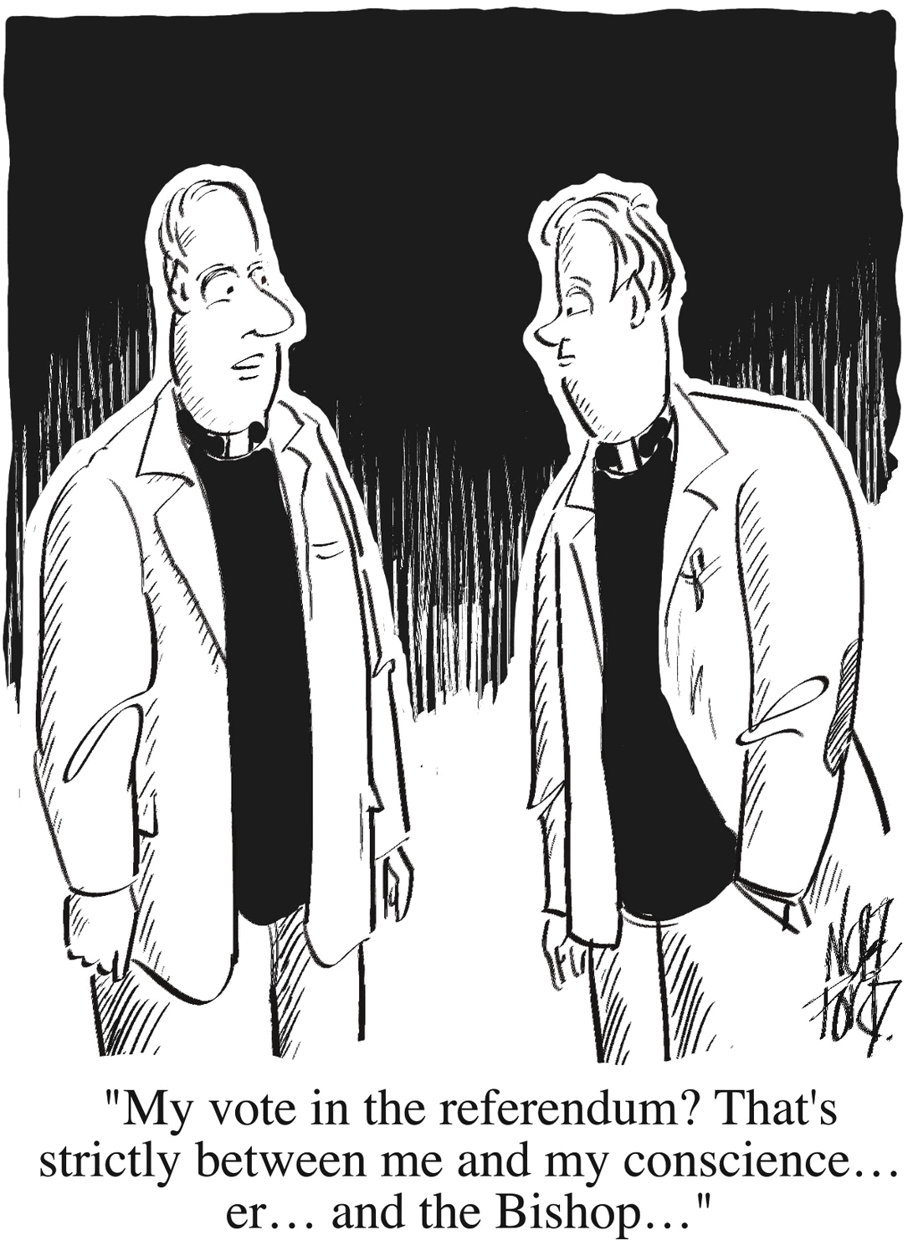

© 2016 Parish Pump Ltd, all rights reserved

