**ST EBBA’S**

SCOTTISH EPISCOPAL CHURCH

**EYEMOUTH**

 

**Times of worship**

Every Sunday: 11am Eucharist in church

OSCR number SC023275

**C:\Users\Pat\AppData\Local\Microsoft\Windows\Temporary Internet Files\Content.IE5\34GZLM5O\MC900371036[1].wmf Priest’s Letter C:\Users\Pat\AppData\Local\Microsoft\Windows\Temporary Internet Files\Content.IE5\34GZLM5O\MC900371036[1].wmf**

The story of Jacob wrestling with God (Genesis 32) is one that appeals to all those for whom faith does not come easily. On that occasion, Jacob was renamed ‘Israel’ which means ‘struggle’. Often, the struggle is not with having a belief in God, but in connecting that belief with the experiences of life and, especially, with relationships.

The conflict is in the effort to reconcile what you believe with what you do and vice versa, which invariably involves a divided loyalty to God and to some form of behaviour or human passion.

The *Catholic* novels of Graham Greene explore this theme with profound realism. His concerns are with those things that drive individual lives: fear, hate love, lust, revenge, greed, pity, faith and doubt and the blinding, uncontrollable pull that those awkward human factors exert on individual lives. His central characters – Pinkie, Scobie, Bendrix and the whisky priest – struggle with the pain and guilt of falling from grace. They live in various degrees of sin and doubt but still cling to a belief in the very God who causes them so much anguish. The moral conundrums in which they are engulfed bring them experience of both heaven and hell, pleasure and pain.

Somehow they cannot have one without the other. The awareness of human weakness attracts divine grace. Good and evil, faith and doubt, love and hate, sin and grace are simply two sides of the same coin. The angelic and the demonic seem uncomfortably close.

Many of Greene’s characters are aware of God’s unconditional love for them but that very awareness compounds their guilt when they knowingly commit a sin. The love of God also gives them pain and this sometimes turns to anger and hatred of Him. God is an intrusive and irritating Presence they can neither live with nor live without; hence the struggle. The more they turn to God, the greater the conflict with the human passions and weaknesses that drive them. They prefer to risk staying with their sinful human pleasures and being damned than gain heaven by denying them. It is almost as if they are testing the patience of God! Greene exposes the tension between the moral ideal and the reality, our human unworthiness and the grace of God. He once wrote, ‘The basic element I admire in Christianity is its

sense of moral failure. That is its very foundation.’

2

In Greene’s *The Power and the Glory,* the whisky priest speaks of God’s love as judgement:

*It might even look like hate. It would be enough to scare us – God’s love. It set fire to a bush in the desert, didn’t it, and smashed open graves and set the dead walking in the dark. Oh, a man like me would run a mile to get away if he felt that love around*.

In spite of all his unworthiness, the whisky priest shows that he is still, in some profound sense, faithful. Mercifully and miraculously, human weakness once again becomes a channel of divine power. The grace of God prevails over the frailties of our human condition and all the struggles that faith brings.

With love from

*David*

**Women Walking With God in Berwickshire Conference**

**ON THE JOURNEY**

**Speaker: Tara Devlin**

Saturday 14 March, 9.30am – 4.30pm

Paxton House, Berwickshire

A day of singing, teaching, prayer and reflection

Tickets £10 (includes coffee/tea and cakes)

Booking forms and further information available at St Ebba's.  Last year’s conference was over subscribed so early booking is advisable as numbers are limited.

3

**FEBRUARY DIARY**

**Sun 1st EPIPHANY 4**

11am Eucharist

Readings Deuteronomy 18, vs 15-20

Psalm 111

1 Corinthians 8, vs 1-13

Mark 1 vs 21–28

**Wed 4th PRESENTATION OF THE LORD**

10.00am Eucharist in the Parsonage

**Sun 8th EPIPHANY 5**

11am Eucharist

Readings Isaiah 40 vs 21-31

Psalm 147, VS 1-12

1 Corinthians 9 vs 16-23

Mark 1 vs 29-39

**Sun 15th SUNDAY BEFORE LENT**

11am Eucharist

Readings 2 Kings 2 vs 1-12

Psalm 50 vs 1-6

2 Corinthians 4 vs 3-6

Mark 9 vs 2-9

**Wed 18th ASH WEDNESDAY**

10am Eucharist

**Sun 22nd LENT 1** WITH HEALING

11am Eucharist

Genesis 9 vs 8-17

Psalm 25 vs 1-18

1 Peter 3 vs 18-22

Mark 1 vs 9-15

4

**INTERCESSORS AND READERS – DECEMBER**

|  |  |  |  |
| --- | --- | --- | --- |
|  | **Server** | **Intercessor** | **Reader** |
| Sun 1st | Debbie Higson | Sheila Cox | Brian Payne |
| Sun 8th | Joan Shelmerdine | Jennifer Edie | Frankie Taylor |
| Sun 15th | Richard Oldale | Joan Thomas | Irene Morris |
| Wed 18th | Joan Shelmerdine | Simon Furness | Richard Oldale |
| Sun 22nd | Joan Shelmerdine | Ernie Cox | Ian Taylor |

**Diary Dates**

Saturday 7th February, 9.30 - 11.30

Coffee Morning

Mason's Hall, Eyemouth

******

Sunday 22nd February, 2.30pm

**ECLECTICA**

popular & classical music supporting Berwickshire Christian Youth Trust

Coldingham Priory

Entry £5.00. (children under 16 free when accompanied by an adult)

******

2nd & 4th Mondays, 7.30pm

East Berwickshire Churches Together Bible Study Group

Eyemouth Parish Hall

******

1st Saturday of the month, 8.30am

East Berwickshire Churches Together Prayer Breakfast

Eyemouth Parish Hall

******

Eyemouth Churches Together plan to hold a Lent Study Group. The group will meet in St Ebba’s Parsonage at 11 am each Wednesday throughout Lent. Coffee available from 10 30 am followed by a time of discussion prayer and reflection . Everyone welcome to come and we hope this time together will be a useful part of our journey towards Easter. More information on content and specific dates will be available from Richard Oldale and Irene Morris by 5th February.

**LENT**



In Lent this year I am planning to follow the latest York Course called 'Praise Him'.  The following paragraph is how it is described on the York website:

*We are used to singing hymns of praise when we go to church but often we miss the hymns and poems that are there in the New Testament.  This course will explore five different Songs of Praise from the New Testament, looking at what they tell us about God and Jesus but also reflecting on what they tell us about us and our faith.*

*Participants on the course CD are Archbishop Justin Welby, Sister Wendy Beckett and actor  David Suchet.*

If you would like to know more about it, or would like to follow it with me, please do get in touch*.*

Jennifer

6



**Saluting Free Trade**

February celebrates two decades of the Fairtrade movement, founded back in 1995. Recent research showed that 78 per cent of the UK public now recognise the Fairtrade Mark, which stands for the world’s largest and most recognised fair-trade system. Its aim is to secure a better deal for farmers and workers.

Based in Bonn, Germany, it sets international standards, organises support for producers around the world and promotes trade justice internationally.

The work of building a market for fair-trade products is carried out by national Fairtrade organisations across the world. There are such organisations not only in Europe but also in India, South Korea, Hong Kong and Kenya.

An independent company runs the Fairtrade certification system, ensuring that the relevant social and environmental standards are met for new raw materials and products. Here in the UK, the Fairtrade Foundation is an independent organisation that provides independent certification that licenses use of the Fairtrade Mark on products in the UK.

The Foundation was established in 1992 by CAFOD, Christian Aid, Oxfam, Traidcraft and the National Federation of Women’s Institutes (to name just a few)

7



**Questions?**

After celebrating the Eucharist in another church, one of the congregation asked me why I held my arms out during the Eucharistic prayer. I explained that the custom of praying with outstretched, raised hands is ancient, common to both Jews and Gentiles and other faiths. That the position of upward stretched arms with the palms of the hands facing upward was commonly used by Christians is evident in its early appearance in the wall paintings in the [catacombs](http://orthodoxwiki.org/Catacombs) of Rome and it is still used in communal and private prayer.

On my way home from that service, it occurred to me, that perhaps some of you might have questions about why we do things the way we do. You can of course always ask after a service but if you would like to send questions to the Editor of this Newsletter then we can tell everyone the answers. It would be interesting to discover how important you think it is that that the priest and/or the people should make particular gestures or stand in particular places at particular times during a service. Why not write and tell us?

**Jennifer**

**Quote of the Month**

Hatred and bitterness can never cure the disease of fear; only love can do that. Hatred paralyses life; love releases it. Hatred confuses life; love harmonises it. Hatred darkens life; love illumines it.

Martin Luther King

8

**HAVE YOU VOLUNTEERED YET …**

to prepare and serve coffee in the Parsonage after Sunday morning services on a rota basis?

Please contact Sheila on 077885 57102 to add your name to the rota.



The Vestry is pleased to confirm that Brian Payne has been appointed as the Diocesan Synod Lay Representative for St Ebba’s congregation.

**Children ignorant of the Bible**

The Radio 4 presenter, Roger Bolton, has told the Radio Times that some secular teachers are ‘unsympathetic to religious education’ and even afraid of ‘offending’ different faiths.

Bolton pointed to a recent Bible Society survey that found that a quarter of children had ‘never read, seen or heard of Noah’s Ark’ and that 43 per cent had never even heard of the Crucifixion. Did that matter? “I think it does …. a lack of understanding of Christianity is also preventing youngsters from gaining a proper understanding of religious imagery in literature and drama as well as European art.”

9

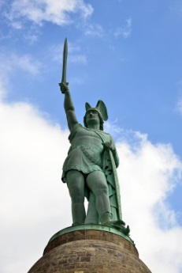 **Outside our Borders**

*In a further trip to foreign shores, Brian Payne reflects on a very recent expression of amity*

Just south of Detmold in Germany, the motorist hammering along the Autobahn towards the north east will see an enormous bronze statue of a medieval warrior, helm on his head and with his sword pointed to the sky. Standing on a great and ornate masonry plinth, the statue rises high above the trees that surround it. This monument is called Hermmansdenkmal, and represents the Germanic Chief Hermann who is said to have defeated the Romans. Seventy years’ worth of irreverent British soldiers have called him Hermann the German. Generations of military convoys have passed him on the road to the ranges, and to defend the Border when Germany was divided. And Hermann the German is what the locals call him as well…it is his proper title after all.

Hermann is big – without his plinth, he could stand in the Eyemouth Co-op carpark and look down on the roof of St Ebbas. The statue was started in 1840 – but not finished until 1871, when the disparate states of Germany finally came together under Bismark. The thinking behind the statue was that he would be an indication of national pride – for a new nation still conscious of multiple humiliations at the hands of the French and others. Hermann survived two World Wars untouched – unlike the national reputation of the State that created him. He became a joke for the Army of Occupation in 1919 and for the British Army of the Rhine in 1945.

I’ve written about Hermann because the old boy can start to hold his head up again. The appalling fundamentalist attacks in France in January produced a sight that I would never have thought probable a year ago. The President of France and the Chancellor of Germany walked with arms linked at the head of a gigantic crowd in Paris to show unity in the face of fanaticism. Last year, we saw the Centenary of the start of the Great War, and 70 years since Paris was liberated in the Second War. Old wounds were said to have been healed, but there remained an obvious tension. That a female Chancellor brought up under Communist rule could be welcomed as a sister in mourning last month is an indication that the past can be shelved, tensions eased and the common good pursued.

10

**Lend a hand**

[](http://weonlydothisonce.com/1363/resolve-to-declutter/) At a time when increasing numbers of members of a congregation find it difficult to maintain an active role in church life, perhaps it is necessary to review and simplify life. There is a need to decide what is really important and how the necessary elements can be kept in working order.

I would like to suggest that we need to declutter. It’s a fashionable word which means to to organize, prioritise and simplify.

I would therefore like to invite anyone interested in achieving this to come and help me clear the extraneous and unnecessary paper and accumulated and superfluous items in the Parsonage office. Perhaps if we can achieve this, we can move on to other areas.

Please contact me if you have any thoughts on this idea.

**Jennifer**

tel: 01890750169 e: rev.jennifer@gmail.com

**A Prayer for February ……**

Dear Lord, February can seem such a bleak, mid-winter month, often flavoured with ‘flu and bad weather. But the days are lengthening. There are snowdrops and other signs of new life, if we look expectantly. Spring is beckoning. Open our eyes, Lord, to see the wonders of your creation. May we appreciate the rhythms of the seasons you designed for us, and rejoice in the hope you have given us in Jesus, who came to wonderfully re-create, to make all things new, by his death and resurrection. Amen.

By Daphne Kitching

11

**Satire or Sacrilege?**

***Satire****: the use of humour, irony, exaggeration, or ridicule to expose and criticise people's stupidity or vices, particularly in the context of contemporary politics and other topical issues.*

***Sacrileg****e: (an* [*act*](http://dictionary.cambridge.org/dictionary/british/act) *of)* [*treating*](http://dictionary.cambridge.org/dictionary/british/treat) *something* [*holy*](http://dictionary.cambridge.org/dictionary/british/holy) *or* [*important*](http://dictionary.cambridge.org/dictionary/british/important) *without* [*respect*](http://dictionary.cambridge.org/dictionary/british/respect)*; the violation or profanation of anything sacred or held sacred.*

While no one could conceivably condone the savage murder in Paris on 8 January of Charlie Hebdo magazine cartoonists, it must raise the contentious question of respect for others’ beliefs.

According to a report in the Guardian, Charlie Hebdo editor Stéphane Charbonnier ‘was undeterred by death threats for depicting his visual image in a manner certain to offend many Muslims. Devout Muslims regard any depictions of Muhammad, or other prophets including Moses or Abraham, as heresy.’

Yet, one week after five of its staff were killed, the magazine carried a front cover cartoon of the prophet Muhammad displaying a placard ‘Je suis Charlie’ and declaiming ‘All is forgiven’.

Rhazoui, a surviving columnist at the magazine, claimed this new cover was ‘a call to forgive the terrorists’ and urged Muslims to ‘accept humour’. But Omer el-Hamdoon, president of the Muslim Association of Britain, said ‘My reaction to the cartoon is disgust … what [is] caused is … offence.’ He challenged the notion that what is at stake was freedom of speech.

So where do we stand as Christians?

Is the satirical Charlie Hebdo magazine a champion of free speech or does it tip the balance into sacrilege? Does the end – a unifying display of outrage against extremism – justify the means? Should we turn the other cheek or should we stand firm against perceived offensiveness, sacrilege and profanity?

Pat Elliott

*The views expressed here are those of the writer and not necessarily of St Ebba’s or the Episcopal Church in general.*

12

**Food Glorious Food**

** Good fruit**

When you finish reading this, you will want to eat some fruit. It seems that eating just one or two pieces of fruit a day can cut the risk of a heart attack or stroke by up to 40 per cent.

 A recent study by Oxford University has found that people who eat fruit daily have a far lower rate of heart disease, and a lower rate of the two main types of stroke. And the more often people ate fruit, the more the risk fell. Another recent study, at Washington State University, has found that an apple a day can also help keep obesity away, as it makes people feel fuller for longer.

**Food intolerance**

Do you believe that you are intolerant to certain foods? It seems that more than one in five of us could be avoiding certain foods because we have become convinced that we are allergic or intolerant towards them. A survey for the Food and Drink Innovation Network found that dairy and gluten are the most common types of food which we give up.

This has enormous implications: up to a third of all households could by now have had to adapt to having a member of their family either unable or unwilling to eat certain food. This in turn has spawned a phenomenal growth in the industry which supplies us with foods free from gluten, lactose, nuts, or other ingredients.

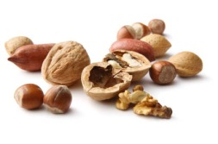

13

**LAUGHTER LINES FOR FEBRUARY**

**With Valentine’s Day and romance in mind…**

Marriage is….

* not always just a word; sometimes it is a sentence.
* the only permanent cure for love.

While a marriage license is ….

* the only permit taken out after the hunt is over

**But children often have an original take on love …**

*A group of 4 to 8 year-olds was once asked: 'What does love mean?' Some of the answers they gave were surprising for their depth of insight….*

* “When someone loves you, the way they say your name is different. You just know that your name is safe in their mouth.” Billy - age 4
* “Love is when a girl puts on perfume and a boy puts on shaving cologne and they go out and smell each other.” Karl - age 5
* “Love is when you go out to eat and give somebody most of your chips, without making them give you any of theirs.” Chrissy - age 6
* “Love is when mum makes coffee for my dad and she takes a sip before giving it to him, to make sure the taste is OK.” Danny - age 7
* “Love is when you kiss all the time. Then when you get tired of kissing, you still want to be together and you talk more. My Mum and Dad are like that. They look gross when they kiss.” Emily - age 8
* “If you want to learn to love better, you should start with a friend who you hate.” Nikka - age 6

(*We need a few million more Nikka's on this planet*)

14

**CHURCH CONTACTS**

Priests the Revd Sheila Cox 01890 771764

the Revd Jennifer Edie 01890 750169

the Revd David Smout 01890 771220

the Revd Tim Morris 01289 386615

Lay Rep Brian Payne 018907 81825

Alt Lay Rep David Garside 01890 751159

People’s Warden Richard Oldale 01890 750939

Administrator Jennifer Edie 01890 750169

Treasurer David Garside 01890 751159

St Ebba’s Church, Fort View, Paxton Terrace, Eyemouth, TD14 5EL

St Ebba’s Parsonage, Beach Avenue, Eyemouth, TD14 5EL

[www.stebbas.org.uk](http://www.stebbas.org.uk)

***If you are in hospital and would like us to know and/or to visit, under the current regulations you have to specifically ask the hospital to inform us.***

If you want to keep up with what’s happening here and across the Borders, you will find the minutes of our own Vestry meetings and the Borders Area Council meeting in the files at the back of the church.

***EDITOR’S NOTE:***

*Our thanks, as always, to the Parish Pump website for providing material for our newsletters throughout the year and thanks too to this month’s contributors.*

*Copy for your March newsletter is 15 February. Do drop me a line to the email address below or to Birchfield House, Auchencrow, TD14 5LS to share your stories, thoughts, news and views.*

*Yours,*

Pat

E: [info@thebordersdesignhouse.co.uk](mailto:info@thebordersdesignhouse.co.uk) T: 01890 761271

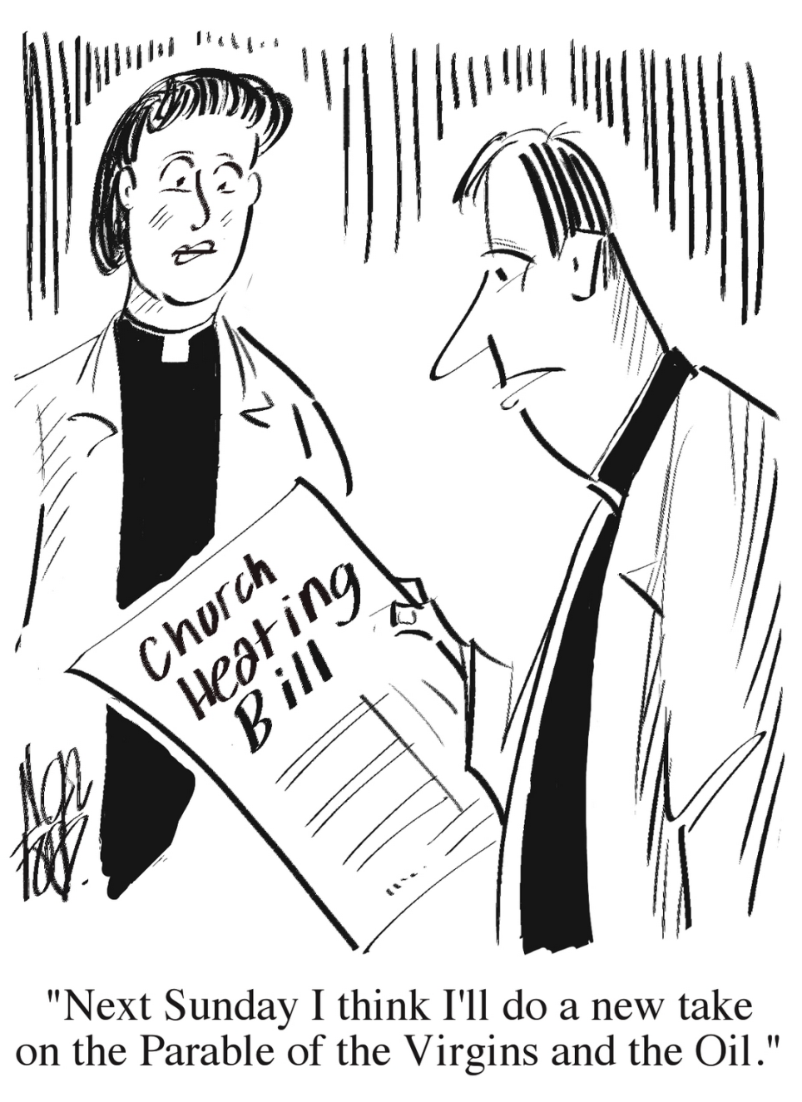

© 2015 Parish Pump Ltd, all rights reserved