**ST EBBA’S**

SCOTTISH EPISCOPAL CHURCH

**EYEMOUTH**

**April 2015**

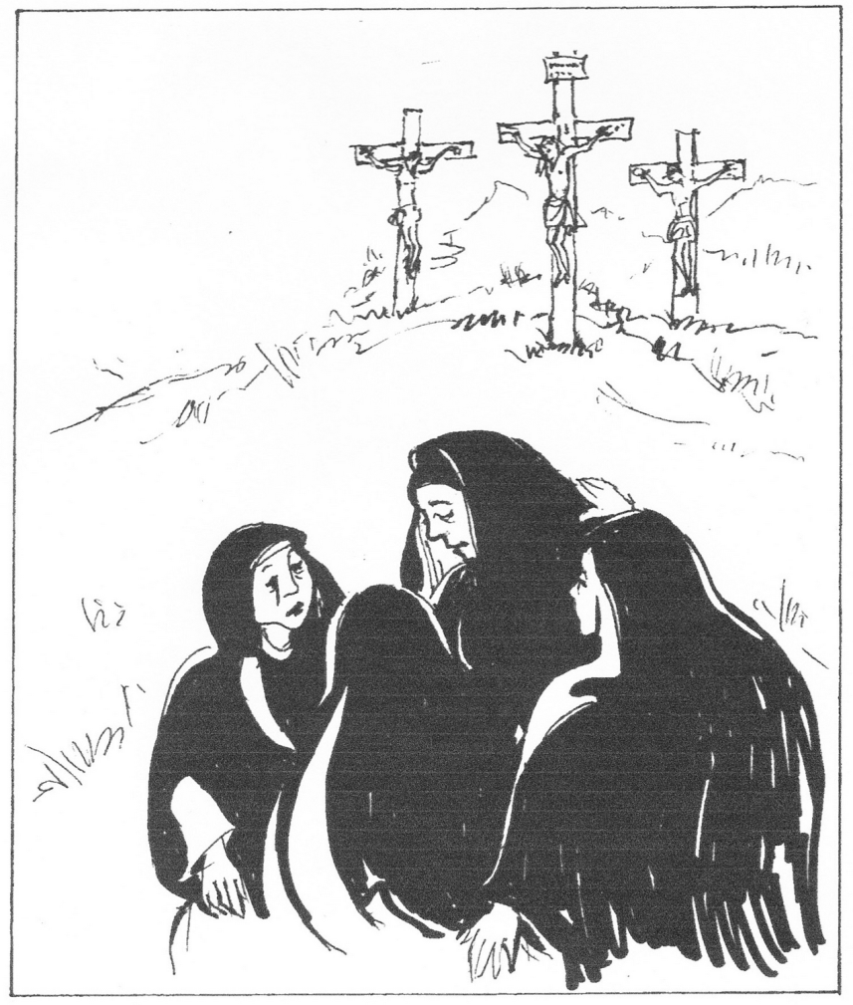

**Times of worship**

Every Sunday: 11am Eucharist in church

OSCR number SC023275

**C:\Users\Pat\AppData\Local\Microsoft\Windows\Temporary Internet Files\Content.IE5\34GZLM5O\MC900371036[1].wmf Priest’s Letter C:\Users\Pat\AppData\Local\Microsoft\Windows\Temporary Internet Files\Content.IE5\34GZLM5O\MC900371036[1].wmf**

I wish you all a joyous Easter.

In our ecumenical Lent study group, we have been looking at some of the hymns of praise in the New Testament and I have found it inspiring to be reminded of the glorious hope that God offers us through the life and death of his Son, confirmed in the letters of his early followers to the young churches. We have learned that theology is not abstract and irrelevant in our lives but a preparation for living, for action. In daily life today for so many people, hope has become a vague idea – wished for but not certain. For us as Christians, it is a living reality. In Hebrews, we are told “We have this hope, a sure and steadfast anchor of the soul”. In the first letter of Peter, we read that it is a “living hope”. When the world seems dark and threatening, full of strife, war and persecution, we can hold on to the long view because we know that this is not all there is. Christian hope does not deny present fear and suffering but fixes our eyes on a different horizon, offering a vision of the God of life in whom we can have absolute confidence because of the resurrection of Jesus Christ.

I am aware of concern about the future of our church, St Ebba’s. One thing I am painfully aware of is how rarely we have time to talk to each other, to give each other support in difficulties, share our joys and sorrows. We gather for worship on Sunday mornings but that is hardly the time for chat or more serous conversation. Not many people stay for coffee after the service. I would love to know how you feel about our future and have been wondering whether you would welcome some sort of social gathering to have a chance to get to know each other a little better. It might also be an opportunity for the Vestry to share their plans and hopes for the future with you. Please do let me know what you think about this idea and when would be a suitable time and day to organise it. Perhaps a “bring and share” lunch or early supper as the daylight lasts longer?

I hope that you will be able to share our Holy Week and Easter services at St Ebba’s. On Maundy Thursday evening, we watch with Christ as he prays in Gethsemane. On Good Friday we contemplate the crucifixion, amazed at Christ’s suffering for humanity. At 6.30 on Easter morning, we gather with ecumenical friends outside our church to greet the Easter dawn with songs of praise as the sun rises above the sea – and then it’s off to the Parsonage for bacon butties before gathering again in church for the Eucharist to give thanks and praise for all that Jesus did and is doing for us and for the world.

Please do let us know what you think about the future and whether you would welcome a time to come together in friendship and hope.

My love and prayers

Jennifer

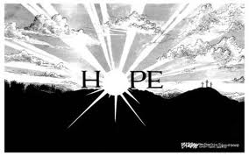

*Contributions from readers are always welcome. If you would like to write an introductory letter for our monthly newsletter, please let the editor or one of the Vestry or Ministry Team know.*

A SPACE TOURIST’S VIEW OF EARTH



‘The sheer beauty of it (the earth) brought tears to my eyes. If people from up here see it without those borders, see it without any differences in race or religion, there would be be a completely different perspective. Because when you see it from that angle, you cannot think of your home or your country, all you can see is one earth……..’

Anousheh Ansari, Iranian-American space tourist

**APRIL DIARY**

**Thur 2nd Maundy Thursday**

7.30pm Service

Readings Exodus 12 vs 1-4, 11-14

1 Corinthians 11 vs 23-26

John 13 vs 1-17, 31b-35

Exodus 12 vs 1-4, 11-14

**Fri 3rd Good Friday**

2pm Service

**Sun 5th EASTER**

6.30am Worship

11am Eucharist

Readings Isaiah 25 vs 6-9

Psalm 118 vs 1-2, 14-24

Acts 10 vs 34-43

Mark 16 vs 1-8

**Sun 12th Easter 2**

11am Eucharist

Readings Acts 4 vs 32-35

Psalm 133

I John 1 vs 1 – 2 vs 2

John 20 vs 19-31

**Sun 19th Easter 3**

11am Eucharist

Readings Acts 3 vs 12-19

Psalm 4

I John 3 vs 1-7

Luke 24 vs 36b-48

**Sun 26th Easter 4**

11am Eucharist

Readings Acts 4 vs 5-12

Psalm 23

I John 3 vs 16-24

John 10 vs 11-18

**INTERCESSORS AND READERS – APRIL**

|  |  |  |  |
| --- | --- | --- | --- |
|  | **Server** | **Intercessor** | **Reader** |
| Sun 5th | Joan Shelmerdine | Sheila Cox | Brian Payne |
| Sun 12th | Richard Oldale | Ernie Cox | Pat Elliott |
| Sun 19th | Joan Shelmerdine | Simon Furness | Susan Struthers |
| Sun 26th | Richard Oldale | Jan Simpson | Ernie Cox |

**VOTING DUTY**

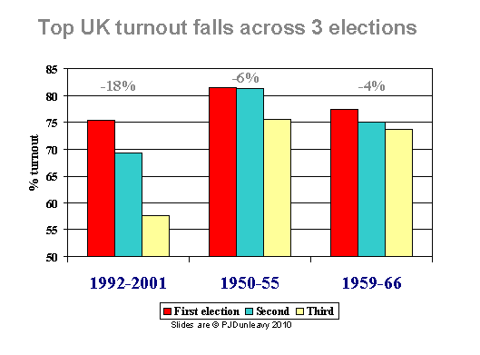

We are a nation of disaffected voters. The last three elections have seen the lowest turnout in living memory and, despite the long run-up, we've enjoyed courtesy of the Fixed-Term Parliament Act, there's no indication that 2015 will be any different. Indeed, if there was a box on the ballot for the Apathy Party, voters would flock to their sofas to avoid ticking it.

With the threat of a hung parliament, a drastic shake-up of the Union, and the verbose but dulcet tones of Russell "don't vote" Brand still ringing in many people's ears, it seems a hopeless time for politics.

Yet as Christians, hopelessness is not something we can afford, much less subscribe to. When we understand more about God's vision for how our society and communities should look, we can respond meaningfully to the challenges we face - as well as voting in a way that honours our faith.

Do you agree?

**An Alzheimer Poem**

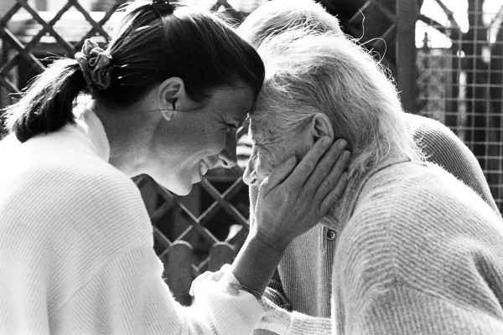

Do not ask me to remember

Don't try to make me understand

Let me rest and know you're with me

Kiss my cheek and hold my hand.

I'm confused beyond your concept

I am sad and sick and lost

All I know is that I need you

to be with me at all cost.

Do not lose your patience with me

Do not scold or curse or cry

I can't help the way I'm acting,

can't be different though I try.

Just remember that I need you

That the best of me is gone

Please don't fail to stand beside me

Love me till my life is done.

*Alzheimer Society of Saskatchewan*

*This appeared on Facebook as one piece with no breaks or punctuation. Frankie Taylor put it into four verses, added full-stops and changed some capital letters. One person who read this whose father had Alzheimers, commented “that's very nice, but it's very hard”*

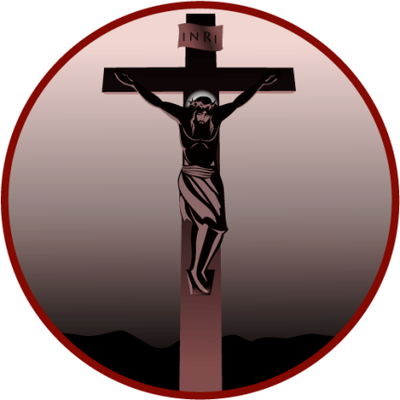

**Good Friday – the day the Son of God died for you**

Good Friday is the day on which Jesus died on the cross. He was crucified at nine am in the morning, and died six hours later, at three pm.

It is the most solemn day in the Christian year, and is widely marked by the removal of all decorations from churches. In Lutheran churches, the day was marked by the reading of the passion narrative in a gospel, a practice which lies behind the ‘passions’ composed by Johann Sebastian Bach (1685 – 1750). Both the St Matthew Passion and the St John Passion have their origins in this observance of Good Friday.

The custom of observing a period of three hours’ devotion from twelve noon to three pm on Good Friday goes back to the eighteenth century.

The ‘Three Hours of the Cross’ often take the form of an extended meditation on the ‘Seven Last Words from the Cross’*, with periods of silence, prayer, or hymn-singing.

*\*The seven last words from the Cross traditionally are said to be:*

*Luke 23:34: Father, forgive them, for they do not know what they do. Luke 23:43: Truly, I say to you, today you will be with me in paradise. John 19:26–27: Woman, behold your son. Son Behold your mother. Matthew 27:46 & Mark 15:34 My God, My God, have you forsaken me? John 19:28: I thirst. John 19:29-30: It is finished. Luke 23:46: Father, into your hands I commit my spirit.*

**FAITH in ACTION**

**APRIL**



**Prisons**

Many prisoners serve long sentences and do not receive visits from family or friends. Often, families have deliberately cut themselves off from the offender. It is hard for prisoners who do not receive visits to see others going off to the Visits Hall.

*Pray for prisoners and their families*

Lord, you know that prison life is hard, and

that many find it difficult to cope.

We pray for vulnerable prisoners.

For those beginning long sentences.

For those preparing for release.

For those seeking to change their lives.

We pray for the families of prisoners who

often suffer discrimination and hardship.

Strengthen them and help them with your

love;

Through Jesus Christ our Lord.

AMEN

*Faith in Action: The Church in Society Committee of the Scottish Episcopal Church, the Methodist Church in Scotland and the Church & Society Committee of the United Reformed Church Synod of Scotland*

**Bishop’s Address to Edinburgh Diocesan Synod**

**7th March 2015**

In the letter to the Philippians, St Paul advises us: *‘Whatever is true, whatever is honourable, whatever is just, whatever is pure, whatever is pleasing, whatever is commendable, if there is any excellence and if there is anything worthy of praise, think about these things.’ (Phil 4.8)*

St Paul isn’t in denial here. He’s well aware from his own personal experience that the world is often a dark and grotesque place. Recent stories from Bristol and Oxford and Rochdale, documentaries from India, online videos from Syria make this all too plain. These stories crowd our living rooms and invade our social media. Paul isn’t telling us to avoid reality – but he is telling us something important about how we’re formed as human beings. Fill our minds with the things of God and there’s a chance we’ll grow to be more like God. Conversely, concentrate only on what is dishonourable and impure and we’re likely to become infected by it.

Today’s synod won’t be in denial either. We can’t receive a report on safeguarding the vulnerable, or reflect on what makes a good society without being well aware of the many threats to human well-being. One of the causes I’m asking you to support in my Lent Appeal only exists because of injustice. On the other hand, I hope the emphasis in our agenda, as in our support for IJM is about making right not bemoaning wrong.

After all, the second cause I’m asking you to support this Lent is quite clearly about offering a positive and thankful response to those increasing numbers of women and men offering themselves for authorised ministry in God’s service and in service of God’s church. 20 years on from the ordination of the first women priests in this diocese we have much to celebrate about the wholeness of our ministry in Christ – something which for me, and I’m sure for most of you too, is pleasing, commendable and excellent – to put it mildly.

We might add to this the reports from our committees telling of a year in which many people have worked on our behalf to manage things well financially and to develop and support God’s mission in the diocese and beyond. Indeed, there is very little on our agenda today that doesn’t reveal or provide opportunities to reflect on the good, the pure and the honourable. Watch out for them!

Not that we shall all agree about everything. Why should we? But the key is in how we disagree. You may remember me mentioning before Martin Luther’s interpretation of the commandment not to bear false witness. He doesn’t confine it to telling the truth in a law court, or to guarding our tongues from false rumours and malicious gossip, it also has to do, he says, with how we think of people inwardly. Do we assume the best of people, do we give their actions the best possible interpretations? Or do we, perhaps because we’re anxious or envious or because we’re stuck in a rut of cynicism assume the worst – creating in our minds a web of intrigue and conspiracy? Do we make allowances for others’ very human fallibility; do we give them as much leeway as we would want to claim for ourselves? I hope this will guide our synod today.

But not just our synod. You may have noticed that a General Election is on the way. Plenty of opportunity therefore to bear false witness. You may have picked up too that the Church of England bishops have sent a letter to their parishes offering thoughts about some of the vital issues that could be addressed in the election. Interestingly, their letter begins with exactly the same quotation from St Paul I began with, for they’re calling for a vision for the future based on a shared sense of what we consider to be good, excellent, honourable and true. They criticise party politics for being too often ‘consumerist’ – shaping policies around sectional interests rather than focusing on a commitment to the common good. For Christians, they say, *‘every human being is created in the image of God. But we are not made in isolation. We belong together in a creation which should be cherished and not simply used and consumed.’*

In Scotland we have already done a lot of work on this in our preparation for the referendum – what kind of nation do we want to live in? What are its foundational values? But I would commend the bishops’ letter to you (it’s online) as a further contribution to this debate. It’s quite long and you probably won’t agree with all of it. Some parts you may find too simplistic or too brief, but it is a helpful contribution to a debate that Westminster politicians tend to shy away from. Indeed, it was very interesting to watch the reaction of some politicians when the letter was published. Rather than taking the opportunity to explain why their policies do spring from a strong commitment to the common good, from a concern to support the weakest, from a desire to nurture a community of communities rather than a ‘society of strangers’, there was an immediate reaction from some to ridicule the church or to claim that it is left-wing or that it should not be ‘meddling’ with politics. I must say, that ever since the 1980s, whenever a national politician tells the church to keep out of politics I assume that the church is getting something right not wrong.

Besides, this kind of kneejerk reaction from some politicians (and only some it has to be emphasized) indicates the very malaise that the Bishops highlighted, that whenever you are criticized your critic must by definition always be in the wrong. A kind of institutionalized ‘false witness’. There’s plenty of recent evidence to remind us that politicians too have feet of clay, but that should not stop us from expecting more, demanding more from them.

However, as William Temple once said, it’s not what bishops say but what the people do that matters. And this synod focuses our attention on some of the things people are doing, in churches large and small, in city and in country. We’ll see this under the Mission and Ministry Committee report, whether through St Hilda’s funding or in other examples of social engagement. I hope this will help you to recognize, perhaps for the first time, the many things you do in your community, either individually or through your church, which you do because you are seeking to be faithful to Christ and to build a good society.

We need to be vocal about this, not because we alone have sorted what this good society is supposed to look like, nor because we always get it right. The CofE bishops were caught out on the issue of the Living Wage. I suspect we may be caught out on this too. I recently asked all our charges to tell me whether they were paying the living wage. I got 6 responses!

The reality is that poverty is a huge problem in our society. There is a huge gap between rich and poor. And the awful truth is that it costs more to live if you are poor – it’s called the poverty premium. Even gas to heat your home can be twice as expensive if you rely on a pay as you go meter. And as things stand, as more and more measures are introduced to counteract global warming and deal with the consequences of climate change it will be the poor, in this country and beyond, who will have most to lose.

These things trouble us, or they ought to trouble us. This is why Paul tells us to set our minds on all that is praiseworthy, excellent, commendable, pure and just. For it is in thinking about these things that we begin to understand how far we and the world we share falls short of these qualities, falls short of the Kingdom as Jesus taught it. And in understanding this we are enabled to respond to God’s call to show what love for neighbour really means.

**EASTER DAY 2014**

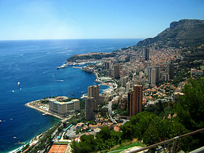

Easter Day 2014 was a red-letter day for me beginning at 6.30am with a ‘Son Arise Service’ on the Sports Deck of the Saga Perl II.

The ship’s Chaplain on Captain Dunlop’s Mystery Voyage turned out to be from the next door parish to Old Cleeve in Somerset where I lived for 33 years. This coincidence meant I not only attended all the services proper to Holy Week but said Compline every evening at 9pm in the ship’s cinema.

As fifty or so pious souls announced ‘Jesus Christ is risen today’, our ship slid gently into the harbour of Monte Carlo. At his breakfast briefing our Captain announced we *were* the largest yacht in the harbour.

What the nearest floating luxury apartment made of a good length of white paint inching past the cabin windows accompanied by reedy warblings of ‘Hallelujah’ will never be known.

Monte Carlo was built on a head land heavily fortified against Barbary pirates, a castle, now the Royal Palace, guarding the landward side. At the foot of the cliff a cove was lined with fisherman’s houses, warehouses and boatyards, the church of San Devote presiding over all. In modern times the creek became a marina and the town so familiar to watchers of the Monte Carlo Grand Prix erupted from made-up land stretching east round the bay.

Hoping to see the Cathedral in full Easter glory, I climbed the headland via long stretches of ladder-steep steps as I stormed the defences of Fort St Antoine. Halfway up a bastion was now a delightful open air theatre. Since piled cannon balls abounded, the authorities used them as supports for seats and park benches.

At the top I discovered the ramparts had been planted as something between a botanical garden and a public park, very green and shady, views over the sunlit sea at every turn. Like many public spaces round the Mediterranean, a selection of sculpture ranging from Walt Disney, a life size pair of painted macaws, to the modern, possibly called Scrap Heap Two, and the classical, the usual nubile female doing a striptease in the best possible taste, appeared at suitable intervals.

The Cathedral, cleaner and better kept than many, was a floral disappointment. Two very large cornucopia-shaped vases had been hitched onto the sides of the great candelabra flanking the high altar. A sheaf of white gladioli had been stuffed into the vases in a formal fan. That was it. No trailing greenery, nothing.

I lit a candle to St Romanus presiding over a side chapel. Dressed

in full Roman military gear. I wondered if he was the centurion on crucifix duty and said a prayer for all military faced with difficult and unpleasant tasks.

The Grimaldi Royal Family vault was under the high altar, stones in a fan round the apse. That of Principessa Gratzia Patricia, Grace Kelly to film buffs of long memory, was decorated with little tributes from fans. Mostly bunches of faded plastic flowers, that rather says it all.

Later I joined a guided tour of the lower town. The Casino, a Belle Epoch building of superb craftsmanship and staggering bad taste has a garden worth seeing. A flame of the forest tree was in flower. I suspect this was a rare sight.

Indeed, the best thing that can be said of this vanity fair of a Principality is the devotion to growing things. Apart from the usual window boxes and planters of urban life, every balcony drips bougainvillea and looking up to the tops of apartment blocks, green creepers and waving branches suggest roof gardens. Indeed, close to the car museum, a cross between the Royal Mews and a Transport-through-the-Ages exhibition, turn to the left, look up and there is a grove of pine trees, dark against the blue sky and many feet above street level.

Patricia F Payne

 A plea from the Diocesan office: 

Here in the Diocesan Office we are updating our photo displays which are often a good talking point when folk visit us. We would like to gather a range of new photos - of stained glass windows from around the Diocesan churches - to display in our meeting room. We invite you to send in your photos and we will let you know which ones we enlarge and use in our new displays. We look forward to your email submissions: [office@edinburgh.anglican.org](mailto:office@edinburgh.anglican.org)

**HEAVENLY HUMOUR**

**For MPs only** …………..

At the pearly gates, St. Peter greeted a minister and a member of parliament and gave them their room keys. "Vicar, here are the keys to one of our nicest single rooms. And for you, Mr MP, the keys to our finest penthouse suite." The vicar began to protest that this was unfair. "Listen," St. Peter said, "ministers are a ten a penny up here, but this is the first MP we've ever seen."

**Shut that door** …………

An exasperated mother, whose son was always getting into mischief, finally asked him, "How do you expect to get into Heaven?"

The boy thought it over and said, ‘Well, I'll just run in and out and in and out and keep slamming the door until St. Peter says 'For Heaven's sake, Dylan, come in or stay out!’’

**Sabbath perfection …………**

A certain priest awoke to perfect golfing weather one Sunday morning. It had been either cold, raining or too windy for a couple of months and, as he thought it over, the temptation was just too great. He called up one of his deacons and told him ‘You’re going to have to cover for me today. I have to go out of town on urgent business.’

He felt a bit guilty as he drove to another town but the birds were singing, the sun was shining, the sky was blue and there was no wind at all so he found ways to justify his absence ‘just this once’.

As he stepped up to the first tee, St Peter said to the Lord, ‘Look, isn’t that one of your men on the golf course? And on a Sunday?’

The Lord said, ‘Don’t worry. I’ll take care of him.’

The priest hit a perfect drive – the best he’d ever hit in his life. It soared about 250 yards, bounced twice, hit the green and rolled right into the hole. St Peter looked at the Lord but didn’t say anything.

The priest was ecstatic as he teed up for the second hole where his shot was just as good. He’d made another hole in one! The second one in his life!

At that St Peter turned to the Lord. ‘I thought you said you’d take care of him,’ he demanded.

‘I did,’ answered the Lord. ‘Who’s he going to tell?’

**CHURCH CONTACTS**

Priests the Revd Sheila Cox 01890 771764

the Revd Jennifer Edie 01890 750169

the Revd David Smout 01890 771220

the Revd Tim Morris 01289 386615

Lay Rep Brian Payne 018907 81825

Alt Lay Rep David Garside 01890 751159

People’s Warden Richard Oldale 01890 750939

Administrator Jennifer Edie 01890 750169

Treasurer David Garside 01890 751159

St Ebba’s Church, Fort View, Paxton Terrace, Eyemouth, TD14 5EL

St Ebba’s Parsonage, Beach Avenue, Eyemouth, TD14 5EL

[www.stebbas.org.uk](http://www.stebbas.org.uk)

***If you are in hospital and would like us to know and/or to visit, under the current regulations you have to specifically ask the hospital to inform us.***

If you want to keep up with what’s happening here and across the Borders, you will find the minutes of our own Vestry meetings and the Borders Area Council meeting in the files at the back of the church.

***EDITOR’S NOTE:***

*Our thanks, as always, to the Parish Pump website for providing material for our newsletters throughout the year and thanks too to each of this month’s contributors.*

*Copy for your May newsletter is 13 April. Do drop me a line to the email address below or to Birchfield House, Auchencrow, TD14 5LS to share your stories, thoughts, news and views.*

*Yours,*

Pat

E: [info@thebordersdesignhouse.co.uk](mailto:info@thebordersdesignhouse.co.uk) T: 01890 761271

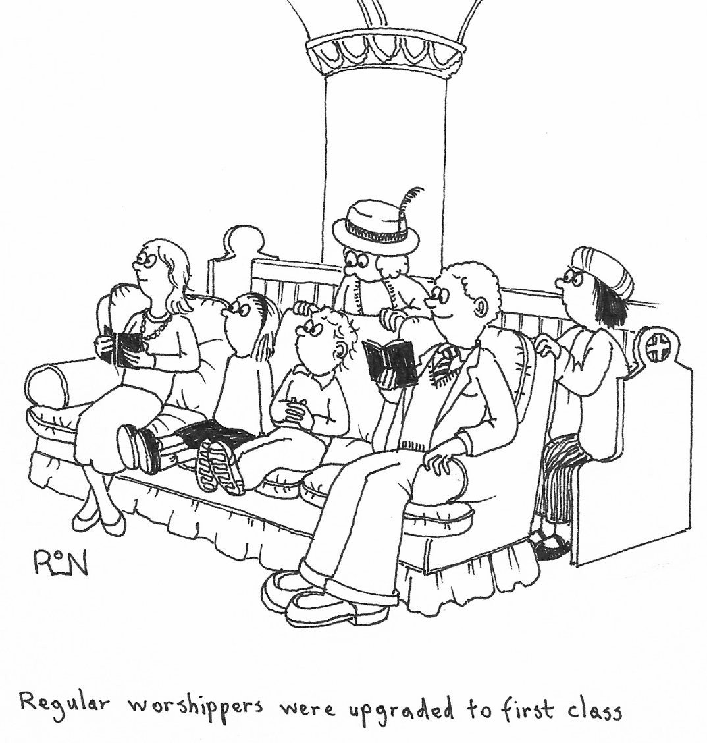

© 2015 Parish Pump Ltd, all rights reserved