**ST EBBA’S**

SCOTTISH EPISCOPAL CHURCH

**EYEMOUTH**

**May 2015**

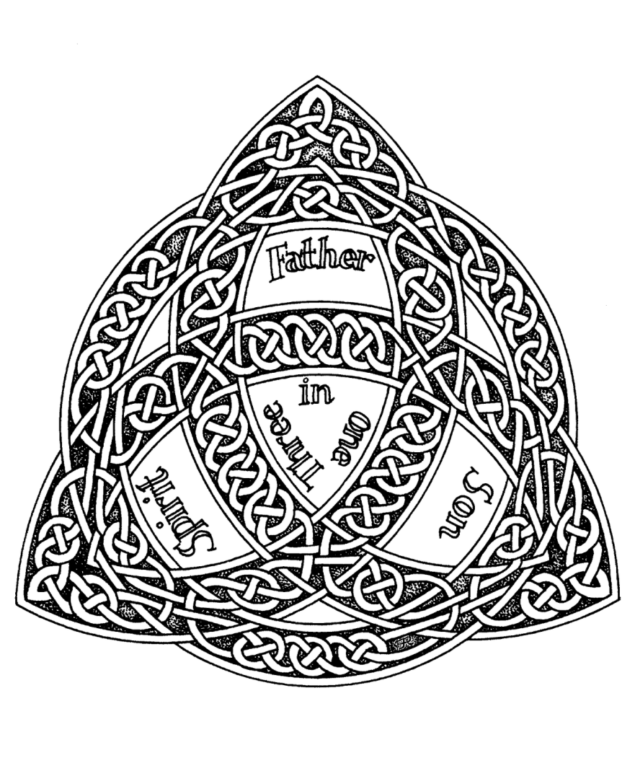

**Times of worship**

Every Sunday: 11am Eucharist in church

OSCR number SC023275

**C:\Users\Pat\AppData\Local\Microsoft\Windows\Temporary Internet Files\Content.IE5\34GZLM5O\MC900371036[1].wmf Lay Letter C:\Users\Pat\AppData\Local\Microsoft\Windows\Temporary Internet Files\Content.IE5\34GZLM5O\MC900371036[1].wmf**

In January, I was asked if I would take on the vacant role of Lay Representative for St Ebba’s. I asked what it might entail, and was told that I would be the only person entitled to vote on Diocesan affairs on behalf of St Ebba’s, as our clergy operate not as incumbents but as individuals authorised for certain roles by the Bishop. Under the rules, they had no vote, and so unless we had a Lay Rep, St Ebba’s as a congregation would have no say in church business. I was told that the time commitment would be pretty minimal with the odd Synod to attend and perhaps a Borders Area Council meeting from time to time. I volunteered on a ‘let’s see’ basis. I have seen how a Synod is conducted, I have attended meetings and I have gone in to bat with the Diocese over what I see as the disenfranchisement of small congregations where through cost and circumstance, there is no incumbent. I have now had a flavour of Church politics, and developed a further respect for the books of Anthony Trollope as a result. I have, more to the point, now got some idea of how and who keeps the St Ebba’s show on the road.

For myself, St Ebba’s represents a strand of continuity in my life. My grandparents worshipped there, my parents married there and in the five decades before we moved to Redhall, I went to services on an ad hoc basis when I was staying at Netherbyres. It remained a constant in the background. I am not an especially religious individual. Having seen what a conflict between two arms of Christianity could result in when I served in Northern Ireland, I came to a private arrangement with God, and while never abandoning the church, I was not a frequent attender. I did the big days [because at the back of my mind were the strictures of confirmation] and the odd Sunday. On moving to Berwickshire, I started coming to St Ebba’s once a fortnight for no particular reason other than keeping my uncle company and doing my bit.

In the last few months, however, it has become clear that the strand of continuity that St Ebba’s represents is more at risk than I had appreciated. In some ways, it can be summarised as ‘If you don’t use it, you’ll lose it’. The Vestry and other volunteers work far harder than the congregation in general might realise to keep the place running. There is always work to be done, and plans to be laid. My request, therefore, is to those who are not especially

driven by faith, or a theological argument. If, like me, you get something out of St Ebba’s, be it only a quiet moment or two in the services you occasionally attend, could you give something back. A bit of time supporting a coffee morning, some light gardening ….detailed architects drawings of a possible new Church Hall…whatever you can give. Oh, and we need an Alternative Lay Rep in case I get run over by a bus…..

**Brian W Payne**

*Contributions from readers are always welcome. If you would like to write an introductory letter for our monthly newsletter, please let the editor or one of the Vestry or Ministry Team know.*

**COFFEE GOES SELF SERVICE**



Since there were so few volunteers to join a Sunday coffee rota, the Vestry has agreed coffee and tea after the Sunday service will now be on a self-service basis.

The Parsonage will be open as usual following the service and all are warmly encouraged to pop in as usual and help themselves to coffee or tea (leaving a donation towards the cost, of course!).

**MAY DIARY**

**Sun 3rd Easter 5**

11am Eucharist

Readings Acts 8 vs 26-40

Psalm 22 vs 24-30

1 John 4 vs 7-21

John 15 vs 1-8

**Wed 6th** 10.00am Eucharist in the Parsonage

**Sun 10th EASTER 6**

11am Eucharist

Readings Acts 10 vs 44-48

Psalm 98

1 John 5 vs 1-6

John 15 vs 9-17

**Thurs 14TH ASCENSION**

10.00am Eucharist

ReadingsActs 1 vs 1-11

Psalm 93

Ephesians 1 vs 15-23

Luke 24 vs 44-53

**Sun 17th Sunday after Ascension**

**Easter 7**

11am Eucharist

Readings Acts 1 vs 15-17, 21-26

Psalm 1

1 John 5 vs 9-13

John 17 vs 6-19

**Sun 24th PENTECOST**

11am Eucharist

Readings Acts 2 vs 1-21

Psalm 104 vs 25-35

Romans 8 vs 22-27

John 15 vs 26-27 & 16 vs 4b-15

**MAY DIARY (cont)**

**Sun 31st TRINITY**

11am Eucharist

Readings Isaiah 6 vs 1-8

Psalm 29

Romans 8 vs 12-17

John 3 vs 1-17

**INTERCESSORS AND READERS – MAY**

|  |  |  |  |
| --- | --- | --- | --- |
|  | **Server** | **Intercessor** | **Reader** |
| Sun 3rd | Richard Oldale | Sheila Cox | Brian Payne |
| Sun 10th | Joan Shelmerdine | Joan Thomas | Ian Taylor |
| Thur14th | Richard Oldale | Joan Shelmerdine | Ernie Cox |
| Sun 17th | Joan Shelmerdine | Jan Simpson | Frankie Taylor |
| Sun 24th | Joan Shelmerdine | Simon Furness | Richard Oldale |
| Sun 31st | Richard Oldale | Ernie Cox | Susan Struthers |

** GET TOGETHER **

The Vestry would like to arrange a social gathering where we can all get to know each other a little better and the Building Committee can explain what is happening to future plans. If you would like to take part, please add your name to the list at the back of the Church and indicate which days and times would best suit you.

  **CHRISTIAN AID WEEK 9th - 16th May**   
 

**Friday 8th May, 7.30 p.m. - FILM NIGHT**, 'Sunshine on Leith' homegrown film with music by the Proclaimers set in Edinburgh, non-violent and happy, well mostly. Parish Church Hall.  
**Saturday 9th May - SPONSORED WALK** from Berwick Holiday Park to St Abbs but there are 5 sections so you can do as many as you are able.  Marshall Meadows;  Burnmouth;  Eyemouth;  Coldingham Sands;  St Abbs.  Ian and I will hopefully be taking part but just back from Australia the day before so if anyone else would like to join in please get in touch with Ishbel Dorward on 018907 51732.  
**Sunday 10th May**– **LUNCH,**  Parish Church Hall 12.15 p.m.  We are asked to make a loaf of ham sandwiches and a loaf of tuna, mayonnaise and sweetcorn.  Could I have offers for that please?  Glynis and I did it last year.  I also helped serve the soup and clear up so any offers to assist this year?  I'm a bit worried I maybe jet lagged and falling asleep so would rather I knew there was somebody else lined up but I'll help if I'm fit.   
**Saturday 16th May - COFFEE MORNING** 9.30 - 11.30, Masonic Hall.  
NEEDED:  Scones;  other home baking or jams to sell;  RAFFLE PRIZES  
PLUS help on the day from 9 a.m.  I can be there from after 10 a.m. but I need someone else, preferably 2 in case we have B and B guests.  
**Saturday 16th May -** **STREET COLLECTION**, 9.30 - 12.30.  Can you spare an hour or even half an hour to collect donations for Christian Aid either outside the Co-op or beside Willie Spears statue?  This is instead of doing a house-to-house collection.  
   
Please study above list and let me know what you can help with:  your time;  sandwiches;  baking;  raffle prize and if you can't do any of those please at least attend one of the events or sponsor Ian or me!  
   
 Frankie Taylor 018907 51123 [taylor_fct@hotmail.com](mailto:taylor_fct@hotmail.com)

**FAITH in ACTION**

**MAY**



**AID AGENCIES**

* Pray for the work of Aid Agencies locally, nationally and internationally.
* Donate to Christian Aid as it is heavily dependent on the fundraising of Christian individuals and congregations. And, if you are a UK taxpayer, remember to Gift Aid your donation so that the tax can be refunded.
* Participate in Christian Aid Week each May.
* Make your will a will to live by setting up a legacy with Christian Aid or another Aid Agency.
* Sponsor a child.

Lord, You come to us in neighbours

we do not know and are unlikely to meet.

You come to us when people's needs are

measured in statistics, argued about in political

programmes, or estimated in development plans.

Give us the grace to see past numbers to the real

lives behind them.

So that we might, with you, build your Kingdom. AMEN

*Faith in Action: The Church in Society Committee of the Scottish Episcopal Church, the Methodist Church in Scotland and the Church & Society Committee of the United Reformed Church Synod of Scotland*

**WHO WAS HE?**

[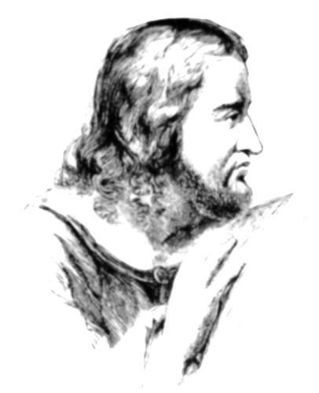](http://pixgood.com/james-the-less-the-apostle.html)

***1st May is the holy day of James the Less – quiet son of Alphaeus***

**One thing for sure, the apostles were not self-obsessed. In fact, many a church historian has wished that they had left us just a few more personal details about themselves in the New Testament.**

**James the Less is an excellent example. This is the name we give to James the son of Alphaeus, but – beyond that, who was he? Sometimes he is identified as the James whose mother stood by Christ on the cross. Sometimes he is thought to be the James who was ‘brother of the Lord’. Sometimes he is thought to be the James who saw the risen Christ. He has also, and often, been called the first bishop of Jerusalem. And finally, sometimes James the Less has been thought of as the author of the Epistle of James.**

**But – who knows? If none of these identifications are correct, we know practically nothing about James the Less. So perhaps on this day we can simply recall ‘all’ of the James’ above, and thank God for the mother who stood by the cross, the brother that supported Jesus, the apostle who saw his risen Lord and gave his life to proclaiming the truth, the first bishop of Jerusalem, and the author of the marvellous epistle of James. Whether it was one James or several, they were all faithful to Jesus, and proclaimed him as the Messiah. So perhaps that should make them James the More!**

**James the Less has been given an unusual iconographic emblem: a fuller’s club. Tradition has it that he was beaten to death with one, after being sentenced by the Sanhedrin in AD62.**

**Remember your elders**



Anyone who has ever tried elderflower presse will surely want to try it again!

Elders come into blossom this month, and while these beautiful white flowers are fresh, don’t miss your opportunity to make elderflower presse – it is a simple yet delicious drink.

You will need: 6 – 8 large heads of elderflower; 4.5 litres of water, 600g sugar; two lemons, sliced, and two tbsp white wine vinegar.

The method is easy:

Pick the flowers on a sunny day, when they are dry and fully open. (Just keep an eye out for any bugs!)

Boil the water, and then dissolve the sugar in it.

Leave it to cool, and then transfer it to a sterilised bowl.

Add the elderflowers and lemons, cover and leave for 48 hours.

Then strain the liquid into screw-cap lemonade bottles, and leave it to stand for a week. By then it should be nice and fizzy.

Serve it well chilled. Enjoy!

*Do you have any favourite summer recipes? Send them to me and we’ll share them in our next newsletter. Ed*

** YOU HAVE TO SMILE**

**Subject**

A man stayed at home while his wife went to church. When she returned, he enquired about the sermon. She hesitated, and then said it was okay. When he pressed her as to what it had been about, she admitted: “I don’t really know - the minister never did say.”

**Preaching**

Church members were discussing the vicar’s and the curate’s sermons. The church warden said: ‘Vicar, now, when she says ‘in conclusion’, she concludes. But the curate, when he says ‘lastly’ – my! How he do last.”

**Pillar**

After a certain gloomy Dean retired a number of years ago, he began writing for the press. Even he smiled when a rival paper declared that he was no longer a pillar of the Church of England, but now only two columns in the Evening Standard.

**Find and replace**

A priest I know of uses a standard liturgy for funerals. To personalize each service, he enters a ‘find and replace’ command into his word processor. The computer then finds the name of the deceased from the previous funeral and replaces it with the name of the deceased for the upcoming one.

Not long ago, the priest told the computer to find the name “Mary” and replace it with “Edna.” The next morning, the funeral was going smoothly until the congregation intoned the Apostles’ Creed. “Jesus Christ,” they read from the preprinted program, “born of the Virgin Edna.”

**Tribute**

The newly-arrived minister was asked to take a funeral at short notice. At one point in the service she said: “As I did not know the deceased, is there anyone here who would like to say a few words of tribute?” There was silence for several minutes and then a voice at the back was heard to say: “His brother was far worse.”

**CHURCH CONTACTS**

Priests the Revd Sheila Cox 018907 71764

the Revd Jennifer Edie 018907 50169

the Revd David Smout 018907 71220

the Revd Tim Morris 01289 386615

Lay Rep Brian Payne 018907 81825

Alt Lay Rep David Garside 018907 51159

People’s Warden Richard Oldale 01890 750939

Administrator Jennifer Edie 018907 50169

Treasurer David Garside 018907 51159

St Ebba’s Church, Fort View, Paxton Terrace, Eyemouth, TD14 5EL

St Ebba’s Parsonage, Beach Avenue, Eyemouth, TD14 5EL

[www.stebbas.org.uk](http://www.stebbas.org.uk)

***If you are in hospital and would like us to know and/or to visit, under the current regulations you have to specifically ask the hospital to inform us.***

If you want to keep up with what’s happening here and across the Borders, you will find the minutes of our own Vestry meetings and the Borders Area Council meeting in the files at the back of the church.

***EDITOR’S NOTE:***

*Our thanks, as always, to the Parish Pump website for providing material for our newsletters throughout the year and thanks too to each of this month’s contributors.*

*Copy for your June newsletter is 15 May. Do drop me a line to the email address below or to Birchfield House, Auchencrow, TD14 5LS to share your stories, thoughts, news and views.*

*Yours,*

Pat

E: [info@thebordersdesignhouse.co.uk](mailto:info@thebordersdesignhouse.co.uk) T: 01890 761271

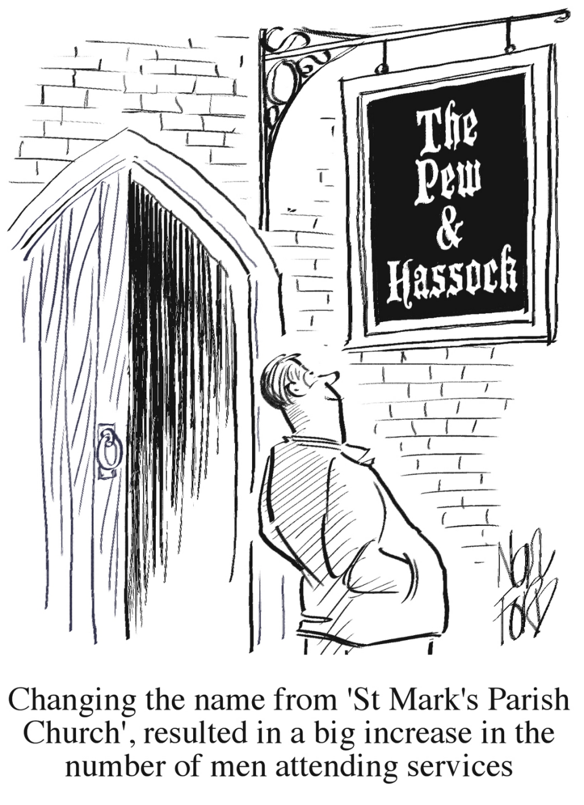

© 2015 Parish Pump Ltd, all rights reserved