**ST EBBA’S**

SCOTTISH EPISCOPAL CHURCH

**EYEMOUTH**

**JULY/AUGUST 2015**

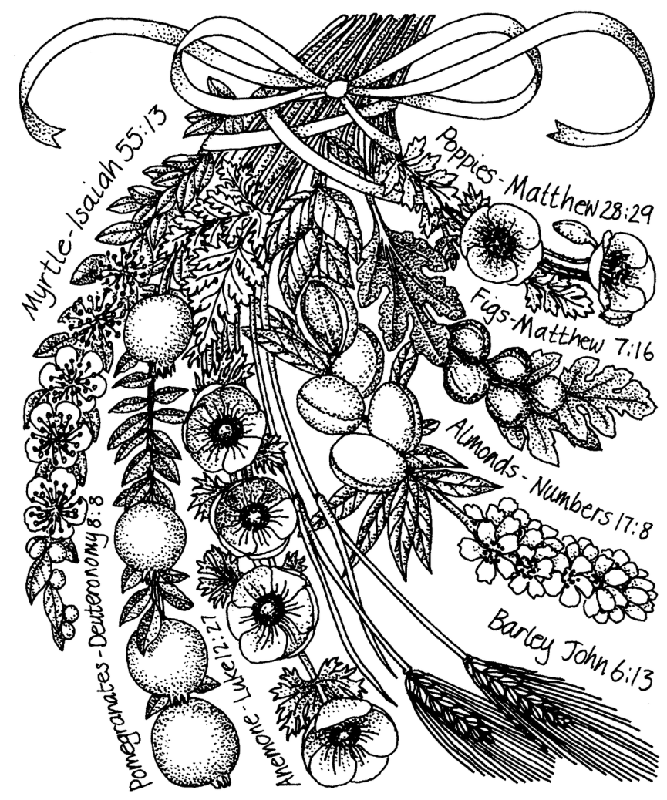

**Times of worship**

Every Sunday: 11am Eucharist in church

OSCR number SC023275

*Last month members of the congregation were invited to write an introductory letter for future newsletters. Brian Payne starts the ball rolling with a reflection on same sex marriage.*

**A view from the touchlines…….**

The Scottish Episcopalian Church is engaged in what is politely described as a conversation about whether or not to allow people of the same sex to get married to each other in our churches. There has just been a protracted argument in the General Synod on the subject, marked by understanding of the various positions that people hold. So far as I can tell, there is a movement towards allowing same-sex marriage, although it is taking this lawyer some time to sort out just what the various votes actually mean.

I mention the law because simple marriage is nothing more than a contract between two people. It is recognised as such in the way marriage – and divorce – is handled by the courts. Two people agree to share their goods and lives in exchange for a mutual and exclusive partnership of love and consideration. When any element of that contract is broken, the contract can be terminated – hence divorce.

Nothing is ever simple in reality, and the argument over a marriage in church of two people of the same sex is based on the long, long traditions of religious observance. However you want to interpret the Bible and Canon Law, it is very clear that the authors and drafters only considered a religious marriage to be valid between a man and a woman. The Church has, with good reason, always supported marriage. People who believe in the traditions and teachings of the Church are uncomfortable about widening the envelope of marriage.

But for me, a traditionalist at heart, the argument doesn’t lie in the way you interpret scripture. As a lawyer, I know how words can be refined into different meanings or even senses of meanings. I prefer to adopt the ‘love one another as yourself’ approach. If two people love each other enough to want to make an exclusive contract with each other, we should support and applaud their decision. We should, logically, allow them the same privileges as we enjoy. I have always

2

found in the profession of law, that the argument that is founded on an intense reliance on the rules as they are written is an argument that fails to acknowledge that fallible humans draft the rules. What guides the good lawyer is a sense of justice. And, for me, justice in the case of marriage is that it should be available to all in whatever combination of sexes that fate and love has drawn together.

Feel free to disagree…….

Brian Payne

**C:\Users\Pat\AppData\Local\Microsoft\Windows\Temporary Internet Files\Content.IE5\6ZOC9YMM\MC900371064[1].wmf KEEP UP TO DATE**

If you would like to know what is going on in our diocese, you can read about it in the printed copy of the fortnightly Diocesan Newsletter – The Communicant – which Jennifer will leave in the Parsonage.

**Note Your Diary**

ADVANCE DIARY DATES C:\Users\Pat\AppData\Local\Microsoft\Windows\Temporary Internet Files\Content.IE5\YKXCP52E\MC900113480[1].wmf

21 September UN International Day of Peace

5 October Harvest Festival & Food Bank fund raiser

12 October Eyemouth Churches Together Service

18 October St Ebba’s Coffee Morning

3

**JULY DIARY**

**Wed 1st St Peter**

10.00am Eucharist

Readings Ezekiel 3 vs 4-11

1 Peter 2 vs 19-25

Matthew 16 vs 13-19

**Sun 5th PENTECOST 6**

11am Eucharist

Readings Ezekiel 2 vs 1-5

2 Corinthians 12 vs 2-19

Mark 6 vs 1-13

**Sun 12th PENTECOST 7**

11am Eucharist

Readings Amos 7 vs 7-15

Ephesians 1 vs 3-14

Mark 6 vs 14-29

**Sun 19th**  **PENTECOST 8**

11am Eucharist

Readings Jeremiah 23 vs 1-6

Ephesians 2 vs 11-22

Mark 6 vs 30-34, 53-56

**Sun 26th PENTECOST 9**

**HEALING**

11am Eucharist

Readings 2 Kings 4 vs 42-44

Ephesians 3 vs 14-21

John 6 vs 1-21

**INTERCESSORS AND READERS – JULY**

|  |  |  |  |
| --- | --- | --- | --- |
|  | **Server** | **Intercessor** | **Reader** |
| Sun 5th | Richard Oldale | Ernie Cox | Susan Struthers |
| Sun 12th | Debbie Higson | Simon Furness | Brian Payne |
| Sun 19th | Joan Shelmerdine | Sheila Cox | Jan Simpson |
| Sun 26th | Richard Oldale | Joan Thomas | Ian Taylor |

**AUGUST DIARY**

**Sun 2nd PENTECOST 10**

11am Eucharist

Readings Exodus 16 vs 2-4, 9-15

Ephesians 4 vs 1-16

John 6 vs 24-35

**Wed 5th Transfiguration**

10.00am Eucharist

Readings Daniel 7 vs 9-10, 13-14

2 Peter 1 vs 16-19

Luke 9 vs 28-36

**Sun 9th PENTECOST 11**

11am Eucharist

Readings 1 Kings 19 vs 4-8

Ephesians 4 vs 25-5.2

John 6 vs 35, 41-51

**Sun 16th**  **PENTECOST 12**

11am Eucharist

Readings Proverbs 9 vs 1-6

Ephesians 5 vs 15-20

John 6 vs 51-58

**Sun 23rd ST EBBA**

11am Eucharist

Readings Isaiah 61.10-62.5

1 John 2 vs 15-17

Luke 12 vs 32-37

**Sun 30th PENTECOST 13**

**HEALING**

11am Eucharist

Readings Deuteronomy 4 vs 1-2, 6-9

James 1 vs 17-29

Mark 7 vs 1-8, 14-15, 21-23

5

**INTERCESSORS AND READERS – AUGUST**

|  |  |  |  |
| --- | --- | --- | --- |
|  | **Server** | **Intercessor** | **Reader** |
| Sun 2nd | Richard Oldale | Joan Shelmerdine | Frankie Taylor |
| Sun 9th | Joan Shelmerdine | Joan Thomas | Debbie Higson |
| Sun 16th | Debbie Higson | Ernie Cox | Pat Elliott |
| Sun 23rd | Richard Oldale | Sheila Cox | Simon Furness |
| Sun 30th | Richard Oldale/  Joan Shelmerdine | Jan Simpson | Susan Struthers |

**Faith in Action for July focuses on children and young people**

About one third of children in Scotland live in poverty. Children and young people across Scotland experience a range of difficulties and hardship: 100,000 live with domestic violence; 40,000 to 60,000 with their parents' drug misuse and another 80,000 to 100,000 are affected by parental alcohol misuse.

These children, along with others whose parents have mental health problems, are often acting as young carers of needy adults and they are not able to enjoy their childhood as they should. The numbers of children on child protection registers who are suffering neglect has increased by 70% recently, and those suffering emotional abuse have doubled. One in nine children run away every year as a means of expressing their unhappiness.

Gracious God,

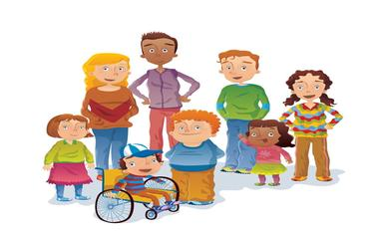Help young people to know you as a constant presence through all changes, and the church as a place of welcome. Help us to provide examples of Christian life for them to follow, and to offer friendship where it

is wanted. AMEN

http://www.scotland.anglian.org/spirituality/prayer/faith-in-action

**Can You Hear Me?**



During the past few months I have had some ear treatment. This has for the moment further reduced my already faulty hearing and I rely on lip reading and body language to understand what is being said. As someone who takes up most of the airtime available I am in no position to comment on how others pepper their conversation with a barrage of redundant words but it did make me reflect on my own communication style.

A common assumption is that hearing loss can be eradicated by sheer volume. Enter the person laced with a sniff of tolerant pity who bellows ‘Can you hear me?’ Without waiting for a reply they speak through contorted lips in mono syllabic sounds reducing their words to an indecipherable code. Attempting to ‘help’ further by fervent head nodding, a firm grip and a fixed eye lock the result is both amusing and at times irritating. It is also unhelpful. When silently praying for them to stop this verbal assault it occurred to me that this might be how I pray. The predictable torrent of improbable requests and petitions are sincerely made but do I ever wait for a response or recognise one when it comes?

Assisting a hearing impaired person to understand conversation is often easy to do. Speaking at a normal rate, using clear concise words and sentences and extending meaning through helpful hand signals and facial expressions will help the conversation flow. Just keep it short, simple and to the point. It might work for prayer too.

For all of us, irrespective of our hearing ability, words alone only convey a third of the message and meaning we intend. It’s not what we say but how we say it that matters. Real understanding and good communication is underpinned by our body language. Eye contact, head nods, hand gestures, social distance, word rate and voice tones colour the black and white of our words and bring the message alive. I wonder if prayers are similar in that it’s not the words we say but in the listening and the silence that we connect and communicate.

If I find my attention wandering during a sermon or talk I

7

7

watch the body language of the speaker and the impact of this on the

congregation or audience. Speakers who connect well with their listeners will assist understanding and memory of what is said.

Listening is an interactive thing and how we listen and react helps the speaker to adjust and modify what they say to better engage with us. They need our feedback in looks and reactions to keep going. If we all gazed at the floor five minutes into the sermon the speaker would falter for a few minutes trying to work out what was happening and then more than likely stop altogether.

Communication is a two way process and the more we interact the more we remember and value what is said. When I apply this to praying I am prompted to think about how I pray as well as what I pray. Perhaps listening more carefully and having a dialogue rather than giving a monologue would help me feel more connected.

You may have a preferred form of service, a favourite hymn, reading or prayer that speaks to you and connects you with significant people and times in your life. Whether hearing is perfect or compromised it is good to know that these gems live long in the mind’s ear and memory and are only a thought away.

Irene Morris

**Bible Stories like you’ve never heard them before**

When the Bible Society invited five guest storytellers to re-tell a Bible story of their choice in a different way, the result was Pass it On – Bible Tales. The stories have emerged as everything from a short tale, to a comic strip, to a rhyme, to a rap and poem.

The authors range were Anthony Hororwitz (Alex Rider books), Kev F Sutherland (The Beano), Martin Coleman (The Greedy Crocodile), Revd Gavin Tyte (The Hip-hop Gospel of Luke) and Sir Andrew Motion (Silver-Return to Treasure Island).

You can download a copy of this unique book free at the Bible Society website www.biblesociety.org.uk/about-bible-society/our-work/pass-it-on/p...

**COMMENT **

*Is there a topic upon which you feel strongly? Share your views with us here.*

The recent prosecution of four young tourists who climbed Malaysia’s Mount Kinabalu and, at the peak, took off their clothes and posed for photographs elicited quite disparate reactions. For some, this was viewed as no more than youthful exuberance whose legal consequences were seen as out of proportion to the act.

For others – and, importantly, for those of the Kadazan Dusun tribe – this amounted to gross sacrilege. They believe the mountain houses the spirits of their dead ancestors; Kinabalu derives from a phrase meaning ‘resting place of the dead’.

But which is the reasonable response?

Here in the UK there is, rightly, public outrage when we read of the desecration of cemeteries and memorial stones so, from this perspective, arguably the actions of these young people was not mere high spirits and thoughtlessness but utter lack of sensitivity and respect.

That the Kadazan Dusun people attributed the subsequent earthquake to the young people’s behaviour may be, for us, a tenet too far but, as an atheist friend remarked, to believe that desecrating a mountain top can cause an earthquake seems no more outlandish to him than does the Christian belief in the resurrection.

Any belief system is largely shaped by where we come from ethnically, culturally and spiritually. The pivotal point surely is that all are deserving of our respect, of due regard for the feelings, wishes, or rights of others. After all, not only is that principle enshrined in anti-discrimination legislation but also in the more direct Christian commandment to ‘love your neighbour as yourself’.

Pat Elliott

9

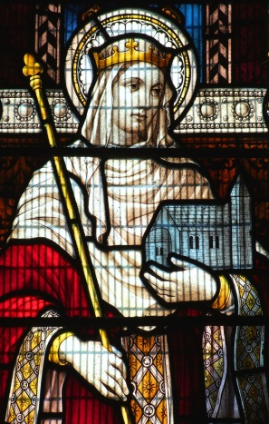**St Ebba**

Eyemouth public library currently holds a small book entitled The Miracles of St Ebba of Coldingham and St Margaret of Scotland according to the Chronicle of Reginald, Monk of Durham. (Edited and translated by Robert Barlett, Clarendon press, Oxford 2003.)

Since it has Brother Reginald’s Latin on the left hand page and the translation on the right, those with medieval Latin can argue over delicate points of interpretation.

Ebba seems to have been connected with the Northumbrian royal family but not actually one of them. So much has been lost, we can only conjecture she was the daughter of the queen by a previous marriage since Ebba is described as the half-sister and aunt to successive Northumbrian kings.

A career as Abbess of a double monastery high on St Abbs head in the late 7th century in communication with eminent churchmen and scholars was more suited to Ebba’s place in the royal family than marriage to a minor chieftain.

St Ebba died in 683 and shortly afterwards the wood, thatch and turf buildings burnt down. One of the monks from the ruined abbey fled to Jarrow, met the historian Bede who recorded all we know of St Ebba.

It was King Edgar of Scotland, who died in 1107, who gave the church and estate of Coldingham to the monks of Durham. So it was, in the 14th century, Brother Reginald wrote what he described as a sermon on the miracles of St Ebba.

The text tells of how St Ebba’s coffin was found in the ruins of the chapel on St Abbs Head by shepherds. Some say the coffin was made of wood which the monks removed to a stone tomb in the Priory Church. At a later date the bones were taken from the tomb and placed in a silver reliquary on the altar. There are grounds for supposing some of the bones went to Durham.

A local man, who would become known as Henry of Coldingham because of his later devotion to St Ebba, had a complicated family life. One of the women concerned poisoned Henry who became raving mad. One wonders if she had knowledge of fungi.

Henry was bound hand and foot by concerned neighbours and left to spend the night before the altar of St Michael in the Priory Church, St Michael having a reputation for fighting evil spirits.

In the morning Henry was sane but convinced he had been cured by a holy virgin who appeared to him. Given Henry’s local reputation, the villagers’ comments on this are best left unsaid.

Henry then devoted the rest of his life in rebuilding St Ebba’s Chapel in dry stone walling up on St Abbs Head and in telling the story of his miraculous cure and change of life to those who came to see where the Saint had lived and worked. He also advocated the miraculous powers of the two springs used by the nuns.

Reginald dates this to 1188 or 506 years after St Ebba’s death and records forty two miraculous cures.

A blind woman, her eyes described as ‘hollows of raw meat full of blood’ washed her eyes in the spring and was cured. Was this viral conjunctivitis? A young man with a goose bone lodged in his throat drank the water and lo! the bone was gone.

Many of the other afflicted pilgrims seeking cures spent the night in the church enjoying a blessed sleep and awaking cured.

One wonders if Brother Infirmarer’s warming posset ensured deep sleep during which minor surgery could be carried out without bringing the patient fully round. Certainly the case of the mother bringing her little son with a huge and painful swelling suggests the draining of an abscess while exhausted mother and child slept.

All cures were attributed to St Ebba which, of course, meant the pilgrims continued to arrive and the alms boxes to fill.

How long the pilgrimages lasted and what happened to the silver reliquary was beyond Brother Reginald’s knowledge.

Patricia Payne

11



**Should have gone to Specsavers?**

**A man from Poland goes to the optometrist. He is shown a chart:**

**CZWXNQSTACZ**

**‘Can you read this?’ the optometrist asks.**

**‘Read it?’ replies the Pole. ‘I know the guy!’**

**How did you spell that?**

A friend who wished to check some point on aeronautics asked in his library for books on Metropolitan Vickers. He was handed a copy of Crockford’s Clerical Directory.

**Spell checker?**

Why are t and m the most unused letters in the alphabet ?

Because they’re empty.   
Which letter of the alphabet has got lots of water?

The C   
  
**Spelling test**

THE teacher announced that to practice spelling, each member of the class would say what their fathers did for a living and then spell the occupation.

Mary went first. ‘My Dad is a baker, b-a-k-e-r, and if he were here, he would give everyone a cake’

Next came Tommy. ‘My dad is a banker, b-a-n-k-e-r, and if he were here, he’d give each of us a penny.’

Third came Jimmy. "My dad is an electrician.’ But after struggling through a number of attempts to spell the word, the teacher asked him to sit and think about it for a moment while she called on someone else. She turned to Johnny. ‘My dad’s a bookie, b-o-o-k-i-e and if he were here, he’d lay you 8 to 5 that Jimmy’s never gonnaspell electrician.’

**Heavenly scents**

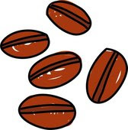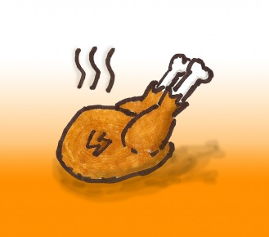

There is nothing quite like the smell of freshly baked bread, it seems. That came top in a recent poll to find Britain’s favourite smells. Other scents in the Top Ten were: bacon frying, newly mown grass, freshly ground coffee, cakes baking in the oven, the seaside, just laundered clothes, a Sunday roast, fish and chips – and fresh flowers.

The Top 50 favourites also included some unusual scents, such as paint, rain, new books, and petrol. The top worst scents were bins, drains, body odour, garlic breath, sports changing rooms and fish. The research by Harris, the decorating brand, also found that six in ten of us believe that certain scents remind us of particular people or places.

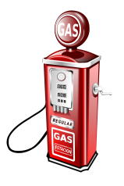

13

**Are you becoming ‘nomophobic’?**

Where is your mobile phone? When did you last check it? If it is close, and you have checked it within the last few minutes or so, you may have nomophobia…. Fear of being separated from your mobile phone. ‘Nomo’ stands for ‘no mobile’, and what you ‘fear’ is being out of contact, not connected.

Nomophobia is taking its toll on family life, it seems. As one father recently admitted: “The very first thing I do when I wake up in the morning – and the very last thing I do at night – is pick up my phone, press the Twitter app and see what’s going on in the world…. During the day I can’t undertake the most basic task – from making the children’s lunch to cleaning my teeth – without swiping the screen…”

Now Ofcom, the communications industry regulator, has released figures that show that the average amount we spend online has more than doubled from 9.9 hours a week 10 years ago to 20.5 hours a week. A separate report finds that the average person in the UK checks their phone 50 times a day.

Psychiatrists are warning of widespread technology addiction, and urge people to take ‘holidays’ from their gadgets. Most of us won’t manage that, but we might do well to heed at least one piece of advice: avoid screen light for an hour before you sleep at night, in order to sleep properly. Phone addiction can be just as damaging as addiction to alcohol or gambling. If this is you, be honest, and consider the effect your screen addiction could be having on those people close to you.

*How do you use your mobile ‘phone? Is it on all the time and checked frequently or are you an occasional user? Share your praises – or complaints – about mobile ‘phone use.*

14

**CHURCH CONTACTS**

Priests the Revd Sheila Cox 018907 71764

the Revd Jennifer Edie 018907 50169

the Revd David Smout 018907 71220

the Revd Tim Morris 01289 386615

Lay Rep Brian Payne 018907 81825

Alt Lay Rep David Garside 018907 51159

People’s Warden Richard Oldale 018907 50939

Administrator Jennifer Edie 018907 50169

Treasurer David Garside 018907 51159

St Ebba’s Church, Fort View, Paxton Terrace, Eyemouth, TD14 5EL

St Ebba’s Parsonage, Beach Avenue, Eyemouth, TD14 5EL

[www.stebbas.org.uk](http://www.stebbas.org.uk)

***If you are in hospital and would like us to know and/or to visit, under the current regulations you have to specifically ask the hospital to inform us.***

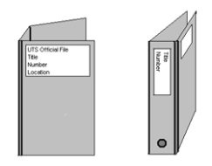If you want to keep up with what’s happening here and across the Borders, you will find the minutes of our own Vestry meetings and the Borders Area Council meeting in the files at the back of the church.

***EDITOR’S NOTE:***

*Thank you to those who have contributed to this month’s newsletter. All contributions – including a welcome letter – are much appreciated to help keep your newsletter lively and in touch.*

*Please send your thoughts, comments and ideas to me by the 15th of August for inclusion in September’s issue.*

Pat

*Pat Elliott,* [*thebordersdesignhouse@hotmail.com*](mailto:thebordersdesignhouse@hotmail.com) *01890 761271*

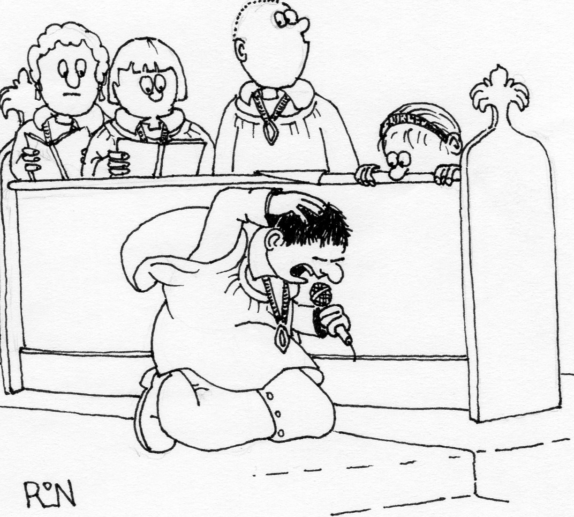

*Gary sang the verse 'The purple-headed mountains...' as a solo*

© 2015 Parish Pump Ltd, all rights reserved