**ST EBBA’S**

SCOTTISH EPISCOPAL CHURCH

**EYEMOUTH**

**October2015**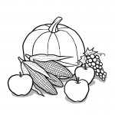

**Times of worship**

Every Sunday: 11am Eucharist in church

OSCR number SC023275

*This month our introductory letter is a message from Bishop John*

Dear Friends

The humanitarian crisis in Syria and other parts of Europe has been much in our prayers in recent months.  I am sure that this has played a part in the upsurge of compassion that has recently forced a change of heart from the UK government.  This means, no doubt, that we shall shortly be enabled to answer our own prayers as we find ways of welcoming and supporting refugee families to our communities.  I know that many from Christian and other faith communities have been deeply moved by this situation and many have already begun to plan ways of offering practical support.  There are also many organisations already working to bring relief both to those in refugee camps and those in transit seeking a safer life in Europe – obviously, if you are not already doing so, you might want to consider how your congregation might support such efforts.

I have also received a number of communications suggesting that the College of Bishops should take a lead in some way.  We shall certainly consider possible initiatives Province-wide.  But even more important, it is what you are able to do on the ground, in your local community, that will bear most fruit.  It is essential that our churches be seen to act in concert not only with other Christians and those of other faiths but with the ’secular’ authorities.  For example, I have been in touch with our local council leader in Edinburgh to offer whatever support the churches can give and I am in touch too with our Interfaith Association and Churches Together group.  I would suggest that you all take the earliest opportunity to speak with your own local councillors and council leaders.  If you wish me to write to them I shall certainly do so.  It may be helpful to remind our political leaders that when the time does come to settle refugee families in our towns and cities, faith communities are ideally placed to welcome and provide for their well–being.  Some folk have even suggested that they might accommodate visitors in their own homes.  This may or may not be the preferred option in the long run but I am conscious that the offer comes from the heart and this is undoubtedly a situation which demands our compassion and willingness to be inconvenienced in the cause of love.

As St Paul said, we are the recipients of God’s blessing in abundance, of God’s indescribable gift – the more we share that blessing the more the blessing increases.  It seems appropriate that at the time of year when our farmers gather the harvest of the fields we should be ready to sow and reap the harvest of righteousness. (2 Cor 10.6ff).

Please keep in touch and let me know what is happening about this in your own neighbourhoods.  Simon and the diocesan staff will endeavour to keep the information flowing.

With my love and blessing

+John

The Rt Revd Dr John A Armes

Bishop of Edinburgh

*Would you like to write the introduction to our monthly newsletter? Please send your letter to the editor or pass to any member of the Vestry.*

**TAKE A MOMENT**

If you are in Eyemouth at 10 a.m. on the first Wednesday of any month, you could come to the 10 a.m. Eucharist which we celebrate in the Parsonage.  This is a quiet and reflective celebration - a time to pause and listen to God in the midst of life's busyness.

**OCTOBER DIARY**

**Sun 4th St Francis**

11am Eucharist

Readings Micah 6 vs 6-8

Galatians 6 vs 14-18

Luke 12 vs 22-34

**Wed 7th William Tyndale**

10am Eucharist

Readings Proverbs 8 vs 1-11

2 Timothy 3 vs 12-17

John 17 vs 6-8, 14-19

**Sun 11th Harvest**

11am Eucharist

Readings Joel 2 vs 21-27

[Philippians](http://lectionary.library.vanderbilt.edu/texts.php?id=324) 4 vs 4-9

John 6 vs 25-35

**Sun 18th St Luke**

11am Eucharist

Readings Sirach 38 vs 1-4, 6-10, 12-14

2 Timothy 4 vs 5-17

Luke 4 vs 14-21

**Sun 25th Pentecost 22**

11am Eucharist

Readings Jeremiah 31 vs 7-9

Hebrews 7 vs 23-38

Mark 10 vs 46-52

**INTERCESSORS AND READERS – OCTOBER**

|  |  |  |  |
| --- | --- | --- | --- |
|  | **Server** | **Intercessor** | **Reader** |
| Sun 4th | Debbie Higson | Sheila Cox | Brian Payne |
| Sun 11th | Richard Oldale | Joan Thomas | Pat Elliott |
| Sun 18th | Joan Shelmerdine | Simon Furness | Frankie Taylor |
| Sun 25th | Richard Oldale | Ernie Cox | Susan Struthers |

A. G. M.

sunday

29TH NOVEMBER

This is an important part of our life as a church community so we hope as many people as possible will make the effort to attend. There will be a shortened Eucharist at 11 a.m. (no sermon) and we move directly into the A.G.M. as a part of our life and service for God. We need

**NEW MEMBERS FOR THE VESTRY**

Please think about this. Volunteer yourself or ask other members if you may nominate them. This is your church and you have a contribution to make to our future so please **come to the meeting** and take part in discussions about future plans. If you have been in church lately, you will see that our numbers are getting smaller. Can you help us with suggestions of how we might make changes if you think they are necessary? Come and tell us what you would like to see happening in St. Ebba’s.

**NOTE THE DATES….**

**ST EBBA’S COFFEE MORNING**

**Saturday, 3 October 9.30 – 11.30am**

**Masonic Hall, Eyemouth**



Come and join us for home baking, preserves and a raffle

**ST EBBA’S HARVEST FESTIVAL**

**Sunday, 11 October at 11am**

**

*Donations of money and/or non-perishable food items will, again, support the Food Bank*

Help needed to decorate the church the day before.

**Faith in Action for October**



* Pray for the good stewardship of the world and all its riches
* Eat mindfully, aware of the work of earth, rain, sun, wind and human endeavour which has brought the food to your table
* Use your LOAF when you buy food – **L**ocally produced, **O**rganically farmed, **A**nimal friendly, **F**airly traded
* Bank ethically. Do you know what your money is doing? Are your savings or pension funds paying for arms, oppression or environmental destruction?
* Enjoy the harvest. Celebrate it

**Prayer**

Give us eyes to see your new creation,

Breaking upon us, frail and beautiful like tiny flowers

We stop, and look and water it to help it grow

Until the earth is filled with knowledge of you

And all shall rejoice and blossom abundantly. AMEN

http://www.scotland.anglian.org/spirituality/prayer/faith-in-action

**C:\Users\Pat\AppData\Local\Microsoft\Windows\Temporary Internet Files\Content.IE5\6ZOC9YMM\MC900371064[1].wmfKEEP UP TO DATE**

If you would like to know what is going on in our diocese, you can read about it in the printed copy of the fortnightly Diocesan Newsletter – The Communicant – which Jennifer will leave in the Parsonage.

** Books **

As I’m sure some of you know I am devoted to books. I’ve just been sorting out my books on faith and religion and wondered how many people shared my enthusiasm for reading. I find it continually opens my eyes and my mind to new ideas that are sometimes threatening and sometimes glorious but I welcome them all because they make me think in new ways about the world and about God.

I thought I might occasionally put a note in the Newsletter about what I’ve been reading and I’d be delighted if other people would follow suit and give us a chance to share what they have enjoyed.

I’d like my first recommendation to come from someone who feels like a friend and I was deeply saddened to hear of his death earlier this year. **Marcus J Borg** was a leader among a movement known as Progressive Christianity which originated in America among some theologians who spent time studying and discussing the gospels to try to understand them better and to discover which of the words of Jesus recorded there might really be close to what he said. Knowing that the gospels as we have them did not begin to take shape until at least a generation after the crucifixion, they were sure that the writers had never heard Jesus speak and were using what other people had told them about him and his teaching.

I have read and reread many of his books but the one that has gripped me most is his last: **Convictions.** He called it a manifesto for progressive Christians and it is also his autobiography of faith. He identifies the convictions that have emerged in his life and thought. The question he posed himself was: What might the things we can know about the Bible, Jesus and the Christian past mean for Christians today? And what should they mean?

I have been challenged and excited, and consoled, by his luminous reassurance of the love and mercy of God. I commend him to your attention if you are an enquiring reader.

Jennifer

**MIGRANT CRISIS – the shame of our time?**

[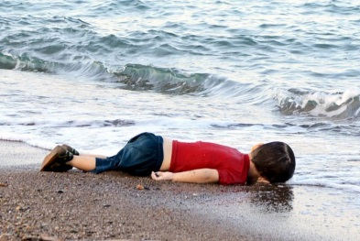](http://www.ibtimes.co.uk/migrant-crisis-would-you-welcome-syrian-refugee-into-your-home-1518351)

Little [Aylan Kurdi](http://ibt.uk/A006My9) washed up on a Turkish beach

*The phrase "migrant crisis" rose to popular use in April 2015, when five boats carrying almost two thousand* [*migrants*](https://en.wikipedia.org/wiki/Migrants) *to Europe* [*sank in the Mediterranean Sea*](https://en.wikipedia.org/wiki/List_of_migrant_vessel_incidents_on_the_Mediterranean_Sea)*, with a combined death toll estimated at more than 1,200 people. Most of the migrants are refugees fleeing war, persecution and destitution.*

Mima, the Ethiopian pastor of the church in the so-called 'Jungle' refugee camp in Calais has said he is no longer trying to get to the UK. Instead, he believes God wants him to stay and help distressed people in the camp.  
 In a recent interview, Mima said: “Maybe Jesus has brought me [here]. For me it's better than to go to Britain." And in a message to Christians in the UK, he said: "Pray for the immigrant people...the ones who are dying on the Mediterranean Sea, those who are dying on the train station. All Christians need to pray for these people. Ask Jesus to give us protection and send the angels. We're eating once a day. We don't have any facilities. People are dying."  
 In light of recent criticism of the migrants from various quarters of British life, there have been calls for more sympathy for those in the camp. The Bishop of Dover said, “Some of those people in Calais at the moment have come from the most horrific situations, where they've been subject to violence; where they've had their homes destroyed. And we have to say to ourselves what would happen to us if we were in that place? We're very fortunate in Britain. We've got freedom."

Scotland’s First Minister, Nicola Sturgeon said, "We cannot walk by on the other side or that little boy we were all touched by will just become many, many more” and she added, “"As first minister I pledge that I will ensure Scotland will do everything possible to help in this refugee crisis.”

**THE SYRIAN REFUGEE CRISIS – WHAT CAN WE DO?**

Many people have been asking if there are practical steps that they can take to respond to the urgent needs of refugees fleeing Syria and Iraq.

**Borders Aid for Syria** is a local organisation collecting and forwarding basic domestic items.

The following are particularly required:

Padded jackets

Welly boots

Warm sweaters

Socks

Baby clothes

Gloves

Hats

Scarves

Winter sleeping bags

Blankets

Underwear

Toothpaste

Toothbrushes

Soap

Detergents

Toilet rolls

Nappies

Sanitary pads

Wet wipes

*Plus: Notebooks, A4 paper, pens/pencils, boardwriters, sewing materials, wool*

**If you can help with any of these items, please deliver to**

**31 The Avenue or 51 Hurkur Crescent, Eyemouth**

(or leave them at the back of the church marked “Syrian Appeal” and they will be passed on)

### ****Joining the pilgrimage of justice and peace****

To belong to the people of God requires us to be a channel for God's inclusive love. It's about being civil to one another, treating one another with respectful reserve, listening to what others have to say. It's about overturning the status quo of social order, gender, ethnic, cultural and religious divisions and moving towards God's promise to bless all humankind.

It's not about food for some and not for others. It's about food for all. We are invited here to place ourselves in the shoes of 'the other', however that term 'the other' may be defined.

I am also an integral part of nature. I respect other organisms, not only because of their intrinsic value; but because of the countless relationships and balances that exist between them that have a value greater than their use to me.

The destiny of humans, as of all intelligent creatures, is to 'be opened', liberated in other words, to share in the divine nature. We are becoming aware of life's interrelatedness. What we do to nature, we do not do in part. We do it to the whole. We are joined together in a common purpose.

The Christian faith offers a distinctive perspective on political issues, and the Church has every right to articulate such reflection on matters concerning care for creation, economic justice and world peace. But the secular world does not want to hear us. They would prefer that we retreat into our private devotions.

However, the earth is in distress and is calling to us to respond, as individuals and communities with ideas and action, particularly at this time, with reference to the COP21 climate talks due to take place in Paris at the end of this year.

We have heard the story of Jesus and through our imagination and reason, informed by biblical wisdom, we can learn to revere one another and revere the rest of creation.

Jesus lifts the veil of dominance from our eyes, gives us ears to listen and unstops our mouths. We are called from a place of sacred wholeness and reverence to take up again our ancient and sacred duty of care for the physical world.

*Taken from Christian Aid’s Reflection for the Month*

**Speaking the truth**

The announcement of the election of Jeremy Corbyn as the leader of the U.K. Labour Party brought about an avalanche of statements from politicians and the media. In my mind the saddest comment that I heard was one from the new BBC Political Editor, Laura Kuenssberg. She said (and I am quoting from memory and in my own words) that until his election, while still a backbencher, Jeremy Corbyn had a reputation for being a man of principle even if you disagreed with what he stood for. He was also respected as someone who told the truth. She added that from now on, as leader of a political party, he would need to give up that bad habit.

I think it is a sad reflection on the state of the United Kingdom that honesty and truthfulness in speech seem to be regarded both as eccentric and unusual qualities to be avoided at all costs and also fundamentally unhelpful to the cause of leadership and government of nations or parties. Of course there must be times and occasions for state secrecy and when – as the lesser of two evils – lies have to be told or half-truths uttered. But these must be the exceptions rather than the rule.

Surely there ought to be a default position of truthfulness for politicians, both in government and in opposition so that we as ordinary citizens and voters can put our trust in what they say. If telling the truth means sometimes making mistakes, saying the wrong things on the spur of the moment or being politically incorrect, that must be far better than living in a perpetual world of “spin” where truth and deceit are all bundled together in a “appropriate and acceptable communication” which so often means little and satisfies no-one.

Is it coincidence that the recent Epistle readings on Sundays have been taken from the book of James. Nowhere in the New Testament is there a plainer message about the importance of what we say (see ch.3 vs 1 -12 on the use and danger of the tongue), which concludes with an absolute demand for truthfulness, echoing words of Jesus himself: “Let your “Yes” be Yes and your “No” be no” (ch.4 vs 12).

Much has been made of Jeremy Corbyn’s new approach to politics, much of which I agree with even if I may not follow all his ideas. But I sincerely hope and pray that he will not give up his “bad habit” and that he will continue to speak honestly, openly and truthfully, without fear or favour. By his own admission he is not a Christian believer, but in this respect he can show an example of Christian behaviour.

Tim Morris

**\*\*\*\*\*\*\*\*\*\*\***

## **THE WAY I SEE IT: of House and Home**

By David Winter

[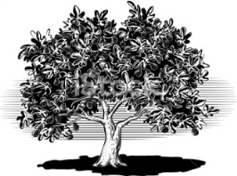](http://www.spiderpic.com/search/fig-tree-alone)

Houses have been in the news in recent months – a hot political topic for those in power or seeking it, a source of desperate concern to those who simply can’t find a place to live.   
 In towns and villages across Britain, young people planning to set up home together face years and years of saving simply to afford the deposit on a house. Many settle for renting, which means that there’s no money left to save for that deposit. The short answer, obviously, is to build more affordable houses. Everyone agrees, but whenever there are plans to build some, the cry goes up ‘Not in my back yard!’ The Government also agrees that we need such housing, but what, in terms of the average monthly wage, is ‘affordable’? Houses matter. Or, rather, homes do. There’s a lovely vision drawn by the Jewish prophet Micah of a day when everyone will ‘sit under their own vines and under their own fig trees, and no one shall make them afraid’. It doesn’t mention a house, but it’s a lovely picture of a home: a place where we feel secure, welcome and loved.   
 Sadly, not every house is a home, but every home is a precious gift. Somehow or other, and before it’s too late, we need to find a way to house all those would-be families, not luxuriously, but decently.

The fig-tree in the back garden can be optional.

**Laughter Lines or Words of Wisdom?**



**Fish**

Give a man a fish and he will eat for a day. Teach him how to fish, and he will sit in a boat and drink beer all day.

**Lend**

If you lend someone £20 and never see that person again, it was probably worth it.

**Truth**

If you tell the truth, you don't have to remember anything.

**Bug**

Some days you are the bug; some days you are the windscreen.

**Judge**

Good judgement comes from bad experience, and a lot of that comes from bad judgement.

**Quick**

The quickest way to double your money is to fold it in half and put it back in your pocket.

**Mouth**

A closed mouth gathers no foot.

**Duct tape**

Duct tape is like the Force. It has a light side and a dark side, and it holds the universe together.

**Women**

There are two theories to arguing with women. Neither one works.

**Lips**

Generally speaking, you aren't learning much when your lips are moving.

**Experience**

Experience is something you don't get until just after you need it.

**CHURCH CONTACTS**

Priests the Revd Sheila Cox 018907 71764

the Revd Jennifer Edie 018907 50169

the Revd David Smout 018907 71220

the Revd Tim Morris 01289 386615

Lay Rep Brian Payne 018907 81825

Alt Lay Rep David Garside 018907 51159

People’s Warden Richard Oldale 018907 50939

Administrator Jennifer Edie 018907 50169

Treasurer David Garside 018907 51159

St Ebba’s Church, Fort View, Paxton Terrace, Eyemouth, TD14 5EL

St Ebba’s Parsonage, Beach Avenue, Eyemouth, TD14 5EL

[www.stebbas.org.uk](http://www.stebbas.org.uk)

***If you are in hospital and would like us to know and/or to visit, under the current regulations you have to specifically ask the hospital to inform us.***

If you want to keep up with what’s happening here and across the Borders, you will find the minutes of our own Vestry meetings and the Borders Area Council meeting in the files at the back of the church.

***EDITOR’S NOTE:***

*Thanks to all this month’s contributors. All contributions – including a welcome letter – are much appreciated to help keep your newsletter lively and in touch.*

*Please send your thoughts, comments and ideas to me by the 15th of October for inclusion in November’s issue.*

Pat

*Pat Elliott,* [*thebordersdesignhouse@hotmail.com*](mailto:thebordersdesignhouse@hotmail.com) *01890 761271*

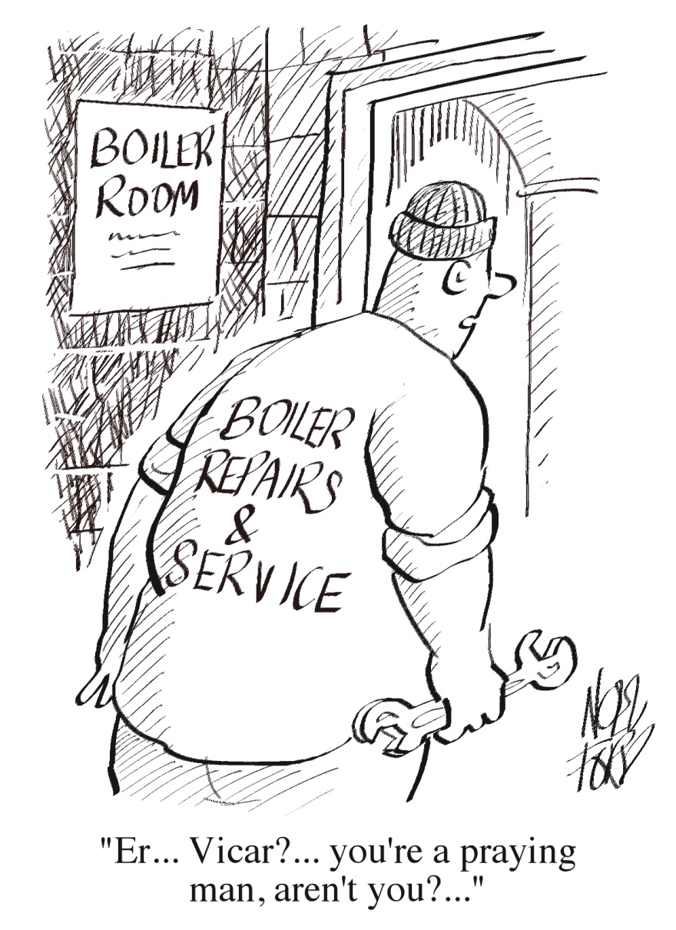

© 2015 Parish Pump Ltd, all rights reserved