**ST EBBA’S**

SCOTTISH EPISCOPAL CHURCH

**EYEMOUTH**

**September 2015**

**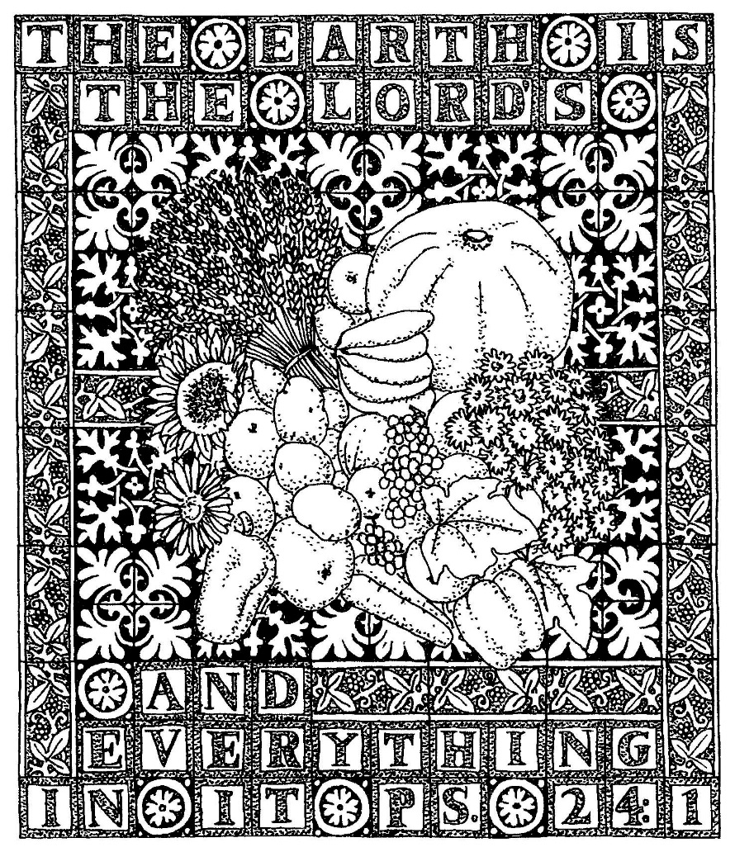**

**Times of worship**

Every Sunday: 11am Eucharist in church

OSCR number SC023275

**IS THERE ROOM HERE FOR JESUS?**

Regularly this summer we have had scenes on our television news of would-be migrants trying to smuggle themselves on board trucks in Calais to gain access to the United Kingdom. Tragically some have lost their lives in the attempt, along with many thousands who have perished in the Mediterranean trying to cross from Libya to Italy.

The British government has struggled to find ways to cope with the constant flow of people wanting to find refuge here, either by reducing the number of those setting out on this perilous journey from Africa or the Middle East or by finding means of properly and speedily processing their asylum applications. But this should not surprise any of us when we sense how much policy has been driven by media headlines or by the suspicion of some Tory backbenchers of any pan-European strategy.

However - even by the Government – it is still sometimes claimed that Britain is a Christian country and so it is surely right that decisions should be based on principles which are drawn from the Christian tradition rather than from the Daily Mail or the Monday Club. At the very least, our Christian faith must be about loving God and loving our neighbours as ourselves, and the Parable of the Good Samaritan – told by Jesus in response to a question and the contemporary theological discussion about “Who is my neighbour?” – illustrates that the neighbour to be loved is anyone in any sort of need, regardless of colour, creed or cause.

In my mind a truly Christian country should find ways of welcoming and accepting the migrants of Calais, binding up their wounds, putting them on 21st century donkeys and finding inns for them to stay in, just as was done by past generations when Jews were expelled from Germany or Asians expelled from Uganda by dictators. We should hang our heads with shame that numerically this country has failed to match other European countries in accepting refugees, despite our economic prosperity, our historic links with many of the African nations or our having aggravated the problems in them by past foreign policies.

It is perhaps ironic that many of those wanting to come to the United Kingdom do so because they are practising Christians, fleeing religious persecution in Sudan, Nigeria, Iraq or Syria, and that one of the first buildings erected by the migrants in the tented “Jungle” village of Calais is a Coptic Christian church.

Every Christmas we read the story of Mary, Joseph and the child Jesus fleeing from Palestine to Egypt to escape the repressive regime of Herod (Matthew 2. 13 – 14). We might think it was a good job the angel had not told them to go to the United Kingdom as they would have been turned away with dogs, police, fences and pepper spray and probably sent back to their homeland. But maybe Jesus does still come to our border as the stranger seeking welcome – how we treat him shows if we are “sheep” or “goats” (Matthew 25. 31 -46).

Tim Morris

*Would you like to write the introduction to our monthly newsletter? Please send your letter to the editor or pass to any member of the Vestry.*

**TAKE A MOMENT**

If you are in Eyemouth at 10 a.m. on the first Wednesday of any month, you could come to the 10 a.m. Eucharist which we celebrate in the Parsonage.  This is a quiet and reflective celebration - a time to pause and listen to God in the midst of life's busyness.

**PLEASE NOTE: DIARY DATE ERRATUM**

C:\Users\Pat\AppData\Local\Microsoft\Windows\Temporary Internet Files\Content.IE5\YKXCP52E\MC900113480[1].wmf

**St Ebba’s Harvest Festival will be celebrated on Sunday, 11 October and not on 5 October as shown in the last newsletter.**

*Donations of money and/or non-perishable food items will, again, support the Food Bank*

Helpers are also needed on Sat 10th to bring items for use in decorating **and** to help in decorating the church appropriately

**CASCADING CONVERSATIONS**

Cascading conversations are intended to give insights on the question of single-sex marriage in church. St Ebba’s has been invited to send volunteers to a cascading conversation day

**at Melrose Parish Church**

**on 26 September**

**from 10 a.m. for 10.30 start to 3 p.m**

(includes lunch break and opening and closing worship)

More information from and names to Jennifer

**“The Lord’s my shepherd”**

****

It is probably true that the words of Psalm 23 to the tune “Crimond” are the most used and best loved of any hymn, especially here in Scotland. Those of us who have led or been at many funeral services will probably know them off by heart. Phrases from this Psalm have entered into our normal English usage.

But how often do we think what this Psalm means?

To help us to do so, on Sunday September 20th in the context of our normal 11.00 am Sunday Eucharist we will be focussing on Psalm 23. We will say, sing and read it in a variety of ways and paraphrases. Some will be well-known, some will be novel.

Please join us to discover something new about this great part of our Biblical heritage.

Tim Morris

**SEPTEMBER DIARY**

**Wed 2nd St Gregory the Great**

10.00am Eucharist

Readings Ecclesiastes 47 vs 8-11

1 Thessalonians 2 vs 3-8

Mark 10 vs 42-45

**Sun 6th PENTECOST 15**

11am Eucharist

Readings Isaiah 35 vs 4-7a

James 2 vs 1-10, 14-17

Mark 7 vs 24-37

**Sun 13th PENTECOST 16**

11am Eucharist

Readings Isaiah 50 vs 4-9a

James 3 vs 1-2

Mark 8 vs 27-38

**Sun 20th**  **PENTECOST 17**

11am Eucharist

Readings Wisdom 1.66 – 2.1 + 12-22

James 3 vs 13-4.3 + 7-8a

**Sun 27th MICHAEL & ALL ANGELS**

**HEALING**

11am Eucharist

Readings Genesis 28 vs 10-17

Revelations 12 vs 7-12

John 1 vs 47-51

**INTERCESSORS AND READERS – SEPTEMBER**

|  |  |  |  |
| --- | --- | --- | --- |
|  | **Server** | **Intercessor** | **Reader** |
| Sun 6th | Debbie Higson | Simon Furness | Ernie Cox |
| Sun 13th | Richard Oldale | Joan Shelmerdine | Brian Payne |
| Sun 20th | Joan Shelmerdine | Joan Thomas | Jan Simpson |
| Sun 27th | Richard Oldale | Sheila Cox | Ian Taylor |

** Faith in Action for September**

The celebration of the diversity of humanity lies at the heart of the Christian response to other cultures and races across the world. We are fortunate to have people from a diversity of backgrounds and ethnic groups who all contribute to the richness and texture of life in One Scotland. We have a duty to ensure that the dignity of all is respected at all times. We must not stand quietly aside and allow prejudice of any sort to diminish a person's full humanity. We must affirm our faith in God as our creator whose work reflects the diversity that we celebrate.

**Prayer for racial justice**

Our heavenly Father,

You made us in your own image and likeness.

Help us to treat everyone with dignity and respect.

You sent your only Son to show us how to live.

Teach us to live like him, loving and caring for everyone.

Help us to remember that we are all members of the same human family, your family.

Help us to remember that we all experience grief, hunger, pain, joy and happiness in the same way whatever our creed, the colour of our skins or our status in life.

Help us not to judge and be prejudiced but to be

compassionate and kind.

Loving Father, in your mercy, hear our prayer.

AMEN

http://www.scotland.anglian.org/spirituality/prayer/faith-in-action

**C:\Users\Pat\AppData\Local\Microsoft\Windows\Temporary Internet Files\Content.IE5\6ZOC9YMM\MC900371064[1].wmfKEEP UP TO DATE**

If you would like to know what is going on in our diocese, you can read about it in the printed copy of the fortnightly Diocesan Newsletter – The Communicant – which Jennifer will leave in the Parsonage.

** THOUGHT FOR EVERYDAY **

|  |
| --- |
| **Each of us is here** for a brief sojourn; for what purpose he knows not, though he sometimes thinks he feels it. But from the view point of daily life – without going deeper – we exist for each other; in the first place, for those on whose smiles and welfare all our happiness depends, and next, for all those unknown to us personally, with whose destinies we are bound up by the tie of sympathy. A hundred times every day I remind myself that my inner and outer life depends on the labours of others, living and dead, and that I must exert myself in order to give in the same measure as I have received and am still receiving. Albert Einstein Source: [*The World As I See It*](http://www.amazon.com/World-As-I-See/dp/0806527900/?tag=plough-20) |

## **A MORE HEALTHY HEART**

## **C:\Users\Pat\AppData\Local\Microsoft\Windows\Temporary Internet Files\Content.IE5\VMTTKAYW\agivingheart[1].jpg**

## Gratitude can help you recover more quickly from a heart attack. So says a study by the University of California, who examined gratitude as part of an outlook that involves appreciating the positive aspects of life, and often goes hand in hand with spirituality. It was found that people who have a life attitude of being grateful are also likely to have a better mood, better sleep, less fatigue, and lower levels of inflammatory biomarkers related to cardiac health. Researchers said they were surprised to find that gratitude accounted for such beneficial effects. As one scientist put it, “It seems that a more grateful heart is indeed a more healthy heart.”

**SACRIFICE**

****

I have known Madeleine L'Engle for many years as an American writer of brilliant children's books such as *A wrinkle in time.*It's only recently I have discovered her as a writer of Christian books and am currently reading her classic books on  Genesis, beginning with *And it was good* which was inspired by the creation story.  At the same time I am living with a book called *40 day journey with Madeleine L'Engle.*Each day begins with a quotation from Madeleine L'Engle's writings followed by a Bible verse, questions to ponder and prayers.

I was brought up short by today's offering which began with the following quotation:

"There aren't any easy answers to questions about sacrifice and it may be too easy to remember Jesus saying: *"Greater love has no man than to give up his life for his friend."*

Sacrifice is no longer popular, but I think that sometimes it can lead to true joy. Even the simplest of unions does not come free. There is always sacrifice."

The Bible verse was Matthew 10:38:

*Whoever does not take up his cross and follow me is not worthy of me.*

After that came the question for the day:

*"How does your community of faith talk about sacrifice?"*

How would you answer that question?

Today's closing prayer;

All loving God, accept my sacrifice of thanksgiving, and teach me to walk in the way of your cross, embracing both its demands and its joys.   Amen

**COMMENT **

*Is there a topic upon which you feel strongly? Share your views with us here.*

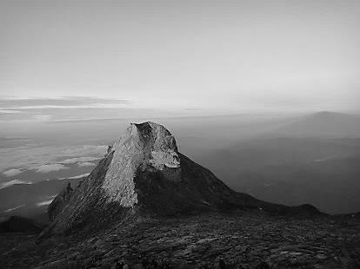

Pat Elliott’s comment on the incident on Mount Kinabalu reminded me of an event which happened in about 1965 when the DLI, in which I was serving, were stationed at a training camp within sight of the mountain. We were preparing for active service in Sarawak during the Indonesian confrontation.

One evening we were challenged to a football match by the local villagers. I was standing in the touch line with the commanding officer and the District Officer when I saw the entire mountain bathed in a bright red light as the sun set. I remarked on the splendid lighting effect on the mountain. The DO said that the locals did not like the red glow as it always meant bad luck.

Five minutes later, while the red effect still continued, a land rover arrived in a hurry to tell the CO that one of our soldiers had been drowned in a river crossing exercise. He was the only casualty that we had, and that was the only evening that the mountain was lit up in such a way.

I respect the local tribe’s belief in the sacredness of the mountain, and so should we all.

Simon Furness

**HOUSEKEEPING**

*SPICK AND SPAN*



Maintaining the fabric of the Church and Parsonage is an ongoing task and we are indebted to several members of the Vestry and of the congregation for tackling jobs large and small and keeping a weather eye open for emerging problems.

Recently, for example, Frankie and Ian oversaw the much needed cleaning of the Parsonage carpet - and arrangements for other pressing repairs are in hand.

*SOW THE SEEDS BUT PULL UP WEEDS*



The garden, too, is an area of perennial need, especially after recent damp weather with weeds springing up like triffids.

Now we Christians are usually urged to go out and plant seeds but, on this occasion, we’re asked to go out and pull up weeds.

If, every time we are in or around St Ebba’s, we take a few minutes to do some weeding, we can keep the front and side garden neat and tidy.

So, on your way to coffee on a Sunday, or just taking a stroll any other day, pop in and pull a few weeds. And if you have time to spare, why not volunteer to do more weeding and tidying. Not only do many hands make light work, they also make a garden neat!

**GROUPS TO GROW**



I have been reflecting on, and discussing with some people, the possibility of getting a group together to think about, read about, talk about faith.

The internet offers some challenging views on faith and ageing.  Some I would describe as ageist - the view that all old people need is being looked after.  Others inspire me with the idea that old age is a time to grow in understanding and in spirituality.

If you are interested in growing, we could look at healing.  I believe that Christian healing is Jesus Christ meeting us at our point of need but I would love to learn more about it.

Another option would be to look at the latest series of courses to be published.  It is called 'Pilgrims' and offers new insights and teaching on various aspects of being a Christian starting with the Creeds: where they came from and what they mean for us today.

Please do let me know if you are interested in either of those themes - healing or the creeds - and we can work out dates and time to begin meeting.

                                                                         Jennifer

## **ASIA BIBI**

## **C:\Users\Pat\AppData\Local\Microsoft\Windows\Temporary Internet Files\Content.IE5\VDN3MCF9\jail_bars[1].gif**

## *Asia Bibi’s stay of execution is welcomed by Release International*

Release International has welcomed a stay of execution for Asia Bibi – a Christian mother who has been on death row in Pakistan for blasphemy. The Supreme Court has suspended the death sentence pending an appeal.  
  
Release, which supports persecuted Christians around the world, wants Asia’s acquittal, a review of all blasphemy cases, and Pakistan to repeal its notorious blasphemy laws. All too often, allegations of blasphemy are used to settle scores with rivals. Those accused can face imprisonment and the death penalty. And even if acquitted, they can be murdered by extremists.  
  
It’s almost five years since illiterate farm labourer Asia Bibi became the first woman in Pakistan to be sentenced to death for blasphemy. Since then, Asia has been confined to a cell on death row. One cleric offered a reward of 500,000 rupees – about £4,000 – for the person who puts her to death. Militants have threatened to blow her up in prison, and her husband and children have been forced to go into hiding.

Prayer moves the hand which moves the world. Anon

*Pray for this woman, who has now been in a cell for five long years.*

## **PATRIOTISM IS NOT ENOUGH**

## *A tribute to Edith Cavell*

In September 1915, at the height of the battles in Belgium and Flanders, a British nurse working in a Belgian hospital was arrested by the Germans and charged with treason.   
 Edith Cavell had resided and worked in Belgium for seven years after training at the London Hospital in Whitechapel and working in several hospitals in England. Now, as the brutal conflict raged around her and the German army occupied most of Belgium, she determined to do all she could to save the lives of those caught up in the fighting, whatever their nationality.   
 She provided shelter and medical care for Germans, Belgians, French and British troops. In the latter two she also – and this was the core of her offence – assisted them in escaping and making their way back to their homelands.  
 Her motivation for this was entirely Christian. A vicar’s daughter, she now saw that the time had come to put the principles of the gospel to practical effect. Her own home became a secret staging post for escapees, but she did this not to ‘take sides’ but out of concern for the young men involved. She took a high view of her vocation as a nurse, seeing it as a calling that transcended racial and national barriers. Those arguments didn’t, of course, carry much weight with the German occupying power. As a Belgian resident, she was charged with treason, an offence which carried a death penalty. Her trial was widely reported, and there were many diplomatic moves made on her behalf, but they fell on deaf ears.   
 She was found guilty and sentenced to death. On 12th October 1915, at the age of 49, she was executed by a firing squad, to world-wide condemnation. Nor was Edith Cavell’s death to be forgotten. After the War her body was brought back to Britain and a service of commemoration held in Westminster Abbey. Her body was reburied in the grounds of Norwich cathedral, near the village of her birth.  
 Cavell famously said, ‘Patriotism is not enough. I must have no hatred or bitterness towards anyone.’

*Canon David Winter*

** COFFEE TIME ** When Ian and I stayed in Pitlochry a couple of years ago the Pisky Church had its service at 11.30 a.m. due to being inter regnum and the clergy were rushing between two churches.  Because of this they had coffee BEFORE the service, from 11 a.m. served at the back of the church.  I thought this was a brilliant idea and would like to suggest it here for St Ebba's.  12.15 p.m. is awfully late to be having coffee when surely we're all going home for lunch?  
 I believe coffee/tea before or after church is a vital congregational function to meet each other, greet new people, catch up, make plans, tell stories and generally be sociable.  Could we try 10.30 coffee please?  Afternoons would be longer if we could be home 12.15 instead of 1 p.m.  
  Frankie Taylor

**WISECRACKS or ‘many a true word ……..’?**

****• We never really grow up; we only learn how to act in public.  
• Knowledge is knowing a tomato is a fruit; Wisdom is not putting  it in a fruit salad.  
• To steal ideas from one person is plagiarism. To steal from many is research.  
• Whenever I fill out an application, in the part that says "If an emergency, notify:" I put "DOCTOR."  
• Why does someone believe you when you say there are four billion stars, but check when you say the paint is wet?  
• Behind every successful man is his woman. Behind the fall of a successful man is usually another woman.  
• A clear conscience is usually the sign of a bad memory.  
• Nostalgia isn't what it used to be.

**CHURCH CONTACTS**

Priests the Revd Sheila Cox 018907 71764

the Revd Jennifer Edie 018907 50169

the Revd David Smout 018907 71220

the Revd Tim Morris 01289 386615

Lay Rep Brian Payne 018907 81825

Alt Lay Rep David Garside 018907 51159

People’s Warden Richard Oldale 018907 50939

Administrator Jennifer Edie 018907 50169

Treasurer David Garside 018907 51159

St Ebba’s Church, Fort View, Paxton Terrace, Eyemouth, TD14 5EL

St Ebba’s Parsonage, Beach Avenue, Eyemouth, TD14 5EL

[www.stebbas.org.uk](http://www.stebbas.org.uk)

***If you are in hospital and would like us to know and/or to visit, under the current regulations you have to specifically ask the hospital to inform us.***

If you want to keep up with what’s happening here and across the Borders, you will find the minutes of our own Vestry meetings and the Borders Area Council meeting in the files at the back of the church.

***EDITOR’S NOTE:***

*Many thanks to everyone who has contributed to the newsletter this month. All contributions – including a welcome letter – are much appreciated to help keep your newsletter lively and in touch.*

*Please send your thoughts, comments and ideas to me by the 15th of September for inclusion in October’s issue.*

Pat

*Pat Elliott,* [*thebordersdesignhouse@hotmail.com*](mailto:thebordersdesignhouse@hotmail.com) *01890 761271*

*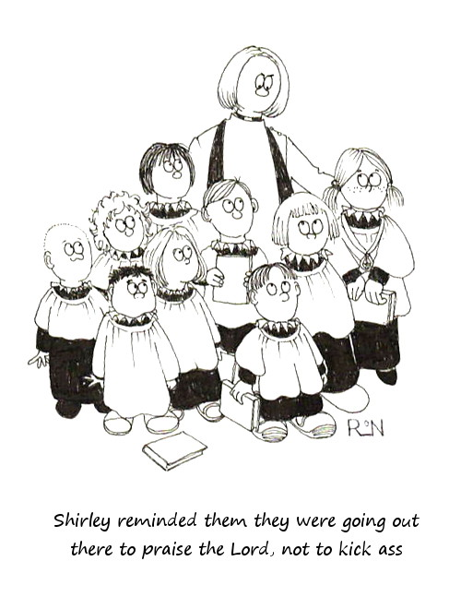*

© 2015 Parish Pump Ltd, all rights reserved