ST EBBA’S
SCOTTISH EPISCOPAL CHURCH
EYEMOUTH

FEBRUARY 2016

Times of worship
Every Sunday: 11am Eucharist in church

OSCR number SC023275
WELCOME TO OUR FIRST NEWSLETTER OF 2016 AND A HAPPY NEW YEAR

Dear All
We all mourned the recent death of David Garside but our sadness was tempered by the knowledge that for him a long period of pain and illness was over.
We remember his devoted service to St Ebba’s, particularly as Treasurer and member of the Vestry. We were all impressed by his cheerfulness and stoicism in the face of his diagnosis of incurable cancer. That he survived for three years after being given six months to live underlines his determination and refusal to give in. That he had to do this while supporting Anne in her illness speaks volumes for his character. We extend our condolences to Anne, who continues to be treated in hospital, and to his daughter Jean and Jackie who has devotedly looked after them both for so long.
While he was still Treasurer, and in the knowledge that his time was limited, Dave brought forward a plan to recast the buildings used by St Ebba’s. In outline the proposal was to sell the Parsonage and use the funds to rebuild the church hall with modern facilities for use by the church and the community. Sadly this plan was not fully supported by the Diocese and has made little progress.
The best way that we can possibly remember Dave is to take this plan forward, which the Vestry is doing. In fact much more is at stake than just commemorating him. I feel that the future of St Ebba’s depends on it. We can either take positive measures to ensure our future, or gently slide into decline and closure.
Although our numbers have held up reasonably well over the years, it is inevitable that we will grow older and fewer as the years go by. We need a place of worship that is warm and convenient with modern facilities. We do not need a parsonage for a non-existent parson. We do not need a decrepit cold church hall. Indeed we have not used it for at least the last five years. If we do not take up the challenge now, we never will.
Dave threw down the gauntlet for us to pick up. Let us honour his memory in the way he would have wanted.
Simon Furness

You will find more tributes to Dave elsewhere in the newsletter
FEBRUARY DIARY
Wed 3rd Candlemas
10.00am Eucharist in the Parsonage
Readings Malachi 3 vs 1-4
Hebrews 2 vs 14-18
Luke 2 vs 22-40
Sun 7th Sunday before LENT
11am Eucharist
Readings Exodus 14 vs 29-35
2 Corinthians 3 vs 12-4.2
Luke 9 vs 28-43
Wed 10th ASH WEDNESDAY
10.00am Eucharist
Readings Joel 2 vs 1-2, 12-17
2 Corinthians 5.20b-6.10
Matthew 6 vs 1-6, 16-21
Sun 14TH LENT 1
11.00am Eucharist
Readings Deuteronomy 26 vs 1-11
Romans 10 vs 8b-13
Luke 4 vs 1-13
Wed 17th 10.00am Eucharist
Readings Jonah 3 vs 1-10
Luke 11 vs 29-32
Sun 21st LENT 2
11am Eucharist
Readings Genesis 15 vs 1-12, 17-18
Philippians 3 vs 17-4.1
Luke 13 vs 1-19
Wed 24th 10.00am Eucharist
Readings Jeremiah 18 vs 18-20
Matthew 20 vs 17-28
Sun 28th LENT 3
11am Eucharist
Readings Isaiah 55 vs 1-9
1 Corinthians 10 vs 1-19
Luke 13 vs 1-19

INTERCESSORS AND READERS – FEBRUARY

 | Server | Intercessor | Reader
Sun 7th | Joan Shelmerdine | Jan Simpson | Frankie Taylor
Wed 10th | Richard Oldale | Ernie Cox | Simon Furness
Sun 14th | Joan Shelmerdine | Simon Furness | Susan Struthers
Sun 21st | Richard Oldale | Joan Thomas | Brian Payne
Sun 28th | Joan Shelmerdine | Sheila Cox | Jan Simpson

If you are in hospital and would like us to know and/or to visit, under the current regulations you have to specifically ask the hospital to inform us.

Want to know more about what’s going on in or around the Diocese? Take a look at the Diocesan Newsletter ‘The Communicant’. Copies are available in church or go online to www.dioceseofedinburgh.info. The latest issue is available online at
edinburgh.anglican.org/index.php/resources/by/category/thecommunicant
Keep up with what’s happening here and across the Borders. You will find the minutes of our own Vestry meetings and the Borders Area Council meeting in the files at the back of the church.

LENT COURSE
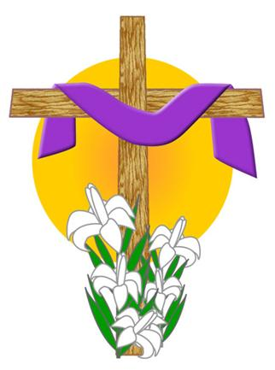

E.B.C.T. have decided to follow this year's York course on Wednesday mornings in Lent in the Parsonage - coffee at 10.30 (after the Eucharist) and meeting starts at 11 a.m.- finishes 12 noon.

This year's York course is:

The Psalms - prayers for today's church

An ecumenical course in five sessions written by Bishop Stephen Cottrell
The ancient poems we call Psalms are over 2000 years old. They were written in very different times from our own when humans could travel at the speed of a camel - not at the speed of sound. But these songs have stood the test of time for they address many of the problems we still face: violence, injustice, anger - and bewilderment. Why do the wicked prosper? Where is God when we suffer? In this 5-session course, Bishop Stephen Cottrell - a prolific and popular author - reflects on the psalms in general (and five psalms in particular). He invites us to join him as he does so.
Stephen Cottrell is Bishop of Chelmsford and was formerly Bishop of Reading. He has worked in parishes in London and Chichester, as Canon Pastor of Peterborough Cathedral, as Missioner in the Wakefield diocese and as part of Springboard, the Archbishop of Canterbury’s evangelism team.

Tributes to Dave Garside
After a long illness, sadly Dave Garside died on Friday, 8 January, 2016. Much loved and admired, Dave will be sorely missed by us all. Here are some of the many tributes by his friends to his life.

An exceptional man, a true friend, utterly unselfish in his response to the needs of others before his own.
I have enjoyed a lot of Dave's company over the years, especially when I was unable to drive. He used to pick me up for Church and to take me shopping and we'd enjoy coffee and cheese scones together. I always felt cared for when with him.
He was always good company and in later years, as his illness got worse his unfailing courage and cheerfulness in the face of adversity was a sight to behold and admire. I last saw him in the Knoll just before Christmas and even then he still compared his own 'good fortune' with those say, with motor neurone disease. I am sure that his willpower and positive attitude enabled him to live far beyond his predicted time.
I shall never forget the example he set in his service to the Church and the community. I shall miss him greatly. It was a privilege to have known him and his memory will live on.
Joan Shelmerdine

On the 4th March 2013 I was driving down from Acredale to the High School when from the otherwise deserted cross roads shot a speeding Eyemouth bound car. He made a direct hit which spun me round, landing me in a battered heap on the Toll Bridge.
Instantly, it seemed, Dave appeared, quickly ascertained I required no immediate medical help, wrapped me in his fleece jacket and found me a seat. He dealt with the police, freed the car wheels of enough of its bodywork to roll it off the road and took me home.
Even then Dave was terminally ill, on rigorous medication. Despite that he was, as borne out by the above, a man who always seemed to be in the right place at the right time, knowing how to cope. Bringing light.
I believe we all meet with angels from time to time, in various human guises. I think Dave was an angel to many. I so enjoy remembering his laughter when I told him this.
Joan Thomas

Among the many fine features of Dave’s life, the one I would highlight is his generosity. When I was invited to be Interim Pastor at Holy Trinity in Melrose in 2013, Dave immediately and spontaneously offered me the use of his Volvo so that Irene would not be left stranded, deprived of transport. This offer was repeated later in the year when I went to Kelso and Coldstream and so for over 18 months I had the use of this car, so enabling me to do this ministry. The car was serviced and even cleaned for me. This quiet act of generosity – done without fuss or bother – was typical of the Dave I knew and respected.
Tim Morris

From our first meeting, I found Dave to be the most selfless man I have ever met. Nothing was ever too much trouble and he was always the first volunteer when there was a job to be done. In a Bible study group, I came to respect his deep faith - the faith which is beyond words but underlies every action.
He was unfailingly kind and courteous, always ready with a smile and a laugh and full of interesting knowledge and experience of the world. He will leave a huge gap in the life of St. Ebba's but I am sure he would want us to do our best to fill that gap by carrying the word and the work forward.

Jennifer Edie

Ian and I were only just getting to know Dave early in 2012 when he invited us to join him on the Christian Aid sponsored walk in May. When the Saturday arrived Dave wasn't able to take part as he had pains in his legs but he acted as driver support with his car turning up at each vehicle access along the coastal walk from Berwick to St Abbs. He told us he was getting an MRI scan booked at the BGH for 17th May. It was into June before I remembered to enquire how he'd got on. The next evening he phoned and told us the news that he didn't think he'd got long. He joked that the scans were upside down and they'd got it all wrong!
We had coffee with Anne and Dave early in 2014 and were fascinated to hear of the interesting and varied life they had had. Dave hoped to be able to vote in the Scottish Referendum that coming September and he did - and he made that Christmas and the next Christmas. Just amazing.
Dave's devotion in caring for and visiting Anne was just incredible. He managed to drive daily to either the BGH or Western General in Edinburgh last summer, whilst suffering himself. He struggled on crutches without full movement and power in his legs but was determined to keep on driving for as long as he could. Ian and I went to visit him in the Margaret Kerr Unit at the BGH only to find he was waiting to be discharged. Once he had his large bag of medication he was off - where to? to visit Anne in The Knoll at Duns of course!
Always cheery, never complaining and never asking for help. I’m only sorry we didn't know you for longer. We will miss you Dave, you wonderful man.
Frankie Taylor

******************

The story behind the Hymn - ‘Who Would True Valour See’

John Bunyan (1628-88) wrote these words, which appeared as a poem in The Pilgrim’s Progress, while a prisoner in Bedford jail.
What was Bunyan doing in jail? He had got caught up in the religious/political tensions of the times, and suffered for it.
Bunyan had been brought up a Roundhead, and even became a soldier for a while in Cromwell’s army. When another soldier died in his place, Bunyan was stricken with grief, and went on to become a committed Christian.
After the Restoration of the monarchy and the Established Church in 1660, Bunyan was viewed with suspicion as a Puritan sympathiser. He was ordered to stop preaching in public, but refused. He was convicted and altogether spent 12 years in prison.
The poem appears in Pilgrim’s Progress at the point where Christiania and her four sons meet and help Mr Valiant-for-Truth on the road. They wash his wounds, give him food and drink, and learn his story.
The poem/hymn has been praised as ‘calculated to inspire the most doubtful spirit; the most disconsolate soul and to rekindle the fire of zeal and enthusiasm for the pilgrim journey.” … it was born out of Bunyan’s own struggle… to be a pilgrim.’ And it is the same faith, in the same Lord, and the same journey, that keeps millions of Christians today strong and looking forward… to the Celestial City.
Extract from Parish Pump editorial ’Looking at God’

PORVOO COMMUNION PRAYER DIARY
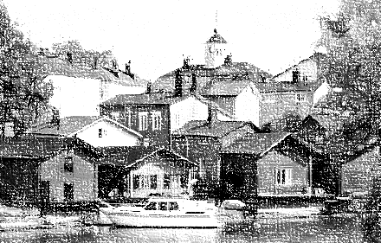

The Porvoo Declaration commits the churches which have signed it ‘to share a common life’ and ‘to pray for and with one another’. An important way of doing this is to pray through the year for the Porvoo churches and their Dioceses.
The Prayer Diary is a list of Porvoo Communion Dioceses or churches covering each Sunday of the year, mindful of the many calls upon compilers of intercessions, and the environmental and production costs of printing a more elaborate list.
Those using the calendar are invited to choose one day each week on which they will pray for the Porvoo churches. It is hoped that individuals and parishes, cathedrals and religious orders will make use of the Calendar in their own cycle of prayer week by week.
In addition to the churches which have approved the Porvoo Declaration, we continue to pray for churches with observer status. Observers attend all the meetings held under the Agreement.

FEBRUARY
7/2
Church in Wales: Diocese of Bangor, Bishop Andrew John
Church of Ireland: Diocese of Dublin and Glendalough, Archbishop Michael Jackson
14/2
Church of England: Diocese of Worcester, Bishop John Inge, Bishop Graham Usher
Church of Norway: Diocese of Hamar, Bishop Solveig Fiske
21/2
Church of Ireland: Diocese of Limerick and Killaloe, Bishop Kenneth Kearon
Evangelical Lutheran Church in Denmark: Diocese of Roskilde, Bishop Peter Fischer-Moeller
28/2
Church of England: Diocese of Peterborough, Bishop Donald Allister, Bishop John Holbrook
Church of Ireland: Diocese of Meath and Kildare, Bishop Pat Storey

FAITH in ACTION
FEBRUARY

WELLBEING

Pray for the wellbeing of others
♣ enrol on a first - aid course with the St Andrew's Ambulance Association or the Red Cross
♣ give blood regularly
♣ volunteer in the local hospital or hospice
♣ volunteer as an advocate for one of the advocacy charities
♣ become a reader for Talking Newspapers
♣ fundraise

A Prayer for people with disabilities
Lord, we give thanks for the glorious diversity of
ability within your children,
Open us up to see you in the differing abilities of the different people we meet,
Let us recognise the insight of the blind,
Let us hear your voice in the deaf,
Let us encounter your Wisdom in those with learning difficulties.
For although different, together in our great diversity of gifts and abilities we reflect the inexhaustible richness of your love, and the
beauty of your holy name. Amen

Faith in Action: The Church in Society Committee of the Scottish Episcopal Church, the Methodist Church in Scotland and the Church & Society Committee of the United Reformed Church Synod of Scotland
http://www.scotland.anglican.org/spirituality/prayer/faith-in-action

OLD AND NEW

OLD AND NEW
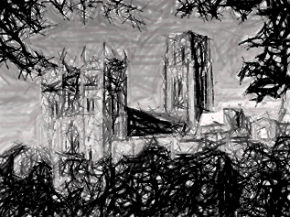
Last month Irene and I were invited to the graduation ceremony for an old friend, Don Phillips, the Bishop of Rupert’s Land in Canada who was receiving a doctorate at Durham University. This took place at what is technically called a “Congregation” of the University in the magnificent Cathedral which dominates the city.
As we waited for the ceremony to start - drying off and warming up after waiting outside in the first real snowstorm of the winter – it was impossible not to be impressed by the beautiful building in which we sat. Our eyes scanned the great round Saxon pillars and arches, the altar behind which St. Cuthbert’s tomb is located and the stained glass windows, and our ears were thrilled by the lovely organ playing. It all spoke of the history of the Cathedral as a centuries-old place of Christian worship and community, of which we were also reminded in the ceremony by the formal welcome of the acting Dean.
What was remarkable to me was the juxtaposition of these historical features with modern technology. For not only were the acoustics impeccable so that we could hear every word spoken on the podium over 100 metres away from where we sat but the whole event was videoed and relayed to dozens of televisions located around the cathedral. Everyone had a clear sight of the University Chancellor, all the speakers and - especially important – their family member or friend graduating. Without the modern technology the ceremony would have been remote and impersonal but because we could see and hear, it became alive and full of meaning.
Durham Cathedral has survived for over 1000 years because it has learned to bring together the ancient and the modern. Its traditions of worship are maintained as they have been for centuries, with daily morning and evening prayer and eucharist. Its witness to and use by the city and the University continue to be enjoyed by all concerned. But all this has only happened because the Cathedral has not been afraid over the years to grasp the needs of the contemporary age, and to make necessary changes in its structures, building and context. So it is not an ancient monument, frozen in the past, interesting to tourists and historians but fundamentally irrelevant but it has modernized itself, sympathetically but realistically.
As the new graduates moved through the ceremony into their new futures, I had a feeling that this Cathedral would also move into a future of life and that there was a lesson for us in this.
Tim Morris
******************

DISTURB US LORD
With Lent in mind, you may find this famous prayer attributed to Sir Francis Drake an inspiration...
Disturb us, Lord, when we are too well pleased with ourselves,
When our dreams have come true
Because we have dreamed too little,
When we arrived safely
Because we sailed too close to the shore.
Disturb us, Lord, when
With the abundance of things we possess
We have lost our thirst
For the waters of life;
Having fallen in love with life,
We have ceased to dream of eternity
And in our efforts to build a new earth,
We have allowed our vision
Of the new Heaven to dim.
Disturb us, Lord, to dare more boldly,
To venture on wider seas
Where storms will show your mastery;
Where losing sight of land,
We shall find the stars.
We ask You to push back
The horizons of our hopes;
And to push into the future
In strength, courage, hope, and love.
LENT MADNESS

Lent Madness began in 2010 as the brainchild of the Rev. Tim Schenck. In seeking a fun, engaging way for people to learn about the men and women comprising the Church’s Calendar of Saints, Tim came up with this unique Lenten devotion.
Combining his love of sports with his passion for the lives of the saints, Lent Madness was born on his blog “Clergy Family Confidential” which has subsequently moved locations and become “Clergy Confidential.”
The format is straightforward: thirty-two saints are placed into a tournament-like single elimination bracket. Each pairing remains open for a set period of time and people vote for their favorite saint. Sixteen saints make it to the Round of the Saintly Sixteen; eight advance to the Round of the Elate Eight; four make it to the Faithful Four; two to the Championship; and the winner is awarded the coveted Golden Halo.
For more information and to join in the game, go to
http://www.lentmadness.org/category/lent-madness-2016

YOU’VE GOT TO SMILE

Giving up for Lent
At the end of the vicar’s pre-Lent sermon he suggested, as an example to the rest of the community, that the congregation should worship in an unheated church for the whole of Lent. As they made their way into the chill Sunday air the vicar addressed one member of the congregation, asking what she had decided to give up for Lent. “Church,” she replied firmly.

In a sack
Seen in a church magazine: ‘Bring your old newspapers (and your neighbours), put them in a sack and tie them if possible.’

Wages
Advert for a new minister: ‘Wages not high, but retirement benefits out of this world.’

Sign
Outside a New York Convalescent Home there is a sign: ‘For the sick and tired of the Episcopal Church…’

Ladies
Notice in a church hall where a sale of second-hand clothes was in progress: ‘Ladies may have a fit upstairs’.

CHURCH CONTACTS

Priests the Revd Sheila Cox 018907 71764
the Revd Jennifer Edie 018907 50169
the Revd David Smout 018907 71220
the Revd Tim Morris 01289 386615

VESTRY MEMBERS 2016
Ian Taylor (Treasurer & current chair) 018907 51123
Jennifer Edie (Administrator) 018907 50169
Richard Oldale (Peoples' Warden) 018907 50939
Brian Payne (Lay Rep) 018907 81825
Frankie Taylor (Alternate Lay Rep) 018907 51123
Joan Thomas
Mary Fyall 018907 71749
Debbie Higson 018907 71202
Pat Elliott 018907 61271

St Ebba’s Church, Fort View, Paxton Terrace, Eyemouth, TD14 5EL
St Ebba’s Parsonage, Beach Avenue, Eyemouth, TD14 5EL
www.stebbas.org.uk

EDITOR’S NOTE:
Our thanks, as always, to the Parish Pump website for providing material for our newsletters throughout the year and thanks too to each of this month’s contributors.
Copy for your March newsletter is 15 February. Do drop me a line to the email address below (please note changes to the em address) or to Birchfield House, Auchencrow, TD14 5LS to share your stories, thoughts, news and views.
Yours,
Pat
E: thebordersdesignhouse@hotmail.com

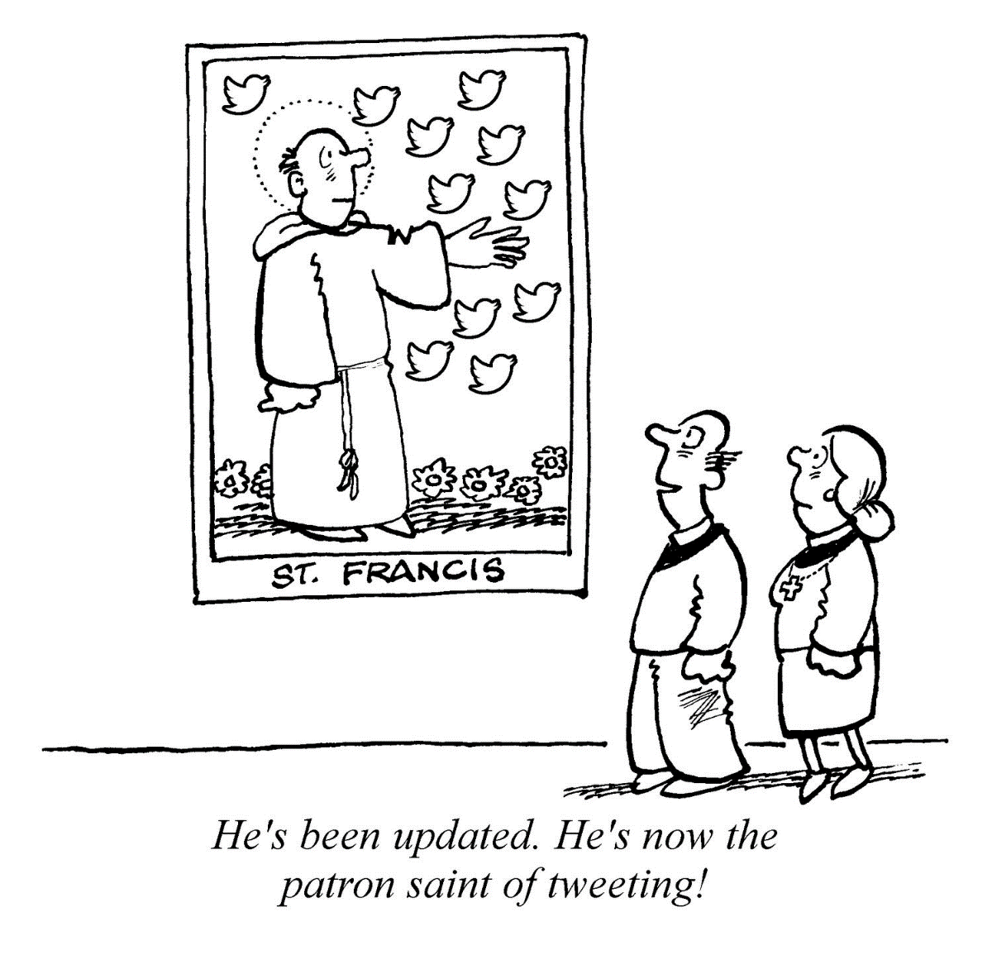

© 2016 Parish Pump Ltd, all rights reserved

