ST EBBA’S
SCOTTISH EPISCOPAL CHURCH
EYEMOUTH

MAY 2016

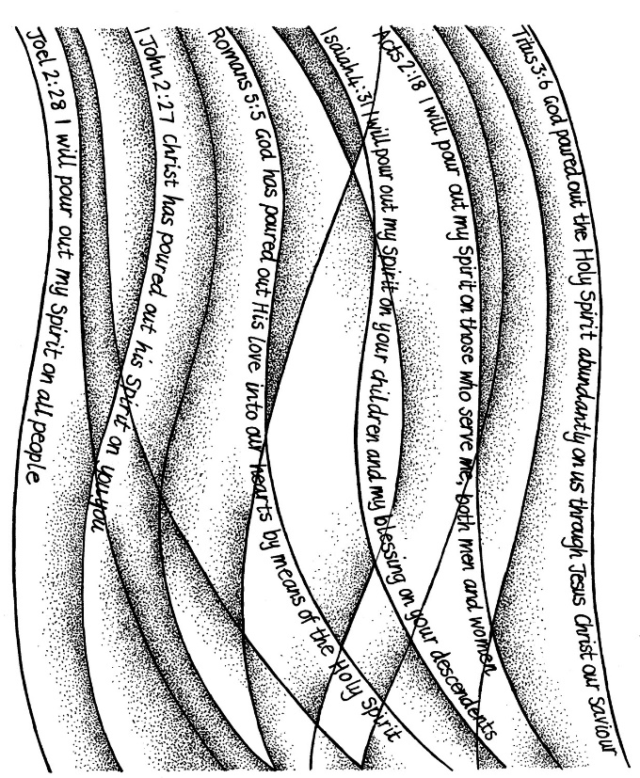

Times of worship
Every Sunday: 11am Eucharist in church

OSCR number SC023275

Meet Reverend Canon Jeffry Smith
As readers will know, Reverend Canon Jeffry Smith, part time rector of St Mary and All Souls in Coldstream, is currently acting as interim priest at St Ebba’s. Here we chat to Jeffry and learn a little more about him.

You’re not originally from the UK, Jeffry, so can you tell us something about where you grew up?
I grew up in Southern California about 40 miles east of Los Angeles in a wonderful college and citrus growing community called Claremont. It really was quite idyllic, just like in the films and in the pictures. Warm sunshine, blue skies, snow capped mountains, palm trees, beautiful beaches, and all the rest. But sadly, beginning in the late 60’s it started to become a victim of its own success. Everyone wanted to move there, and now there are scores of miles of undistinguished suburban sprawl.
What led you into the ministry – and when?
Getting my university education was a real struggle. It was necessary to work to support myself and it took me 7 years to get a degree that most people finish in 4. By the time I had finished I was married with a child. It was hard work, but beyond my own efforts I couldn’t seem to shake this sense that I had been greatly blessed in my achievements and felt inspired to offer my education back to God. That and meeting a priest who was a living example of the kind of ministry I felt I could offer led me to attend a selection conference. I honestly didn’t expect to be accepted and was probably secretly looking forward to the freedom of being able to get on with other things, but the good Lord obviously had other ideas. I was ordained deacon in 1986 and priest in 1987 in the central valley of California in the Episcopal Church USA.
Where have you served since ordination?
Like Johnny Cash it seems as if ‘I’ve been everywhere man’. I began as a curate in a place called Visalia California, moved on to a second curacy in Frimley, Surrey, before becoming Rector of East and West Clandon near Guilford for many years. After that I moved to Devon to be full time prison chaplain at a place called Channings Wood before being fortunate enough to be offered the post of Residentiary Canon of Bermuda Cathedral. After that it was 4 small churches in Northumberland near the border, before finally landing in Coldstream.
What took your ministry to Coldstream?
I had been working in Northumberland for 5 or 6 years on the understanding with the diocese that my position would be temporary and part of a larger transition in the local group of parishes. It had come to the point that it seemed like I had done all that I could do. At this time a friend of mine who was worshipping in Coldstream told me they were about to begin the search for a new rector. We were by then happily living in our own home in Wooler, and as you will appreciate from the above answer a bit tired of moving, so the position suited both myself and the church in Coldstream.
Who, or what, has had the greatest influence on your life so far?
It is hard to narrow this down as we have been richly blessed by so many wonderful people and circumstances over the years. Aside from the obvious, God and my mentor mentioned above I suppose it would have to be teachers. Three in particular come to mind – a high school philosophy teacher, an undergraduate history professor and a church history professor in my theological college in Berkeley California. The last one stands out for his persuasive suggestion that I apply for the Cuddesdon Exchange Programme which first brought us to the UK. The rest is, as they say, history.
What has given you most satisfaction and pleasure?
Personally it would have to be being father to two wonderful daughters. They are so very different but each gives me a great deal of pride, satisfaction and pleasure. The eldest has 4 children and works as a doula in Wisconsin USA, while the youngest works for Save the Children in London. Young people seem to get such a lot of bad press these days but the care and concern for others expressed by our daughters and their friends give me a great deal of hope for the future.
If you hadn’t been ordained, what career path would you have chosen?
I would probably have pursued violin making. Working with wood has always been a great joy to me and I once made an American folk instrument called a dulcimer. Before ordination intervened I had even found a good 4 year course in the subject!
If you have any unfulfilled ambitions, what are these …… and why?
For myself not so many now. A friend of mine and I went on pilgrimage last September and we walked from Porto in Portugal to Santiago de Campostella in Spain. I suppose we have both been bitten by the pilgrimage bug. We are planning to walk from Lucca to Rome this year, and if the body holds out a walk from Krakow to Czestochowa in Poland for 2017 may be on the cards. Beyond that a little motorised travel here and there, and the pleasure of watching the grandchildren grow up.
What do you enjoy doing in your spare time?
Tend my asparagus. I always wanted to grow this but never felt like we were likely to be in one place long enough to succeed at this. Also I enjoy following current events both for myself and in order to be able to try and coherently answer the inevitable question asked of Americans these days, ‘what the **** is going on with Trump?’. American baseball also comes into this. I follow a team that hasn’t won the championship since 1908. There is a saying that sustains the long suffering fan, ‘wait until next year’, but this year they really are very good. Finally, I really enjoy walking in the hills with my dog.
*************************

Á LA BICYCLETTE

Irene and a former Speech and Language Therapist (Joan Munro) are taking on the challenge of cycling from London to Paris, starting on June 13th and arriving on 25th. They have been persuaded to accept sponsorship for this adventure and have chosen to support the charity Smile Train which works internationally with children who have cleft palate.
Many of the congregation have already made contributions and Irene would thank you all for your generosity. If you would still like to sponsor her, please look on line at http://www.justgiving.com/Joan-Munro3 where you can find further details and make a donation. If you prefer to do this personally, please pass any money to me at St. Ebba’s or by post (2, The Firs, Foulden Newton, Berwick-upon-Tweed TD15 1UL). Tim Morris
MAY DIARY

Sun 1st EASTER 6
11am Eucharist
Readings Acts 16 vs 9-15
Revelations 21 vs 10 + 21.22 – 22.5
John 14 vs 23-29

Thurs 5th ASCENSION
10am Eucharist
Readings Acts 1 vs 1-11
Ephesians 1 vs 15-23
Luke 24 vs 44-53

Sun 8th EASTER 7
11.00am Eucharist
Readings Acts 16 vs 16-34
Revelations 22 vs 12-14, 16-17, 20-21
John 17 vs 20-26

Sun 15TH PENTECOST
11.00am Eucharist
Readings Genesis 11 vs 1-9
Acts 2 vs 1-21
John 14 vs 8-17, 25-27

Sun 22nd TRINITY
11am Eucharist
Readings Proverbs 8 vs 1-4, 22-31
Romans 5 vs 1-5
John 16 vs 12-15

Thurs 26th CORPUS CHRISTI
(Thanksgiving for Holy Communion)
10am Eucharist in the Parsonage
Readings Exodus 16 vs 9-15
1 Corinthians 10 vs 16-17
John 6 vs 51-58 (cont)
(MAY DIARY cont)

Sun 29th PENTECOST 2
Proper 9
11.00am Eucharist
Readings 1 Kings 18 vs 20-21, 30-39
Galatians 1 vs 1-12
Luke 7 vs 1-10

INTERCESSORS AND READERS – MAY

Date Intercessor Reader
Sun 1st Ernie Cox Jan Simpson
Sun 8th Joan Shelmerdine Frankie Taylor
Sun 15th Joan Thomas Susan Struthers
Sun 22nd Simon Furness Brian Payne
Sun 29th Sheila Cox Debbie Higson

A little reminder ……. Could all readers and intercessors please use the lectern where there is a microphone for the T loop system. This will pick up your voice and enable those with hearing aids to hear you well. There is also a neat little light (kindly donated by Brian Payne) which you can switch on to see your page better. Clergy and Worship Leaders should have their mikes attached to their robe. This system cost a lot of money so let’s use it!

If you are in hospital and would like us to know and/or to visit, under the current regulations you have to specifically ask the hospital to inform us.

2016 SCOTTISH CHURCH CENSUS

The fourth Scottish Church Census will be held on Sunday 8th May 2016. Giving up-to-date information on church attendance across the country, the census will also help to indicate which areas have changed most in recent years and provide information about congregational community work.
It is planned that results be published in April 2017.
St Ebba’s will take part in the Census and forms will be available in church. Please take one, complete and return it to help produce an accurate overview of Scottish Churches today.

DIARY DATES
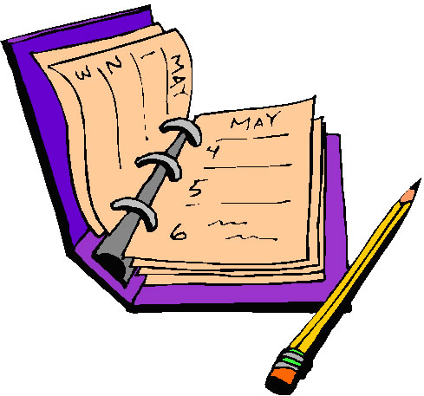
Please note that St Ebba’s Sale and Coffee Morning scheduled for 14 May has been postponed to later in the year.

30 May Last chance to claim any items you may wish to keep from the Parsonage.

21 August Bishop John will be with us at 11 a.m. for St Ebba's day on August 21st with a bring and share buffet lunch after the service. Please keep this date free!
FAITH in ACTION
MAY
Aid Agencies
♣Pray for the work of Aid Agencies locally, nationally and internationally.
♣Donate to Christian Aid. And, if you are a UK taxpayer remember to Gift Aid your donation so that the tax can be refunded.
♣Make your will a will to live by setting up a legacy with Christian Aid or another Aid Agency
♣Look for a new internet server run by an Aid Agency
♣Receive regular updates about Christian Aid's work world-wide, apply for a subscription to their quarterly magazine Christian Aid News.
♣Sponsor a child

Prayer:
Lord, You come to us in neighbours we do not know and are unlikely to meet.
You come to us when people's needs are measured in statistics,
argued about in political programmes, or estimated in development
plans.
Give us the grace to see past numbers to the real lives behind them.
So that we might, with you, build your Kingdom.
AMEN

Faith in Action: The Church in Society Committee of the Scottish Episcopal Church, the Methodist Church in Scotland and the Church & Society Committee of the United Reformed Church Synod of Scotland
http://www.scotland.anglican.org/spirituality/prayer/faith-in-action

*Please take your donated items to St Andrew’s and St George’s West Church, George Street, Edinburgh, EH2 2PA

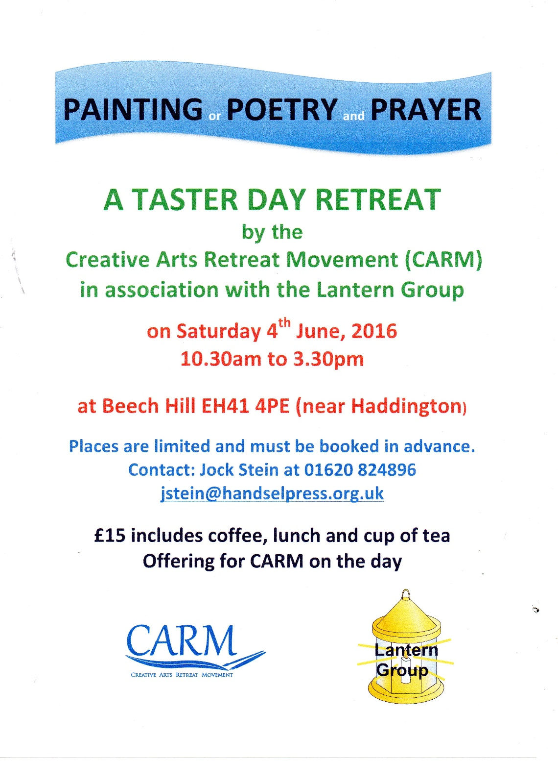

THE PSALMS
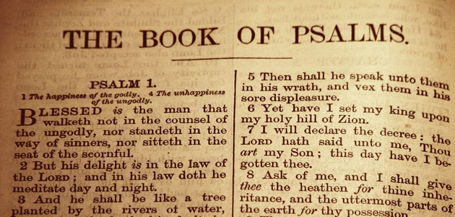
I have been deeply impressed by the York course our joint churches Lent study group followed this year. It was subtitled: prayers for today’s church and it has helped me to see the psalms in a new light.
There are four splendid speakers ( Fr. Timothy Radcliffe, a Roman Catholic priest and Dominican friar the English Province, and former Master of the Order of Preachers; Revd Prebendary Rose Hudson-Wilkinson, Chaplain to the Queen and to the Speaker of the House of Commons; John Bell of the Iona Community; and Revd Dr Jane Leach, Principal of Wesley House, Cambridge). They shared their responses to Psalms 100,130, 13, 23 and 127. Bp. Stephen Cottrell wrote the accompanying booklet, describing the Psalms as the prayer book of the Bible.
He said: “The psalms are a template for expressing who we are and all that we think and feel in the presence of God and they provide wisdom for navigating our way through the challenges and delights of life.”
If anyone is interested in looking afresh at the psalms and interpreting what they have to say to us and for us, please get in touch and perhaps we could start exploring these ideas together.
I have also found it helpful to look at the psalms in different modern versions, such as those by Jim Cotter. He explains that these are not translations from or paraphrases of the original Hebrew but a new unfolding, the aim being to shape them so as to make them prayable today.
Please do let me know if you are interested in finding out more about these ancient songs.
Jennifer

From the Vestry of St Ebba’s Church, Eyemouth:

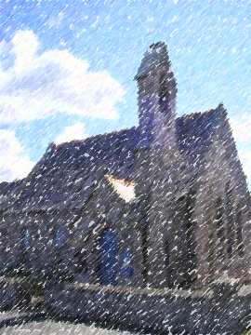
At the meeting last week, the Vestry welcomed the invitation from Rev Andy Haddow to St. Ebba’s. We have been invited to use the Priory for our services while repairs and alterations are carried out in our church.
As you know, we have been investigating the idea of revitalising our church building with the addition of a small kitchen and coffee bar - servery at the back of the church and improving the heating and lighting. This would enable us to make greater use of our much-loved building and invite the local community to use it as well as part of our local mission and ministry.
A plan has been drawn up and the Building Committee will meet the architect for further discussions about the feasibility and cost of such a venture. Such a plan would include the sale of the Parsonage for financing the concept.
It seems likely that if we go ahead, we shall have to find an alternative venue for worship while the work is being carried out. We will also be looking at demolishing the hall as it is no longer fit for purpose and this might prove to be a useful space for car parking for users.
The invitation to use the Priory came totally unprompted and we see this as an amazing gesture of support and friendship from another local church for which we have expressed our heartfelt gratitude. We see it as another sign of the new vigour and depth of care shown by all the churches involved in East Berwickshire Churches Together.
Clearly it will be some time before we reach the start of the work involved but with this invitation we can look forward to temporarily lodging and worshipping in a beautiful building with an ancient local history.
If you have questions about this project, please feel free to ask any Vestry member for more information. We shall continue to keep you informed as plans progress. If you know any members of St Ebba’s who are not online, please pass this message on to them.

BUILD PLANS FOR ST EBBA’S – THE PARSONAGE

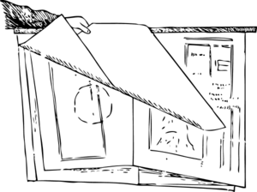

Building options and plans for St Ebba’s, having been discussed at the Church AGM and led initially by Dave Garside then, latterly, by Ian Taylor, continue to progress slowly with a number of different avenues being explored.

The building committee has met with architect Ray Licence (who worked with Kelso on their church renovations) and Ray has now carried out a survey of the current layout and drawn up a draft plan for discussion. Reviewing the use and demands of both Church and Parsonage buildings helps us all to explore ways to maximise our resources while minimising our expenses and clarifying how we might best move forward.

One of our priority tasks, whatever decision is taken on the buildings themselves, is to clear the Parsonage of items accumulated over many years. For this reason, as you may have noticed in the Diary Dates section of the newsletter, everyone is urged to reclaim any items they may have lent or given to the Parsonage which they now would like to have returned. Anything remaining after 30 May which is not in current use will then be disposed of as appropriate.

Help in sorting and clearing would be very much appreciated. If you would like to know more or can lend a hand with sorting and clearing the Parsonage, please contact any of the Vestry members (listed at the end of the newsletter).

PENTECOST

On that long ago first morning of Pentecost, Jerusalem was crowded with thousands of visitors, for it was one of the most popular feast-days in the Jewish calendar – the Feast of Firstfruits, looking forward to the wheat harvest.
In one small room of that great city, a small group of people who had followed Jesus were praying. There was nothing else for them to do: Jesus had died, he had risen, and he had ascended, promising to send them ‘a Comforter’. They were left alone, to wait at Jerusalem. And so they waited – on him, and for him. They were not disappointed: for that morning the Holy Spirit fell upon that small room, and transformed those believers into the Church, Christ’s body here on earth.

Pentecost was not the first time that the Holy Spirit came to the world – throughout the Old Testament there are stories telling of how God had guided people and given them strength. But now his Spirit would use a new instrument: not just isolated prophets, but the Church, his body on earth.
Acts opens with the preaching of the gospel in Jerusalem, the centre of the Jewish nation. Within 30 years the gospel had spread throughout the northern Mediterranean: Syria, Turkey, Greece, Malta... to the very heart of the Roman Empire: Rome. The Church was on the move – God was on the move! He was calling people from every nation to repent, turn to Jesus for forgiveness of their sins, and to follow him.

ON THE EUROPEAN REFERENDUM

- I grew up in an age when children – or boys at least – played pretend games between “Jerries and goodies”.
- I just remember National Restaurants and rationing.
- I walked to school past bomb sites and the burnt out corpse of a Georgian church.
- I saw the fall of harsh dictatorships in Spain and Portugal and these countries open up to mass tourism.
- I saw the tanks roll into Czechoslovakia at the end of the Prague Spring.
- I travelled across Europe by minibus on a school trip, manipulating about 8 different currencies through constant passport checks.
- I watched the plight of Christian communities and the scandal of orphanages in Romania.
- I stayed in a farm used by the resistance movement in Norway.
- I listened on my car radio of the fall of the Berlin wall and the collapse of “Eastern Europe”.
- I met and talked with Evangelical Lutheran Christians from Keila in the newly re-established Estonia.
- I have travelled in 10 European countries so far. My dad went as far as the Somme for 5 days.
- I visited Kantanos in Crete with a Cretan war veteran, the only survivor of his family whose village was razed.
- I watched television pictures of the Srebrenica genocide and the recent interviews with the victims of rape during the Bosnian war.
- I voted “Yes” in the last European Referendum.

And because of all of these influences on my life, I think of myself as a European.
So not because of any perceived economic benefits, trade advantages or migration issues, I will again vote “Yes” to Europe on June 23rd.
Tim Morris

CHURCH CONTACTS

Priests the Revd Sheila Cox 018907 71764
the Revd Jennifer Edie 018907 50169
the Revd David Smout 018907 71220
the Revd Tim Morris 01289 386615

VESTRY MEMBERS 2016
Jennifer Edie (Administrator) 018907 50169
Richard Oldale (Peoples' Warden) 018907 50939
Brian Payne (Lay Rep) 018907 81825
Frankie Taylor (Alternate Lay Rep) 018907 51123
Joan Thomas
Mary Fyall 018907 71749
Debbie Higson 018907 71202
Pat Elliott 018907 61271

It is with great regret that we have to accept the resignation through illness of Ian Taylor as Treasurer and Chair of Vestry . If anyone is willing and able to help with our financial management, please let any Vestry member know.

St Ebba’s Church, Fort View, Paxton Terrace, Eyemouth, TD14 5EL
St Ebba’s Parsonage, Beach Avenue, Eyemouth, TD14 5EL
www.stebbas.org.uk

EDITOR’S NOTE:
Our thanks, as always, to the Parish Pump website for providing material for our newsletters throughout the year and thanks too to each of this month’s contributors.
Please send in copy for your June newsletter by 14 May at the latest. Drop me a line to the email address below or to Birchfield House, Auchencrow, TD14 5LS to share your stories, thoughts, news and views.
Yours,
Pat
thebordersdesignhouse@hotmail.com

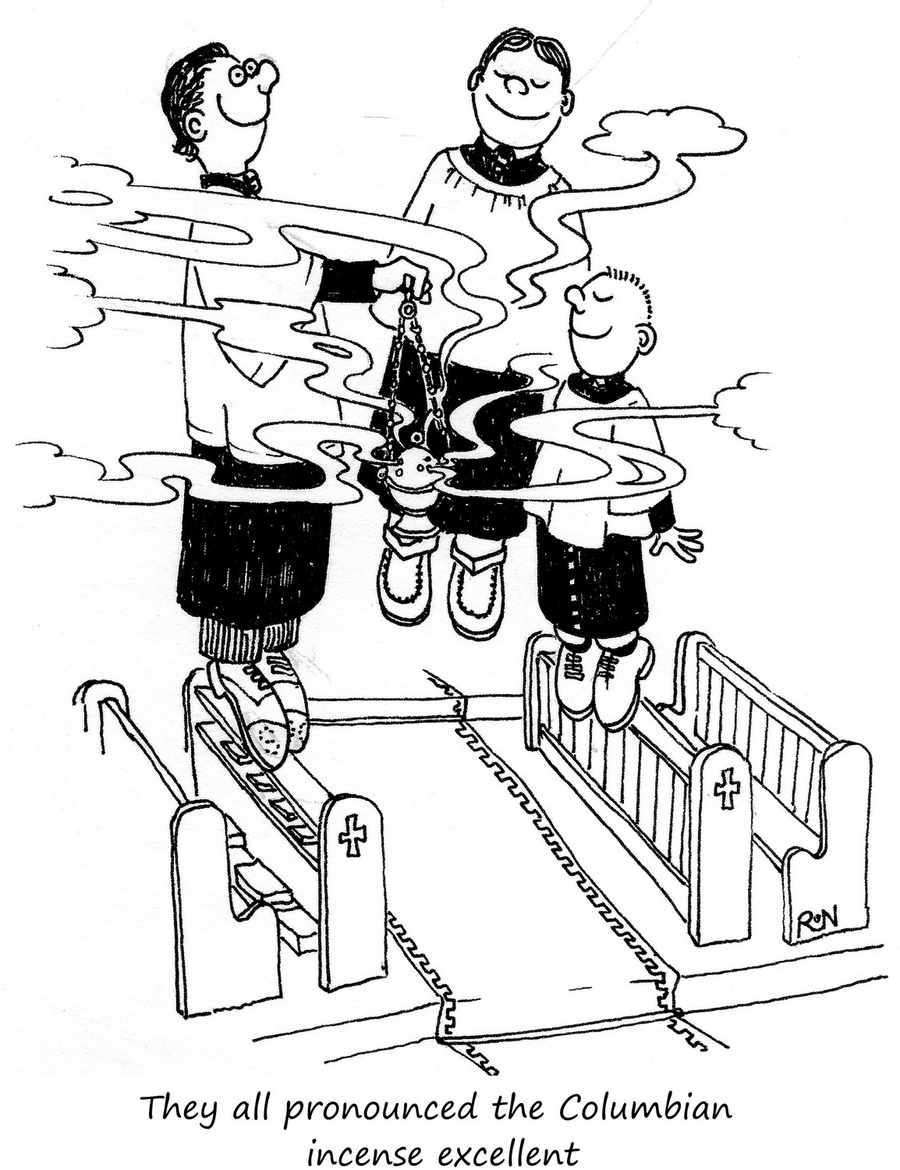

© 2016 Parish Pump Ltd, all rights reserved

